
Division of
Regulatory Services

KERS Soil Testing

Contents
Samples 2
Entering Samples 2
Entering crop information 3
Reports 4
Report Features 4
Reviewing Reports 5
Setting up KERS Soil Testing 6
Client Addresses 6
Signees 6
Notes 7

103 Regulatory Services Building | Lexington, KY 40546-0275 | P: 859-218-2468 | F: 859-257-7351 | www.rs.uky.edu/

An Equal Opportunity University

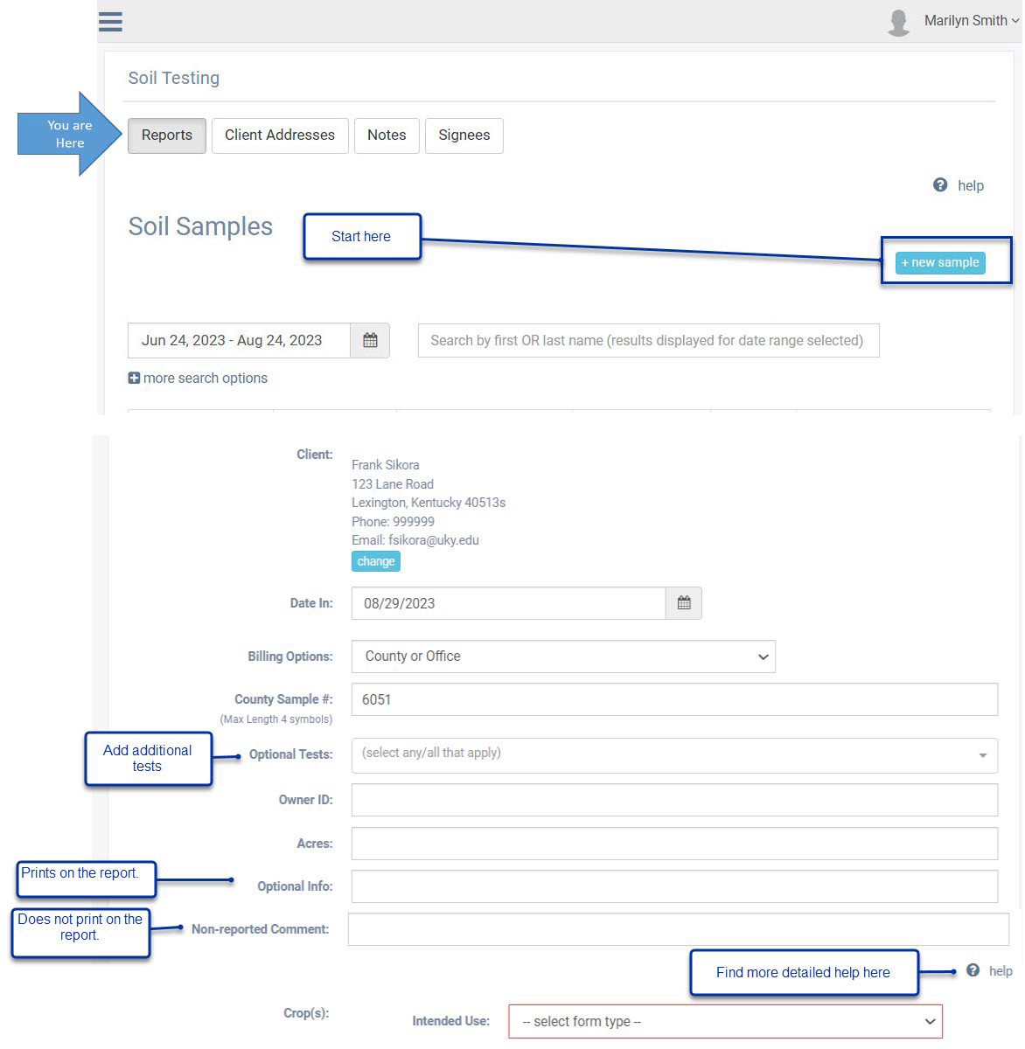
Samples

Entering Samples

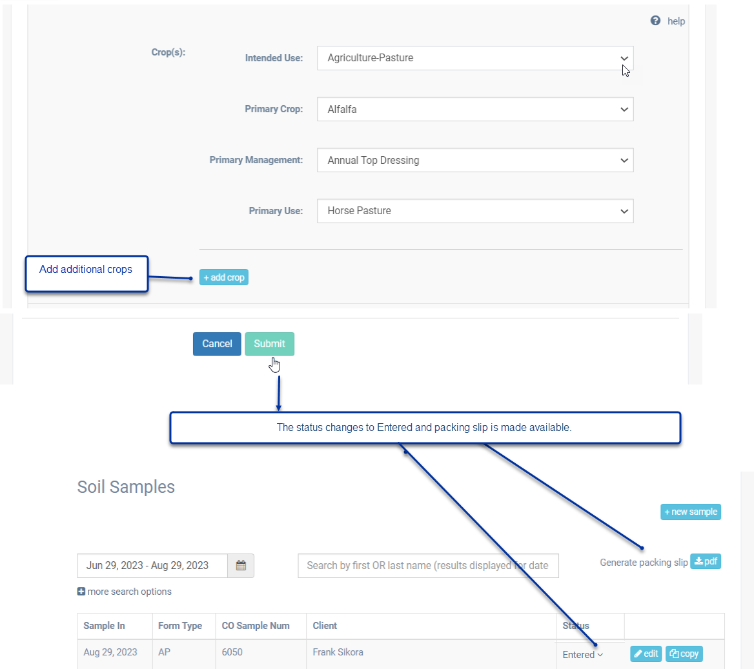
Entering crop information

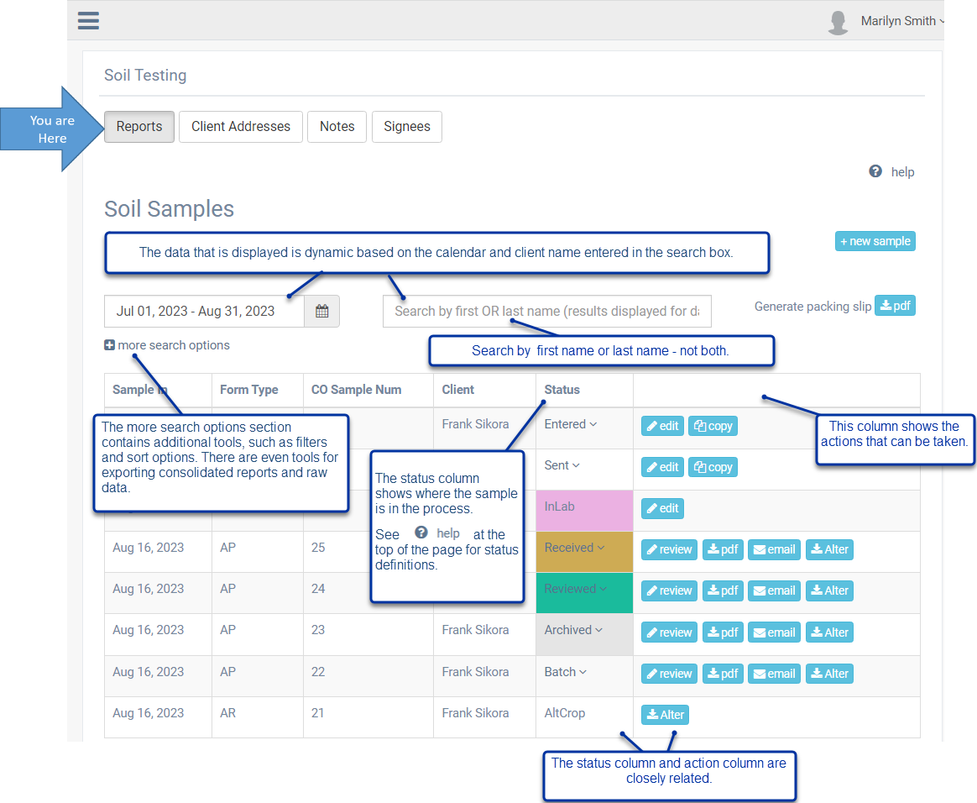
Reports

Report Features

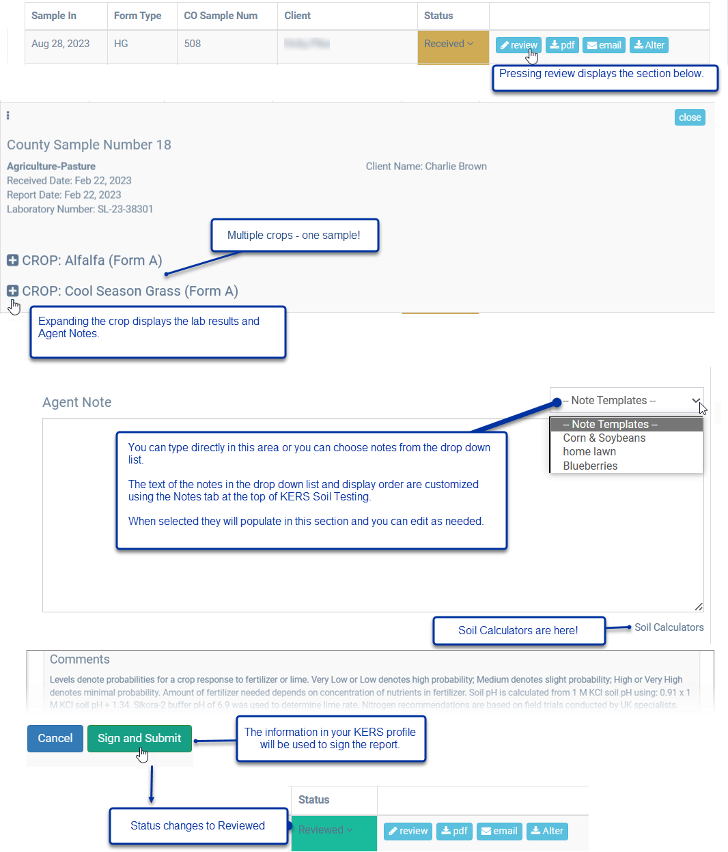
Reviewing Reports

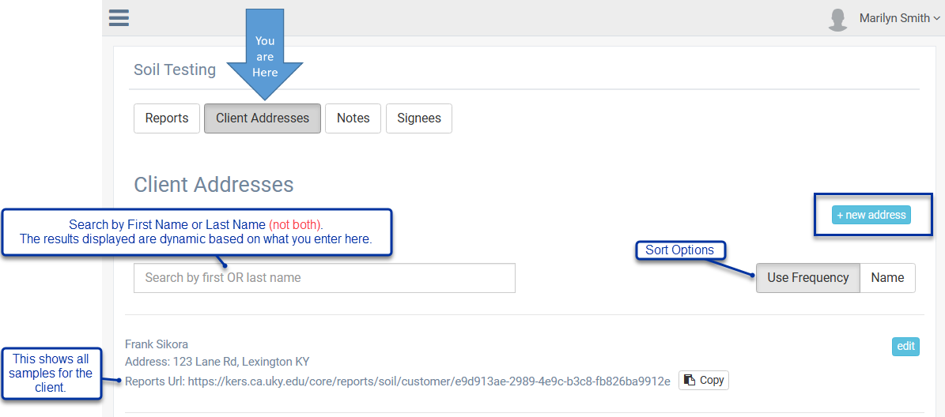
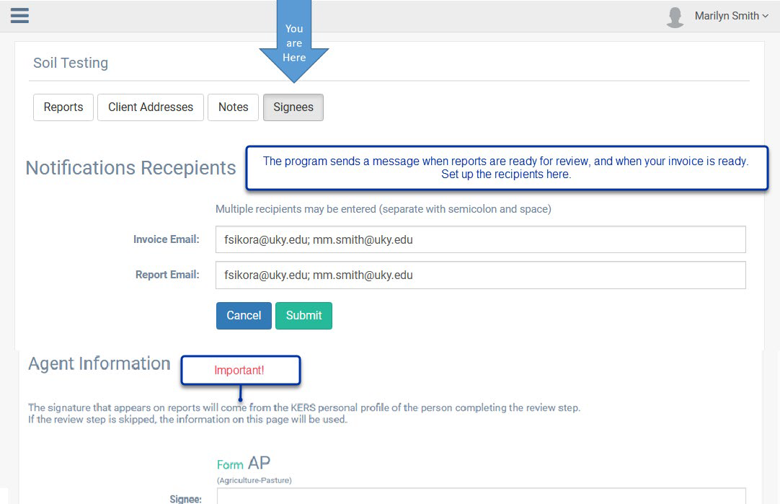
Setting up KERS Soil Testing
Client Addresses
Signees

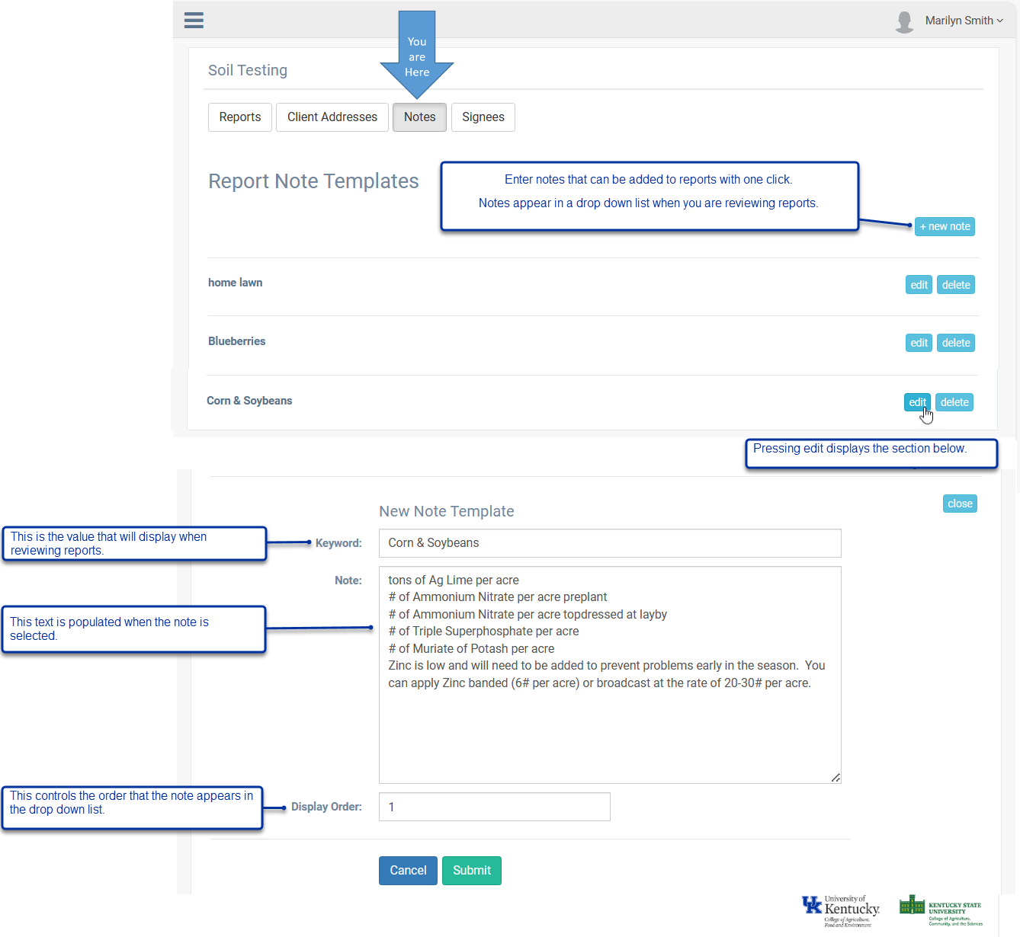
Notes

