Instructions for Entering Soil Sample Crop Information
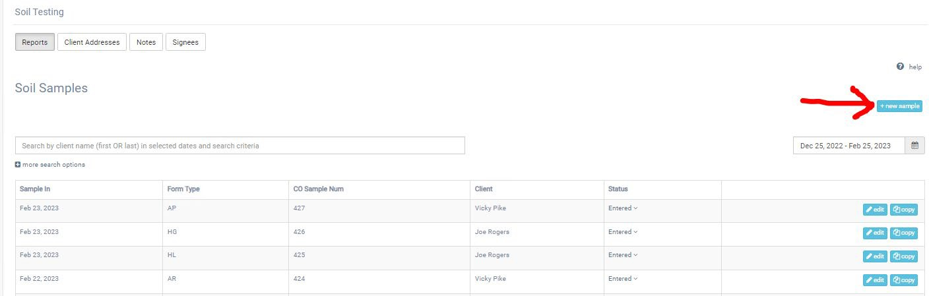
- In the Soil Testing main window, click on the “new sample” button (red arrow).

- A window appears as shown below. Enter first or last name of the client (red arrow) to see if they are in the database. If they do not appear, click on new address button (blue arrow) to enter name, address, phone number, and email for the client.
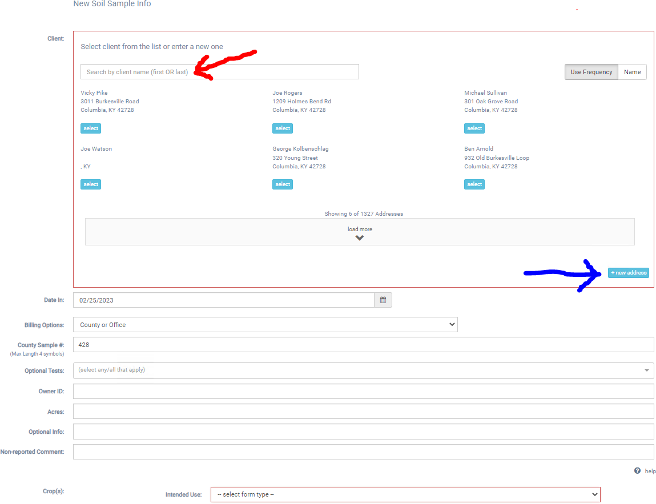

- After selecting an existing client or adding a new client, the screen appears as shown below. The date in will show the current date by default. You can enter a different date if desired.
The billing option will show “County or Office” by default. This indicates the lab will bill the office for the sample. We do not charge if the sample is part of a research project. If the sample is a research sample, you can select “Research” in the drop down list.
The county sample # will be the next incremental number. You can enter another sample number if desired. However, if you enter a number already used in the last 100 days, a warning message will appear that you entered a duplicate number.
If an optional test is requested for the sample, select the drop-down arrow and select the optional test from the list. You can select more than one optional test from the list.
Owner ID is the next item to enter. Owner ID is not required but needed if client submits more than one sample so the client will have indentifying information on the samples.
Acres is the next item to enter. Acres is not required in the program but may be required by the agent that will review reports.
Optional info is supplemental information that will appear on the report. This entry is not required. There is no need to enter phone number or email in this entry box as was often done in the old program since this information will appear on the report if entered with the client address. Example information that can be entered is a note if the sample has been paid for or a special note on the area the sample was taken from.
Non-reported comment is information that may be desired to keep on the sample but it will not appear on the report. This entry is not required. An example entry may be the date and initials of the individual entering the sample.
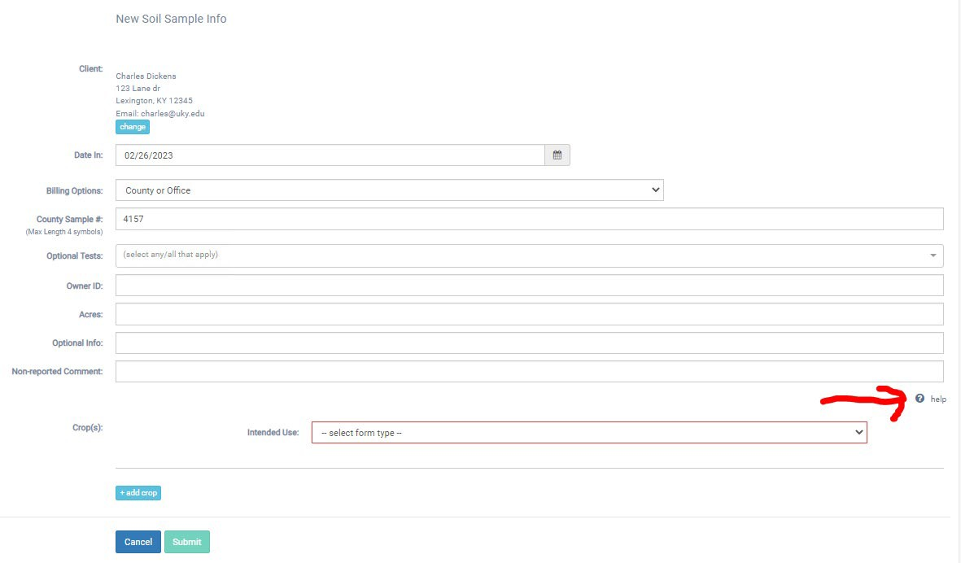

- Clicking the Help above the crop selection (red arrow in figure above) expands the window to show a table with guidelines on what information is needed for various crops as shown below. Not all crop information is needed for every crop. This is a useful guide to know what information is used in the program generating recommendations for various crops. The table does not have guidance for commercial horticulture crops. The only information required for commercial horticulture is the primary crop.
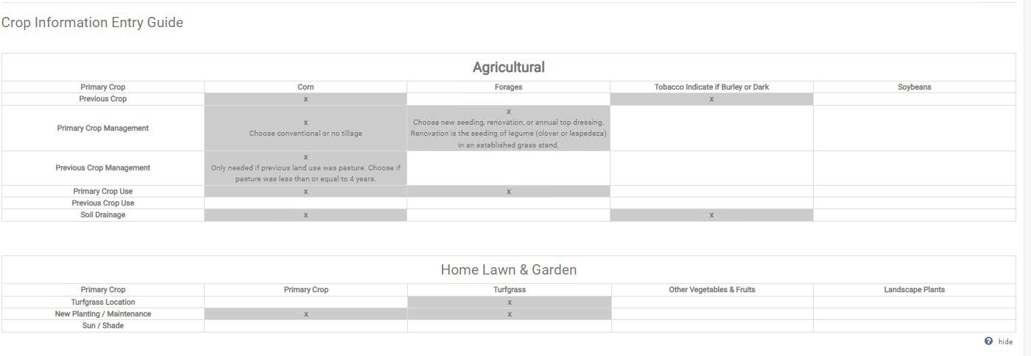

- Select the drop-down arrow to show a list of the different form types, as shown below, to select from for intended use of the field the sample was taken from. The agriculture form (A form) is now divided into Agriculture-Pasture and Agriculture-Row Crop. The home lawn and garden form (H form) is now divided into Home-Garden and Home-Lawn.
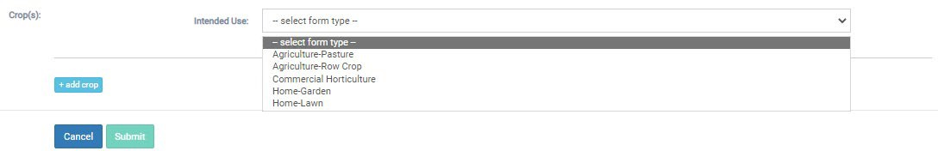

- After selecting an intended use, entry boxes will appear that are pertinent to the intended use. The two examples below show entry boxes appearring when agriculture-pasture and agriculture-row crop are selected.
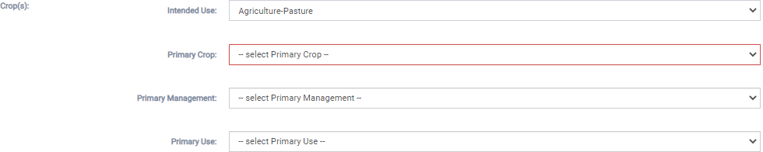

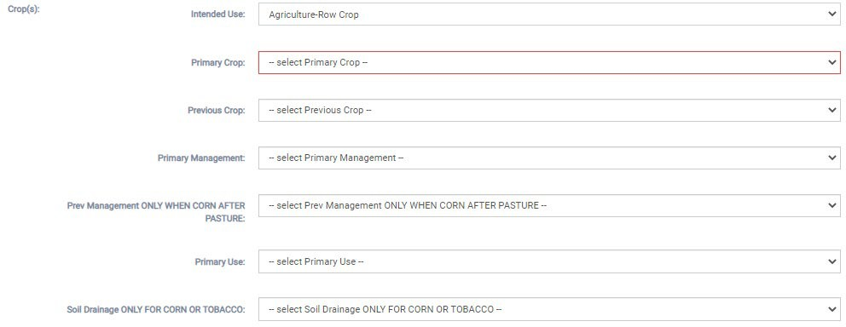

- The primary crop is a required selection. The entries are not required but should be entered based on the crop information entry guide table.

- After entering the information, the last step is to select the “Submit” button to save the sample entries. If a required field is not entered, you will not be able to submit the data and a red circle with a line through it will appear when you hover over the “Submit” button. Required entries include the following.
  - Client
  - Date In
  - Billing Options
  - County Sample #
  - Primary Crop

- After selecting the “Submit” button, you will return to the Reports table. If the sample you just entered does not appear in the table, select the refresh button for the browser you are using.

- If a client brings in several samples, you can select the “Copy” button (red arrow below) for a sample to copy the information into another record with the next highest county sample number. This avoids extra clicking to enter each individual sample. After copying the sample, you select the “Edit” button (blue arrow below) for that sample to enter the different owner ID for the sample and make any changes needed for this new sample.

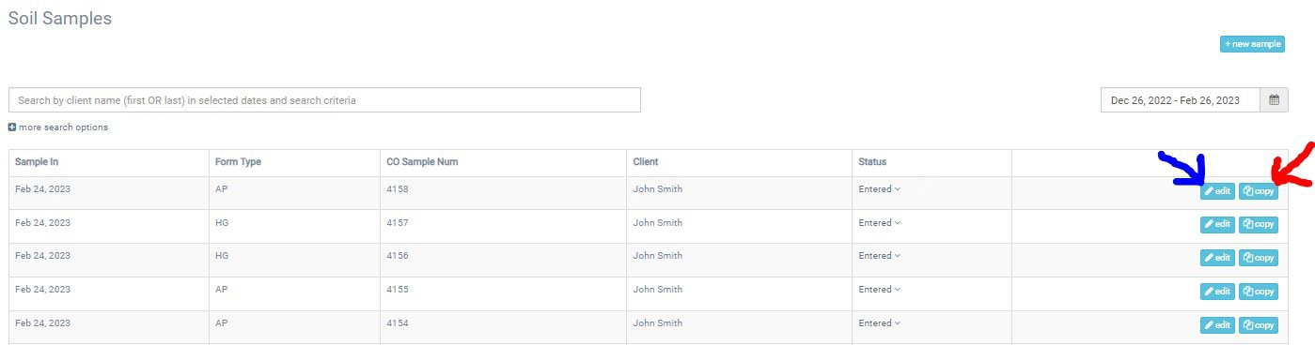
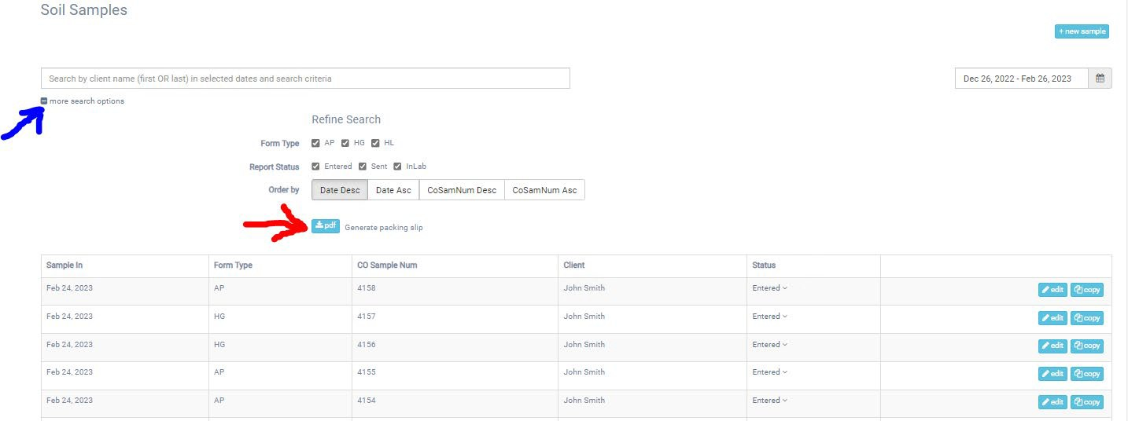
- All the samples entered will have a status of “Entered” in the table as shown below for 5 samples entered for John Smith. To print a packing slip, select the “more search options” button (blue arrow below). This expands the window to show the action button to print a packing slip (red arrow below). After selecting the “Generate packing slip” pdf button, a packing slip will be downloaded as a pdf file.

- The packing slip for the 5 samples for John Smith is shown below. This file is printed and sent with the samples to the lab. Packing slips can have more than one client. If optional tests were selected, packing slip for the optional test sample(s) will appear on separate pages. It is important to verify the county sample numbers on the packing slips match the county sample numbers on the sample bags. Also, make sure that the packing slip placed in the shipping container with the samples has all the samples in the shipment. If samples are split into different shipping containers, you can mark out the samples on the packing slip not present in the containter with a Sharpie pen.

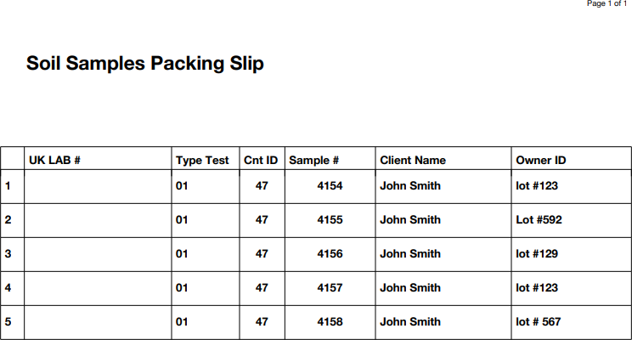

- If a mistake was made and you need to reprint a packing slip after making the correction, you can change the status of the samples from “Sent” to “Entered” by selecting the drop-down arrow for the status (red arrow below) and selecting “Entered” in the drop-down list. This is done for all the samples to be printed on the packing slip.
