Agent Review cheat sheet

- You will receive an email from KERS that informs you reports are ready for review. Login to KERS and go to Soil Test Reports. Note: The list of people receiving this communication is customizable under the “Signees” tab located at the top of the KERS Soil Test Reports window.

- Isolate samples so only the samples in need of agent review are displayed.

  - Expand the more search options section by pressing the + sign pictured below.
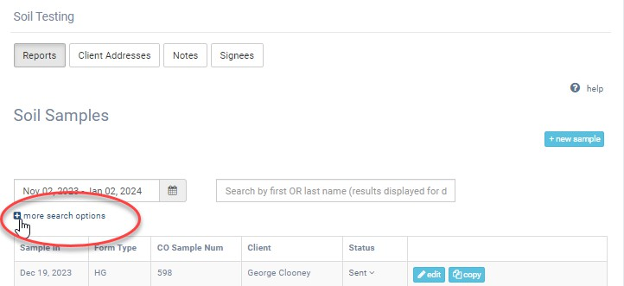

  - Uncheck all statuses except received. This will isolate all samples where the report has not been distributed.
Note: If you do not see “Received” in your list of options: The most likely cause is that the status has changed to “Archived”. This can happen if an action is taken that makes the system think the report has been distributed. You can change the status back to “Received” by using the arrow in the Status column.
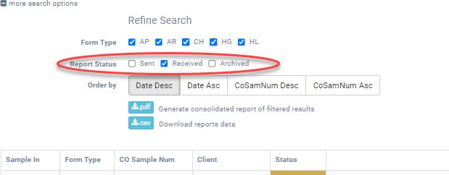

- Press “Review” to begin the agent review process.
