
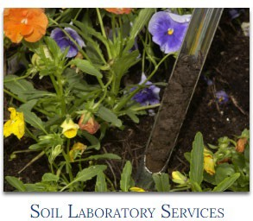
Regulatory Services website for Extension


Division of Regulatory Services home page https://www.rs.uky.edu/home/

Extension Toolbox is a section designed for extension agents. This is where you can find
recommendation calculators and links to the programs used in the soil submission process. Information relating to seed testing services can also be found here. https://www.rs.uky.edu/soil/extension.php
Lime has its own section where lime reports, the recommendation calculator, and related publications can be found.
https://www.rs.uky.edu/soil/technical_info/
Our Lab Services pages can be accessed from the Soil section of the home page or the “Lab Services” quick link of the Extension Toolbox. There is a separate page for each material tested.
This is where you will find publications and detailed information about obtaining samples, submitting samples, and interpreting results.
Note: The pages are designed with the producer in mind.
https://www.rs.uky.edu/soil/
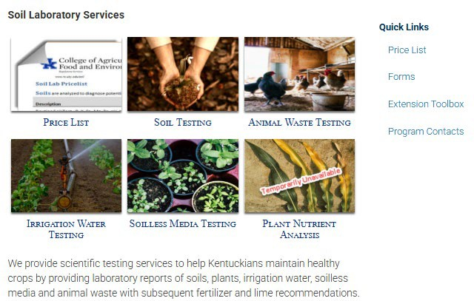

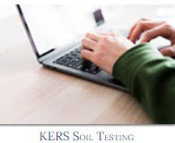
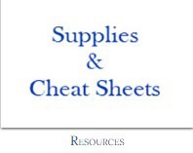
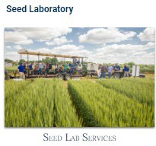

Extension Toolbox https://www.rs.uky.edu/soil/extension.php
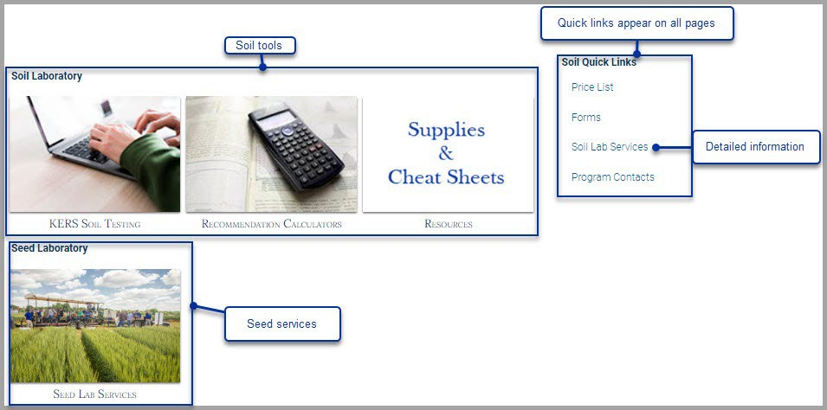

KERS Soil Testing is where you can find training materials for using
KERS Soil Testing. https://www.rs.uky.edu/soil/programs/KERSSoilTesting.php
Resources is where you will find cheat sheets and the form to order supplies.
https://www.rs.uky.edu/soil/resources.php
Do you have a suggestion for an addition? Let us know!
Seed Lab Services is an overview of the services provided by our seed laboratory.
https://www.rs.uky.edu/regulatory/seed/extension.php

