
RS-63-01(8/16) Division of Regulatory Services
103 Regulatory Services Building Lexington, KY 40546-0275
859 218-2468
Fax 859-257-7351

SEED SEMIANNUAL TONNAGE REPORT |  | - MARK APPLICABLE REPORT ( X )
  ^{st} January-June (20 )  Due July 31  Delinquent August 15 |  | 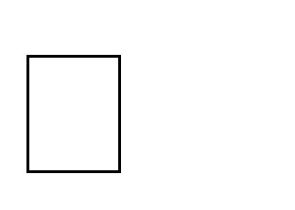  2nd July-December (20 )  Due January 31  Delinquent February 15
(full name and address of firm) | Permit : | All firms holding a permit to label seed must file a report semiannually even if no seed was distributed.  Reports are due no later than 45 days after the reporting period ends. An added assessment of $25 or 10% of the unpaid fee, whichever is greater, is to be made for each late report.

- Number of packages one pound in weight and up to and including 25 pounds in weight.
packages X $.08 = $ 0.00

- Number of packages or units distributed in excess of 25 pounds up to and including 100 pounds.
packages X $.12 = $ 0.00

units X $.12 = $
- Number of pounds or units distributed in Bulk or in excess of 100 pounds.
0.00

pounds X $.0024 = $ 0.00

units X $.12 = $
- Total Inspection Fee Due (total of items 1,2 & 3 ). $
- Late Fee of $25.00 or 10% of unpaid balance, whichever is greater.
(Include if report is more than 45 days after reporting period ends.) $

- Amount of this PAYMENT - - - Check Attached TOTAL $
0.00

0.00

0.00

Printed name and title of person making submittal:

Phone: Fax: Date:

Signature: E-mail:

Please make checks payable to UNIVERSITY OF KENTUCKY and submit with report to :
Division of Regulatory Services, University of Kentucky, 103 Regulatory Services Building, Lexington, KY 40546-0275
Do Not Write in this space – For use of Division of Regulatory Services

Check | Check | Date | Date | Company | Account
Amount | Number | Issued | Received | Code | Code
 |  |  |  |  | 63

