Seed Tag Placement

University of Kentucky
Martin-Gatton College of Agriculture, Food and Environment Division of Regulatory Services
103 Regulatory Services Building Lexington KY 40546-0275
(859) 218-2468
www.rs.uky.edu/seed



Contents
What is the purpose of the seed tag?. 3
What information is required on a label?. 4
What is Certified Seed? 6
How are the tag values determined?. 6
Is seed offered for sale monitored?. 6
How can I get more information?. 7
Seed Tags: What they reveal… 8
Guide for Seed Tag Placement… 11
List of Adapted Varieties 12
Rules of Thumb… 13
Practice Sets… 15
Class I - Red Clover… 16
Class II - Tall Fescue… 18
Class III – Wheat… 20
Class IV – Orchardgrass… 22
Practice Sets Answers… 24
Class I - Red Clover Answer… 25
Class II - Tall Fescue Answer… 26
Class III – Wheat Answer… 27
Class IV – Orchardgrass Answer… 28

What is the purpose of the seed tag?

Seed lot quality is a primary consideration when planning a crop and purchasing seed. Purity and potential germination are important factors in seed lot quality that directly impact establishment and stand as well as the subsequent harvest. To ensure producers have access to accurate seed lot quality information, seed laws exist at the state and federal levels requiring that specific information be made readily available to the purchaser in the form of a seed label. A purchaser can evaluate the information on the tag to make purchasing decision.

Fig. 1. Example seed tag of an accurately labeled red clover seed lot offered for sale in Kentucky.
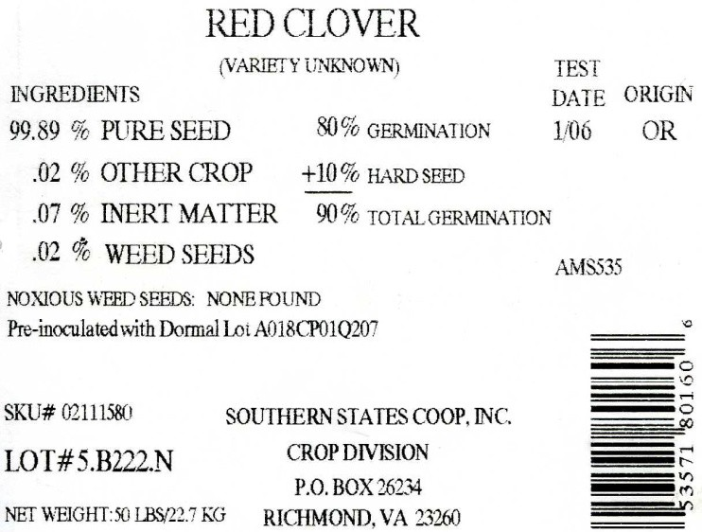

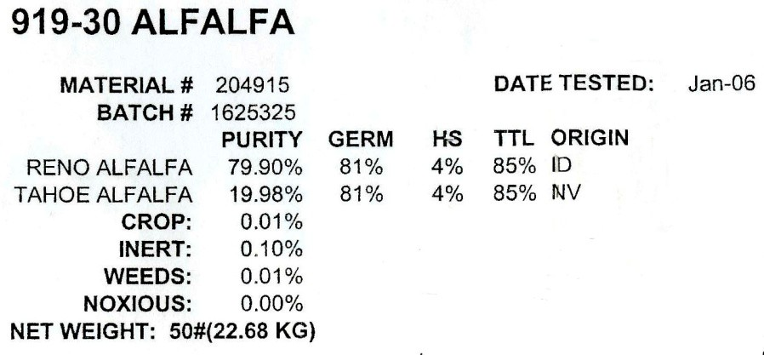
Fig. 2. Example of a seed tag with missing information offered for sale in Kentucky.

What information is required on a label?
In Kentucky (and most states), Seed Kind, Variety, Lot Number, Seedsman, Origin, Test Date, Purity, Noxious Weeds, Germination, and Treatment Statement are required on the label. Each of these items provides valuable information to the purchaser.
Seed Kind refers to the crop seed in the bag. Seed kind choice will be depend on the site and intended use. Given the intentions, a mixture may be best.
Variety is a selection of a seed kind that has specific characteristics. In Kentucky, specialists perform field trials to determine which varieties perform best in our area. These suitable varieties are called ‘adapted varieties’.

Lot Number is unique numbers and/or letters that identifies a batch of seed.

Seedsman (person or company labeling the seed) must have their name and address on the tag. They must also be registered in Kentucky and are responsible for the quality of the seed in the bag.

Origin is the state or country where the seed was grown.

Test Date identifies when the seed was tested for purity and germination. Seed viability declines with age, so a recent test date is important. In Kentucky, seed must be tested every nine (9) months.

Purity Analysis
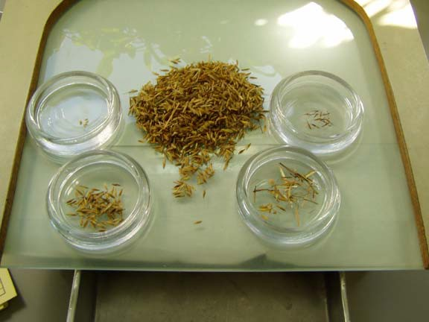
Pure Seed identifies the seed in the bag. This is what is wanted and being paid for, so the higher, the better.
Inert Matter is non-seed materials – chaff, stones, dirt, plant parts– found in the seed lot. A low percentage is best.
Crop Seed refers to other crops kinds present. (Bluegrass in a bag of orchardgrass seed, for example). Usually, a low percentage of other crop seed is desirable.
Weed Seed includes weeds in the bag. Examples include goosegrass, henbit, chickweed and most other common weeds. A low percentage is best – if you have weed problems already, you certainly don’t want to plant more!

Noxious Weed Seed identifies the few weed seeds that are so undesirable that they are restricted by law. There are 2 classes of noxious weeds – restricted and prohibited. Restricted noxious weeds (sorrel or wild onion for example) are allowable in small amounts. Prohibited seed cannot be present in a lot (quackgrass or Canada thistle, for example). There are federal noxious weeds and each state determines its own noxious weeds. Kentucky’s are:

Restricted Noxious Weeds  - Annual Bluegrass  - Buckhorn Plantain  - Corncockle  - Dodder  - Giant Foxtail  - Ox-eye Daisy  - Wild Onion/Garlic  - Sorrel | Prohibited Noxious Weeds  - Balloonvine  - Canada Thistle  - Johnsongrass  - Purple Moonflower  - Quackgrass

Germination is the percentage of seed that should germinate in the field. A high value is best. Total germination (or total viable) may be found on the tag and will be the sum of germination plus any hard or dormant seed.
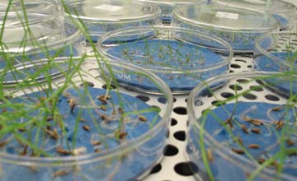
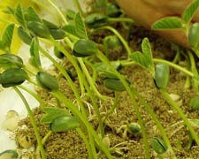

What is Certified Seed?
Certified Seed goes through rigorous field inspections and must meet specific quality standards. Although sometimes more expensive, purchasing certified seed ensures the producer of varietal purity as well as high quality seed. Kentucky Seed Improvement Association (KSIA) is the certifying agency in Kentucky.
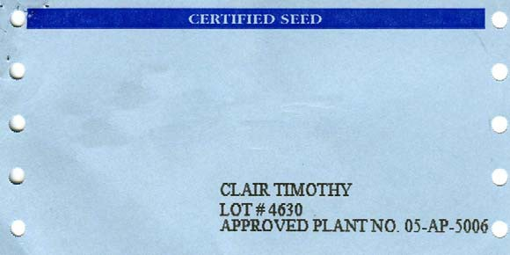
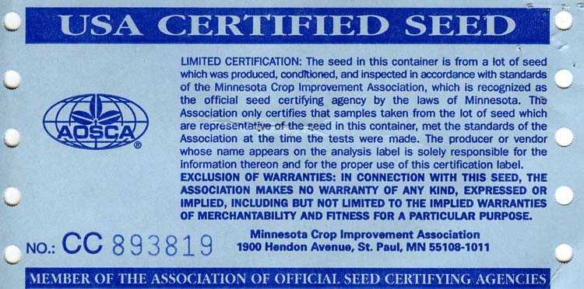

How are the tag values determined?
Laboratory tests are conducted to provide purity and germination information used by seed producers for labeling purposes. Testing protocols are proscribed in the Association of Official Seed Analysts’ (AOSA) Rules for Testing Seeds or International Seed Testing Association’s (ISTA) International Rules for Seed Testing. A purity analysis is a physical separation of the materials found in a sample. A specific weight of seed is analyzed and classified into pure seed, inert matter, weed seed and other crop seed as well as any noxious weed seed. A standard germination test is a direct evaluation of successful germination of the pure seed component under controlled laboratory conditions which correlates well to establishment under favorable field conditions.

Is seed offered for sale monitored?
Regulatory Services, a department of UK’s College of Agriculture, administers a regulatory program to protect the seed industry and consumers through inspection and analysis of seed products in the marketplace. The seed program ensures compliance with the law by inspecting facilities and

sampling seed offered for sale throughout the state. Inspectors sample seed lots and submit those for analysis. Laboratory analyses of official samples are compared to label guarantees to verify that the label is accurate and that seed quality meets a minimum standard. Seed lots not in compliance are restricted from sale until the violation is corrected. Approximately 2500-3000 samples of many seed kinds are tested for regulatory purposes each year in Kentucky.

How can I get more information?
To ask questions about seed regulation and testing, contact our office via email at seed.program@uky.edu.
University of Kentucky Division of Regulatory Services
103 Regulatory Services Building Lexington, KY 40546-0275
Laboratory tours can be arranged for groups interested in learning more about seed in Kentucky, (859) 218-2468.

Seed Tags: What they reveal.

The Kentucky Seed Law requires labeling of all agricultural seeds sold, offered or exposed for sale in bulk or a container of one pound or more (tobacco, one-twelfth ounce or more). This labeling is accomplished by attaching an analysis tag or label to each bag or container, stating the following: Kind and variety of crop seed in the container, name and address of the person labeling the seed, where the seed was grown, and a lot number or other lot identification.
The label must also show the quality of the seed as determined by analyzing and testing a sample taken from the lot. The analysis information on the tag or label includes the percentages of pure seed, crop seed, weed seed, inert matter, germination, and hard seed. The month and year the germination test was made and the name and number per pound of weed seed designated noxious in Kentucky must also be shown on the label.
An example of a seed tag is shown below and an explanation of each item on the tag follows:
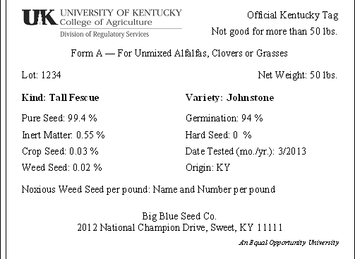
KIND AND VARIETY - The kind and variety of crop seed in the container, the proportion of which is indicated by the percentage of pure seed. For example, the illustrated analysis tag shows 99.40% pure seed which means that 99.40% of the contents of the container is Johnstone Tall Fescue; the remainder, 0.60%, is not and in actuality is worthless to the purchaser.
Determine the kind and variety of seed you wish to plant and make certain that you get what you want (read the tag). For maximum yields, only those varieties that are adapted, disease-resistant, and
recommended for your locality should be planted. Seed stock of known origin and performance should be used in fulfilling this requirement. It is best to avoid planting mixtures unless you have a specific reason to do so. The best source of planting seed is one of the classes of certified seed, such as registered or certified. At any rate, planting seed stock should not be too far removed from the breeder. If you have questions as to what variety, and perhaps kind, you should consult your county Extension agent for agriculture.
LOT IDENTIFICATION - A number or other identification used primarily by the seedsman, seed dealer, and seed law administrators as a means of identification. The lot number is of no particular significance other than for identification and has no relationship to the quality of the seed as determined by reading the tag unless one has knowledge of the particular lot. It does facilitate tracing a lot of seed from the consumer to the producer. One should choose a simple system and not repeat the series of lot designations more often than every 3 years.
PURE SEED - Percent of the KIND and VARIETY named on the tag or label. When two or more are present, each in excess of 5% of the whole, the kind and variety of each, together with their percentages, will appear on the tag or label. A HIGH percentage of pure seed is desirable.
INERT MATTER-Seed-like structures from both crop and weed plants and other materials not seeds such as dirt, chaff, stones, stems, leaves, pieces of broken seeds one-half or less than the original size, nematode galls, and fungus bodies such as ergot.
Amount present is expressed as a percentage. A LOW percentage is desirable.
CROP SEED-Seeds of plants grown as crops, other than the kind and variety named on the tag. Presence is indicated in percentage of the whole. A LOW percentage, preferably none, is desirable.
WEED SEED-Seeds, bulblets, or tubers of plants recognized as weeds by laws, official regulations, custom, or general usage. Their presence is expressed as a percentage. A LOW percentage,

preferably none, is desirable. The Kentucky Seed Law prohibits the sale of seed containing more than 2% weed seed.
GERMINATION Percent of the PURE SEED that germinate and thus are capable of producing a normal plant under favorable field conditions. On the example analysis tag, the germination percentage of 94.00% means that 94% of the pure seed (in this case 99.40%) will germinate under favorable conditions and produce normal plants in the field. The values on the tag reveal that 93.44% (99.40% pure seed x 94% germination) of the total weight of this lot of seed has the potential of producing normal Johnstone. Tall Fescue plants in the field. The planting value, pure-live seed (percent germination x percent pure seed) of any seed lot may be this manner. The Kentucky Seed Law (Regulation) prohibits the sale of uncertified seed unless the sum of the germination plus hard seed: percentage is 60% or more. Standards of germination for certified seed are established by the Kentucky Seed Improvement Association.
HARD SEED-Percent of the pure seed that are viable (alive) but do not germinate during the prescribed test period because they do not absorb water owing to impermeability of the seed coat. Most hard seeds eventually germinate and produce a plant. Hard seeds extend the germination over a longer period of time, which may or may not be an advantage. Hard seeds are undesirable when immediate germination is required. Conversely, the presence of hard seeds would be desirable when an extended germination period will increase the chances of a stand. The sum of the germination and hard seed percentages is the total value of the seed lot with respect to plant-producing potential. Hard seed are common in the Legume family (clovers, beans, etc.), the Mallow family (okra, cotton), and certain tree and shrub seeds. The Kentucky Seed Law (Regulation) prohibits inclusion of hard seed in the germination percentage. Percentages of germination and hard seed must be reflected separately on the analysis tag.
DATE OF TEST- The month and year the germination test was made. Generally, the germinating or plant-producing ability of seed declines with age. Consequently, one should hesitate to purchase or plant seed with an old test date. The test should be fairly recent; the more recent the better. The Kentucky Seed Law (Regulation) prohibits the sale of seed with a test date older than 9 months.
ORIGIN (WHERE GROWN) -The state or county in which the seeds were grown (produced). If the place of origin is not known, this fact must be stated on the analysis tag. Origin is of particular importance in certain kinds of seeds since many varieties are adapted to the climatic conditions of only a particular area. These varieties will not perform; indeed, they may not survive outside their area of adaptation.
Alfalfa, red clover, white clover, timothy, open pollinated com, and forest tree seeds are examples. Some varieties are susceptible to diseases that are prevalent in areas outside the area of production, thus restricting their distribution. Use of seed of non-adapted kinds, varieties or types of crops may result in severe economic loss and perhaps complete crop failure. Only those varieties that are recommended or proven in your area should be planted. If you have doubts, see your county Extension agent for agriculture.
NOXIOUS WEED SEED -Seeds, bulblets, or tubers of plants that reproduce by seeds, bulblets, or tubers and/or spread by underground roots or stems. Such plants are detrimental to the agriculture of this state, are particularly objectionable in lawns and gardens, and are difficult to control by ordinary good cultural practices when established. Presence of noxious weed seed is indicated on the tag or label by name and number of weed seed per pound of seed. Seed containing no noxious weed seed is most desirable.

Seeds designated noxious in Kentucky and their permitted rate of occurrence per pound of agricultural seed are:

Name of Kind | Allowed Per Pound
Balloon vine (Cardiospermum halicacabum) | 0
Purple moonflower (Ipomoea turbinata) | 0
Canada thistle (Cirsium arvense) | 0
Johnsongrass (Sorghum halepense and sorghum almum) and perennial rhizomatous derivatives  of these) | 0
Quackgrass (Agropyron repens) | 0
Annual bluegrass (Poa annua) | 256
Buckhorn plantain (Plantago lanceolata) | 304
Corncockle (Agrostemma githago) | 192
Dodder (Cuscuta spp.) | 192
Giant foxtail (Setaria faberii) | 192
Oxeye daisy (Chrysanthemum leucanthemum) | 256
Sorrel (Rumex acetosella) | 256
Wild onion and wild garlic (Allium spp.) | 96

SEEDSMAN - The name of the person, company, or corporation labeling the seed. The address must also be shown. The seedsman may or may not be the same as the person offering the seed for sale in retail or wholesale outlets. The person who exposes for sale, offers for sale, or sells seed is responsible for insuring that analysis tags or labels are attached to each bag or container offered for sale in his warehouse or place of business. It is also his responsibility to make certain the germination test date is current. The person, company, or corporation whose name appears on the tag or label is the source of the information on the tag or label and is responsible for any and all such information.
KNOW WHAT YOU SOW-Read The Tag Attached To The Bag!

Guide for Seed Tag Placement
This guide has been developed to provide information on the relative importance of various characteristics listed on a seed tag. The relative weights assigned will vary somewhat from crop to crop and hence these provide only a general guide. Other factors will often have to be used to differentiate between seed lots

Variety  Adapted**- certified Non-adapted - certified Adapted - non-certified  Non-adapted - non-certified Not identified | Rating  5  3  3  1  0 | Purity  99-100%  98-98.99%  95-97.99%  90-94.99%  80-89.99%  Below 80% | Rating  5  4  3  2  1  0
Germination and Hard Seed  95-100%  90 - 94%  80 - 89%  70-79%  60-69%  Below60% | 5  4  3  2  1  0 | Test Date  Within 9 months Older than 9 months | 5  0
Origin Kentucky Other State Other Country | 5  3  1 | Noxious Weeds None Present Present | 5  0
Crop Seed  0.00-0.10%  0.11-0.25%  0.26-0.50%  0.51-1.00%  Above 1.00% | 5  4  3  2  1 | Weed Seed  0.00-0.10%  0.11-0.25%  0.26-0.50%  0.51-1.00%  Above 1.00% | 5  4  3  2  1

** Adapted varieties have been tested in the University of Kentucky Variety Tests for at least two years and have had above average performance (yield, disease resistance, etc...)

List of Adapted Varieties

Red Clover Lakeland Acclaim Atlas Kenstar Kenland Redman Cinnamon Redland II Renegade Reddy Concord

Tall Fescue KY 31 Cochise Forager Falcon Bounty Cattle Club Johnstone Mowless Confederate Rebel Finelawn Phyter Fawn Kenhy Winchester Shenandoah Astro 2000 Brightstar Stargrazer Triathalawn Orygum Guardian Crossfire Duke
Dixie Green Finelawn, petite

Orchardgrass Potomac Comet Hallmark Crown Shiloh Amba Penlate Benchmark Lully Boone Sterling Oxford Warrior

Wheat Branson Clark Wakefield Coker 9803 Cardinal Madison Vern Freedom Bannor Becker Sawyer Caldwell Pacer Aurther Grant

*** The above seed kinds are required by the Kentucky Seed Law and Regulations to have a variety statement or the words “Variety Unknown” on the label and MAY NOT be labeled “Variety Not Stated.” ***

Seed Tag Placement
Rules of Thumb



Low Weed/Crop/Inert Noxious Weeds

(especially prohibited – presence of these is always a ‘deal-breaker’)
High Pure Seed/Germination Low Pure Seed/Germination Complete Tag Missing Information
(no variety, no lot #, no seedsman)

Certified Seed Low Hard/Dormant Percentage

Recent Test Date
(within 9 months)
Old Test Date

Named Variety ‘Unknown’ Variety

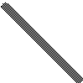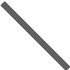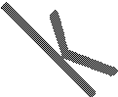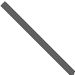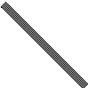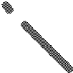

Seed Tag Placement

Practice Sets

The sample tags are based on the premise that the current date is May 2013.



Class I
Red Clover

Form A – For Unmixed Alfalfas, Clovers or Grasses
Lot: 1-06 Pears’s Seed Company
Seedsman
Pikeville, KY
Address
Red Clover Kenstar
 | Kind |  | Variety
Pure Seed Inert Matter Crop Seed Weed Seed | 92.70 %  0.50 %  6.40 %  0.40 % | Germination Hard Seed Date of Test Where Grown | 90%  2%  December, 2012 Canada

Noxious Weed Seeds
If present, number per pound

Annual Bluegrass (Poa annua) Buckhorn Plantain (Plantago lanceolata) Corncockle (Agrostemma githago) Dodder (Cuscuta sp.)
Giant Foxtail (Setaria faberii)
Ox-eye Daisy (Chrysanthemum leucanthemum)
Sorrel (Rumex acetosella)
Wild Onion & Wild Garlic (Allium sp.)
Form A – For Unmixed Alfalfas, Clovers or Grasses
Lot: 2-06 Pear’s Seed Company
Seedsman
Park City, KY
Address
Red Clover Unknown
 | Kind |  | Variety
Pure Seed Inert Matter Crop Seed Weed Seed | 98.0%  0.10%  0.95%  0.95% | Germination Hard Seed Date of Test Where Grown | 50%  44%  February, 2013 Nebraska

Noxious Weed Seeds
If present, number per pound

Annual Bluegrass (Poa annua) Buckhorn Plantain (Plantago lanceolata) Corncockle (Agrostemma githago) Dodder (Cuscuta sp.)
Giant Foxtail (Setaria faberii)
Quackgrass
Sorrel (Rumex acetosella)
Wild Onion & Wild Garlic (Allium sp.)
Form A – For Unmixed Alfalfas, Clovers or Grasses
Lot: 3-06 Peach’s Seed Company
Seedsman
PeeWee, KY
Address
Red Clover Not Stated
 | Kind |  | Variety
Pure Seed Inert Matter Crop Seed Weed Seed | 96.8%  0.95%  2.15%  0.10% | Germination Hard Seed Date of Test Where Grown | 90%  0%  July, 2012 Kentucky

Noxious Weed Seeds
If present, number per pound

Annual Bluegrass (Poa annua) Buckhorn Plantain (Plantago lanceolata) Corncockle (Agrostemma githago) Dodder (Cuscuta sp.)
Giant Foxtail (Setaria faberii)
Ox-eye Daisy (Chrysanthemum leucanthemum)
Sorrel (Rumex acetosella)
Wild Onion & Wild Garlic (Allium sp.)
Form A – For Unmixed Alfalfas, Clovers or Grasses
Lot: 4-06 Pawpaw’s Seed Company
Seedsman
Princeton, KY
Address
Red Clover Certified Kenstar
 | Kind |  | Variety
Pure Seed Inert Matter Crop Seed Weed Seed | 98.9%  0.10%  0.51%  0.49% | Germination Hard Seed Date of Test Where Grown | 62%  34%  April, 2013 Kentucky

Noxious Weed Seeds
If present, number per pound

Annual Bluegrass (Poa annua) Buckhorn Plantain (Plantago lanceolata) Corncockle (Agrostemma githago) Dodder (Cuscuta sp.)
Giant Foxtail (Setaria faberii)
Ox-eye Daisy (Chrysanthemum leucanthemum)
Sorrel (Rumex acetosella)
Wild Onion & Wild Garlic (Allium sp.)
Canada Thistle (Cirsium arvense)

Score:
Seed Tag Placement – Class I
4th
3rd
2nd
1st
Red Clover Seed Lots

Reasons for placing tag # over tag #

Reasons for placing tag # over tag #

Reasons for placing tag # over tag #

Reasons for placing tag # over tag #

Violations of the Kentucky Seed Law
For each of the seed tags, list all violations for that lot. (Tags may have multiple violations or no violations.) If the tag has no violations, write in “No Violations” for that seed lot.
Tag #1

#2

#3

#4

Name:

Class II
Tall Fescue

Form A – For Unmixed Alfalfas, Clovers or Grasses
Lot: 2-05 Waterside Seed Company
Seedsman
Water, KY
Address
Tall Fescue Kentucky 31
 | Kind |  | Variety
Pure Seed Inert Matter Crop Seed Weed Seed | 93.10 %  6.50 %  0.20 %  0.20 % | Germination Hard Seed Date of Test Where Grown | 90%  0%  September, 2012 Kentucky

Noxious Weed Seeds
If present, number per pound

Annual Bluegrass (Poa annua) Buckhorn Plantain (Plantago lanceolata) Corncockle (Agrostemma githago) Dodder (Cuscuta sp.)
Giant Foxtail (Setaria faberii)
Ox-eye Daisy (Chrysanthemum leucanthemum)
Sorrel (Rumex acetosella)
Wild Onion & Wild Garlic (Allium sp.)
10
Form A – For Unmixed Alfalfas, Clovers or Grasses
Lot: Rainy Day Seed Company
Seedsman
Sunshine, KY
Address
Tall Fescue Kentucky 31
 | Kind |  | Variety
Pure Seed Inert Matter Crop Seed Weed Seed | 99.3 %  0.02 %  0.18 %  0.50 % | Germination Hard Seed Date of Test Where Grown | 95%  0%  January, 2012 Oregon

Noxious Weed Seeds
If present, number per pound

Annual Bluegrass (Poa annua) Buckhorn Plantain (Plantago lanceolata) Corncockle (Agrostemma githago) Dodder (Cuscuta sp.)
Giant Foxtail (Setaria faberii)
Ox-eye Daisy (Chrysanthemum leucanthemum)
Sorrel (Rumex acetosella)
Wild Onion & Wild Garlic (Allium sp.)
Form A – For Unmixed Alfalfas, Clovers or Grasses
Lot: 2-07 Stormy Seed Company
Seedsman
Thunder, KY
Address
Tall Fescue Kentucky 31
 | Kind |  | Variety
Pure Seed Inert Matter Crop Seed Weed Seed | 98.0 %  1.80 %  0.11 %  0.09 % | Germination Hard Seed Date of Test Where Grown | 97%  0%  March, 2013 Kentucky

Noxious Weed Seeds
If present, number per pound

Annual Bluegrass (Poa annua) Buckhorn Plantain (Plantago lanceolata) Corncockle (Agrostemma githago) Dodder (Cuscuta sp.)
Giant Foxtail (Setaria faberii)
Ox-eye Daisy (Chrysanthemum leucanthemum)
Sorrel (Rumex acetosella)
Wild Onion & Wild Garlic (Allium sp.)
Form A – For Unmixed Alfalfas, Clovers or Grasses
Lot: 2-07 Flood’s Seed Company
Seedsman
Dropside, KY
Address
Tall Fescue Kentucky 31
 | Kind |  | Variety
Pure Seed Inert Matter Crop Seed Weed Seed | 90.02 %  5.45 %  2.21 %  2.32 % | Germination Hard Seed Date of Test Where Grown | 52%  0%  September, 2012 New Zealand

Noxious Weed Seeds
If present, number per pound
Annual Bluegrass (Poa annua) | 305
Buckhorn Plantain (Plantago lanceolata)
Corncockle (Agrostemma githago)
Dodder (Cuscuta sp.)
Giant Foxtail (Setaria faberii) | 105
Ox-eye Daisy (Chrysanthemum leucanthemum)
Sorrel (Rumex acetosella)
Wild Onion & Wild Garlic (Allium sp.)
Canada Thistle (Cirsium arvense)

Score:
Seed Tag Placement – Class II
4th
3rd
2nd
1st
Tall Fescue Seed Lots

Reasons for placing tag # over tag #

Reasons for placing tag # over tag #

Reasons for placing tag # over tag #

Reasons for placing tag # over tag #

Violations of the Kentucky Seed Law
For each of the seed tags, list all violations for that lot. (Tags may have multiple violations or no violations.) If the tag has no violations, write in “No Violations” for that seed lot.
Tag #1

#2

#3

#4

Name:

Class III
Wheat

Form B – For All Agricultural Seed Except Alfalfas, Clovers and Grasses
Lot: 1 Pap’s Seed Company
Seedsman
Lexington, KY
Address
Wheat Pembroke
 | Kind |  | Variety
Pure Seed Inert Matter Crop Seed Weed Seed | 99.45%  0.30%  0.20%  0.05% | Germination Hard Seed Date of Test Where Grown | 80%  0%  February, 2012 Argentina

Noxious Weed Seeds
If present, number per pound

Annual Bluegrass (Poa annua) Buckhorn Plantain (Plantago lanceolata) Corncockle (Agrostemma githago) Dodder (Cuscuta sp.)
Giant Foxtail (Setaria faberii)
Ox-eye Daisy (Chrysanthemum leucanthemum)
Sorrel (Rumex acetosella)
Wild Onion & Wild Garlic (Allium sp.)
Form B – For All Agricultural Seed Except Alfalfas, Clovers and Grasses
Lot: 2 Pip’s Seed Company
Seedsman
Lexington, KY
Address
Wheat Cumberland
 | Kind |  | Variety
Pure Seed Inert Matter Crop Seed Weed Seed | 99.0%  0.50%  0.20%  0.30% | Germination Hard Seed Date of Test Where Grown | 95%  0%  May, 2013  Kentucky

Noxious Weed Seeds
If present, number per pound

Annual Bluegrass (Poa annua) Buckhorn Plantain (Plantago lanceolata) Canada Thistle (Cirsium arvense) Corncockle (Agrostemma githago) Dodder (Cuscuta sp.)
Giant Foxtail (Setaria faberii)
Ox-eye Daisy (Chrysanthemum leucanthemum)
Sorrel (Rumex acetosella)
Wild Onion & Wild Garlic (Allium sp.)
Form B – For All Agricultural Seed Except Alfalfas, Clovers and Grasses
Lot: 3 Pop’s Seed Company
Seedsman
Lexington, KY
Address
Wheat Independence
 | Kind |  | Variety
Pure Seed Inert Matter Crop Seed Weed Seed | 90.0%  4.90%  2.50%  2.60% | Germination Hard Seed Date of Test Where Grown | 55%  0%  August 2011 Ohio

Noxious Weed Seeds
If present, number per pound

Annual Bluegrass (Poa annua) Buckhorn Plantain (Plantago lanceolata) Corncockle (Agrostemma githago) Dodder (Cuscuta sp.)
Giant Foxtail (Setaria faberii)
Ox-eye Daisy (Chrysanthemum leucanthemum)
Sorrel (Rumex acetosella)
Wild Onion & Wild Garlic (Allium sp.)
4
Form B – For All Agricultural Seed Except Alfalfas, Clovers and Grasses
Lot: 4 Pup’s Seed Company
Seedsman
Lexington, KY
Address
Wheat Unknown
 | Kind |  | Variety
Pure Seed Inert Matter Crop Seed Weed Seed | 97.3%  1.60%  0.00%  1.10% | Germination Hard Seed Date of Test Where Grown | 95%  0%  January, 2013 Kentucky

Noxious Weed Seeds
If present, number per pound

Annual Bluegrass (Poa annua) Buckhorn Plantain (Plantago lanceolata) Canada Thistle (Cirsium arvense) Dodder (Cuscuta sp.)
Giant Foxtail (Setaria faberii)
Ox-eye Daisy (Chrysanthemum leucanthemum)
Sorrel (Rumex acetosella)
Wild Onion & Wild Garlic (Allium sp.)

Score:
Seed Tag Placement – Class III
4th
3rd
2nd
1st
Wheat Seed Lots

Reasons for placing tag # over tag #

Reasons for placing tag # over tag #

Reasons for placing tag # over tag #

Reasons for placing tag # over tag #

Violations of the Kentucky Seed Law
For each of the seed tags, list all violations for that lot. (Tags may have multiple violations or no violations.) If the tag has no violations, write in “No Violations” for that seed lot.
Tag #1

#2

#3

#4

Name:

Class IV
Orchardgrass

Form A – For Unmixed Alfalfas, Clovers or Grasses
Lot: A
Ron’s Seed Company
Seedsman

Weasley, KY
Address
Orchardgrass
Potomac
Noxious Weed Seeds
If present, number per pound

Annual Bluegrass (Poa annua)

Buckhorn Plantain (Plantago lanceolata)

Corncockle (Agrostemma githago)

Dodder (Cuscuta sp.)

Giant Foxtail (Setaria faberii)
Form A – For Unmixed Alfalfas, Clovers or Grasses
Lot: B Hermione’s Seed Company
Seedsman
Granger, KY
Address
Orchardgrass Certified Benchmark
 | Kind |  | Variety
Pure Seed Inert Matter Crop Seed Weed Seed | 99.3%  0.02%  0.18%  0.50% | Germination Hard Seed Date of Test Where Grown | 90%  0%  June, 2012 Kentucky

Noxious Weed Seeds
If present, number per pound

Annual Bluegrass (Poa annua) Buckhorn Plantain (Plantago lanceolata) Corncockle (Agrostemma githago) Dodder (Cuscuta sp.)
Giant Foxtail (Setaria faberii)
Ox-eye Daisy (Chrysanthemum leucanthemum)
Sorrel (Rumex acetosella)
Wild Onion & Wild Garlic (Allium sp.)
Form A – For Unmixed Alfalfas, Clovers or Grasses
Lot: C Harry’s Seed Company
Seedsman
Potter, KY
Address
Orchardgrass Amba
 | Kind |  | Variety
Pure Seed Inert Matter Crop Seed Weed Seed | 98.0 %  1.80 %  0.09 %  0.11 % | Germination Hard Seed Date of Test Where Grown | 88%  0%  March, 2013 Paraguay
Form A – For Unmixed Alfalfas, Clovers or Grasses
Lot: D Albus’s Seed Company
Seedsman
Dumbledore, KY
Address
Orchardgrass Certified Amba
 | Kind |  | Variety
Pure Seed Inert Matter Crop Seed Weed Seed | 99.0%  0.50%  0.25%  0.25% | Germination Hard Seed Date of Test Where Grown | 97%  0%  January, 2013 Kentucky

Noxious Weed Seeds
If present, number per pound

Annual Bluegrass (Poa annua) Buckhorn Plantain (Plantago lanceolata) Corncockle (Agrostemma githago) Dodder (Cuscuta sp.)
Giant Foxtail (Setaria faberii)
Ox-eye Daisy (Chrysanthemum leucanthemum)
Sorrel (Rumex acetosella)
Wild Onion & Wild Garlic (Allium sp.)
Canada Thistle (Cirsium arvense)
217
Noxious Weed Seeds
If present, number per pound

Annual Bluegrass (Poa annua) Buckhorn Plantain (Plantago lanceolata) Corncockle (Agrostemma githago) Dodder (Cuscuta sp.)
Giant Foxtail (Setaria faberii)
Ox-eye Daisy (Chrysanthemum leucanthemum)
Sorrel (Rumex acetosella)
Wild Onion & Wild Garlic (Allium sp.)
Ragweed (Ambrosia trifida)

Score:
Seed Tag Placement – Class IV
4th
3rd
2nd
1st
Orchardgrass Seed Lots

Reasons for placing tag # over tag #

Reasons for placing tag # over tag #

Reasons for placing tag # over tag #

Reasons for placing tag # over tag #

Violations of the Kentucky Seed Law
For each of the seed tags, list all violations for that lot. (Tags may have multiple violations or no violations.) If the tag has no violations, write in “No Violations” for that seed lot.
Tag #1

#2

#3

#4

Name:

Seed Tag Placement

Practice Set Answer Keys

The sample tags are based on the premise that the current date is May 2013.

Score:
Seed Tag Placement – Class I Answer
4
2
1
3
4th
3rd
2nd
1st
Red Clover Seed Lots

Reasons for placing tag # 4 over tag # 2
Certified, Higher purity, Kentucky origin, No restricted noxious, Recent test date

Reasons for placing tag # 2 over tag # 1
Higher germination, Produced in US, Higher germ

Reasons for placing tag # 1 over tag # 3
Recent test date, Unknown (not ‘not stated’)

Violations of the Kentucky Seed Law
For each of the seed tags, list all violations for that lot. (Tags may have multiple violations or no violations.) If the tag has no violations, write in “No Violations” for that seed lot.
Tag
#1 – No violations #2 – No violations
#3 –Expired Test Date (> 9 months), ‘Not Stated’ as variety #4 – No violations
Name: ANSWER KEY

Score:
Seed Tag Placement – Class II Answer
3
2
1
4
4th
3rd
2nd
1st
Tall Fescue Seed Lots

Reasons for placing tag # 3 over tag # 2

High germ, high purity, recent test, Kentucky origin, missing lot number Reasons for placing tag # 2 over tag # 1
High germ, high purity, expired test date, noxious weeds Reasons for placing tag # 1 over tag # 4
Expired test, out of country origin, noxious weeds, germination

Violations of the Kentucky Seed Law
For each of the seed tags, list all violations for that lot. (Tags may have multiple violations or no violations.) If the tag has no violations, write in “No Violations” for that seed lot.
Tag
#1 Expired test date

#2 Expired Test Date, missing lot number #3 No violations
#4 Excess Noxious (annual bluegrass > 256), Low Germination (<60%), Expired Test Date

Name: ANSWER KEY

Score:
Seed Tag Placement – Class III Answer
2
4
1
3
4th
3rd
2nd
1st
Wheat Seed Lots

Reasons for placing tag # 2 over tag # 4 Adapted cultivar, Higher pure seed
Reasons for placing tag # 4 over tag # 1
Expired test date, Kentucky origin, Higher germination Reasons for placing tag # 1 over tag # 3
Noxious weeds, Missing tag information, Expired test date, Low germination, High inert matter, Excess weed seed

Violations of the Kentucky Seed Law
For each of the seed tags, list all violations for that lot. (Tags may have multiple violations or no violations.) If the tag has no violations, write in “No Violations” for that seed lot.
Tag
#1 – Expired test date #2 – No violations
#3 – Expired test date, Germination <60%, Weed seed > 2% #4 – No violations
Name: ANSWER KEY

Score:
Seed Tag Placement – Class IV
2
4
3
1
4th
3rd
2nd
1st
Orchardgrass Seed Lots

Reasons for placing tag # 2 over tag # 4
Certified, high germ, high purity

Reasons for placing tag # 4 over tag # 3
Higher Purity, Kentucky Origin

Reasons for placing tag # 3 over tag # 1
Incomplete Seed Tag (no purity information)

Violations of the Kentucky Seed Law
For each of the seed tags, list all violations for that lot. (Tags may have multiple violations or no violations.) If the tag has no violations, write in “No Violations” for that seed lot.
Tag
#1 – No purity information #2 – No violation
#3 – No violation #4 – No violations
Name: ANSWER KEY

