Know what you SOW!
Home >> Seed Department >> Consumers >> Seed Labels
Read the tag attached to the bag!
The Kentucky Seed Law requires proper labeling for all seed sold in our state. The label provides a wide range of valuable information to inform purchasers about the quality and characteristics of seed. Knowing what these components are allows you to critically evaluate seed quality when buying seed.

Lot Number is unique numbers and/or
letters that identifies a batch of seed.
Seed Kind refers to the crop seed in the bag. Seed kind choice will be depend on the site and intended use. Given the intentions, a mixture may be best.
Variety is a selection of a seed kind that has specific characteristics. In Kentucky, specialists perform field
trials to determine which varieties perform best in our area.
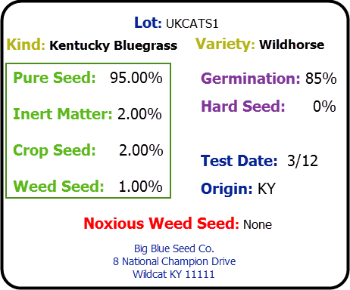
Germination is the percentage of seed that
should germinate in the field. Total germina-tion (or total viable) may be found in the tag and will be the sum of germination plus any hard or dormant seed. A high value is best.

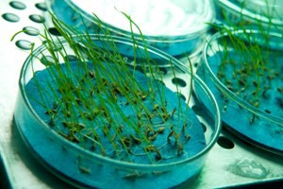

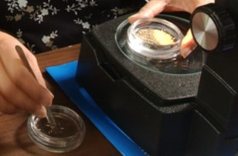
Seedsman (person or company labeling the seed) must have their name and address on the tag. They must also be licensed in Kentucky and are responsible for the quality of the seed in the bag.
Purity Analysis
Pure Seed identifies the seed in the bag. This is what you want and are paying for, so the
higher, the better.
Inert Matter is non-seed materials – chaff, stones, dirt, plant parts– found in the seed lot. A low percentage is best.
Crop Seed refers to other crops kinds present. (ryegrass in a bag of tall fescue, for example). Usually, a low percentage is desirable.
Weed Seed includes weeds in the bag. A low percentage is best – if you have weed prob-lems already, you certainly don’t want to plant more!
Test Date identifies when the seed was tested for purity and germina-tion. Seed viability declines with age, so a recent test date is important.
Origin is the state or country where the seed was grown.
Noxious Weed Seed identifies the few weed seeds that are so undesirable that they are restricted by law. There are 2 classes of noxious weeds – restricted and prohibited. Restricted noxious weeds are allow-able in small amounts. Prohibited seed cannot be
present in a lot at all. There are federal noxious weeds and each state determines its own noxious weeds.

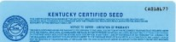
Certified Seed goes through rigorous field inspections and must meet specific quality standards. Although sometimes more ex-
pensive, buying certified seed ensures varietal purity as well as high quality seed. For
more information contact Kentucky Seed Improvement Association.

Two great resources for information about seed kinds and varieties are:

Your county extension agent
Publications from the University of Kentucky, College of Agriculture, Food & Environment

