Home >> Seed Department >> Consumers >> Consumer Protection

We publish an Annual Report of our testing results.
Consumers can see how suppliers and distributors performed.
Seed deteriorates over time, so dealers are required to obtain new germination tests periodically to ensure quality.
If the germination falls below certain standards it may not be sold.

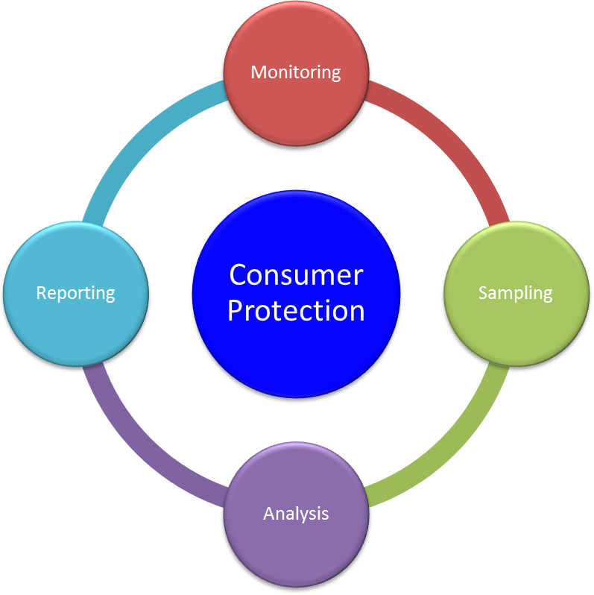

Our laboratory conducts tests to make sure all guar-antees on the label are ac-curate and the seed meets minimum quality standards.
If we find an issue the seed may not be sold until the problem is corrected.

Inspectors follow specific scientific principals when obtaining a sample.

