
Date: January 23, 2023
College of Agriculture, Food and Environment
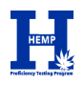
Division of Regulatory Services

Sample ID: OL22NOV-1 | Shipping Date: November 8, 2022
Material: Hemp Oil | Data Due Date: December 20, 2022
Dear Hemp PT Program Participants,
Thank you for your participation in the University of Kentucky Hemp Proficiency Testing (PT) Program.
This PT sample was a composite of 2 commercially available hemp extract oil products. 120 mL of Oil product A was mixed with 680 mL of Oil product B. Label of Oil product A was 451 mg/mL of organic virgin hemp seed oil, 15 mg/mL delta-8 THC, and minimum of 4 mg/mL secondary cannabinoids. Label of Oil product B was 25 mg/mL full spectrum hemp extract and minimum of 17 mg/mL naturally occurring total phytocannabinoids in fractionated coconut oil.
Individual opaque glass vials were filled with 13 mL of composited oil. Homogeneity and stability were evaluated by analyzing total delta-9 THC and delta-8 THC via GC-FID and is presented in the Homogeneity and Stability report.
The final reports have been reviewed and authorized for release. The included reports are:
Summary Statistics | Individual Participant’s Laboratory Trueness | Homogeneity and Stability
All Labs Precision | Individual Participant’s Laboratory Precision | Methodology Survey
All Labs Trueness | Certificate of Analysis
Summary reports, and a guide about how to interpret proficiency testing reports are available at http://www.rs.uky.edu/regulatory/hpt/reports.php. Labs are identified by lab number on summary reports. Participants’ identity will not be disclosed by us.
Individual reports are available through your lab portal at https://hpt.fass.org/data-reporting/ . The individual lab reports are the property of the participating laboratories.
Any concerns or errors in the reports should be immediately communicated to hpt@uky.edu. A timely investigation will occur and you will be advised of the outcome. Errors made by the participant in data entry cannot be changed after the reporting deadline and such errors are not grounds for appeal.
Sincerely,
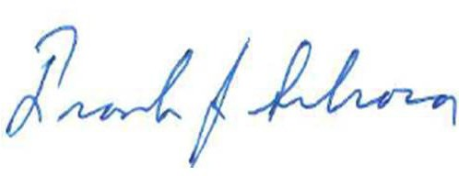
Frank Sikora, Ph.D.
Director of Hemp Proficiency Testing Program University of Kentucky
Division of Regulatory Services

