Date: October 25, 2021
Sample ID: HM21SEP-1 | Shipping Date: September 7, 2021
Material: ground Hemp | Data Due Date: October 15, 2021
Dear Hemp PT Program Participants,
Thank you for your participation in the University of Kentucky Hemp Proficiency Testing (PT) Program.
This PT sample was a composite of pre-harvest samples collected by the Kentucky Department of Agriculture in the Fall of 2020 and analyzed in our laboratory for compliance. Pre-harvest samples were collected from the terminal 20 cm of the central stem containing mature female flowers and dried at 70ºC for one day. All portions of the dried sample were ground in a Fritsch Pulverisette 19 rotary knife mill to pass a 1 mm trapezoidal perforated screen.
All ground material was combined, thoroughly mixed, and passed again through a 850 µm screen to comprise the PT sample. Individual packets were filled with approximately 20 g of hemp by randomly sampling at least a dozen subsamples from the hemp material spread out in a thin layer. Homogeneity and stability was evaluated by analyzing total THC and total CBD via GC-FID and is presented in the Homogeneity and Stability report.
The final reports have been reviewed and authorized for release. The included reports are:
Summary Statistics | Individual Participant’s Laboratory Trueness | Homogeneity and Stability
All Labs Precision | Individual Participant’s Laboratory Precision | Methodology Survey
All Labs Trueness | Certificate of Analysis
Summary reports and a guide about how to interpret proficiency testing reports are available at http://www.rs.uky.edu/regulatory/hpt/reports.php. Labs are identified by lab number on summary reports. Participants’ identity will not be disclosed by us.
Individual reports are available through your lab portal at https://hpt.fass.org/data-reporting/ . The individual lab reports are the property of the participating laboratories.
Any concerns or errors in the reports should be immediately communicated to hpt@uky.edu. A timely investigation will occur and you will be advised of the outcome. Errors made by the participant in data entry cannot be changed after the reporting deadline and such errors are not grounds for appeal.
Sincerely,
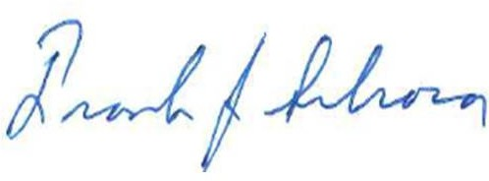
Frank Sikora, Ph.D.
Director of Hemp Proficiency Testing Program University of Kentucky
Division of Regulatory Services

