

Interpreting Hemp Proficiency Testing Reports

2024 Program Year

Statistical analysis of data in the Hemp Proficiency Testing Program follows guidelines in ISO 13528 (ISO, 2015). Laboratories are asked to provide the method performed and triplicate results for each sample. Laboratory results are evaluated for trueness and precision. This document presents information on interpreting each of the following reports.

- Laboratory Trueness Report - Individualized lab report evaluating lab’s trueness.
- Laboratory Precision Report - Individualized lab report evaluating lab’s precision.
- All Labs Trueness - Report evaluating trueness of all lab results.
e) All Labs Precision - Report evaluating precision of all lab results.
- Summary Statistics - Report on medians and variabilities for the analytes.
- Homogeneity and Stability - Summary report comparing analytes and methods.
h) Certificate of Analysis - Analytical results and uncertainties of analytes in samples based on results submitted.

Method Codes, Analytes, and Method Groups
Laboratories report their results for analytes and the methods they used. The methods are defined with method codes as shown in Appendix A. Analytes in the program include cannabinoids, metals, terpenes, and moisture. Laboratories report their results on an as-received or dry weight basis in units of % w/w or µg/g depending on the analyte. Abbreviations of %AR and %DW are used in the reports to identify concentrations on an as-received or dry weight basis, respectively.
Concentration on a dry-weight basis is considered to be the concentration with respect to the mass of material excluding all moisture. Instructions included with the samples provide guidance to calculate concentration on a dry weight basis as shown below.
% dry weight basis = % as-received x (100 / (100 - % moisture) )

Laboratory Trueness and Precision Reports
Prior to 1994, accuracy referred to how close an average result was to the true value.
This term was modified in ISO 5725 (ISO 1994) to include both the closeness of an average to the true value (trueness) and closeness of repeated results (precision). Trueness replaced accuracy as a term to describe the closeness of an average result to the true value. Both figures below display poor accuracy. The figure on the left has good trueness because the average location of the holes is close to the center target. However, there is poor accuracy because the holes have poor precision. The figure on the right has good precision because the holes are close to one another. However, there is poor accuracy because the average location of the holes has poor trueness.
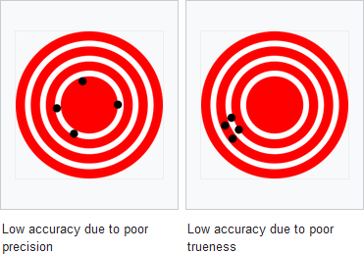

Individualized lab reports are prepared that evaluates trueness and precision of lab results. Page 1 of a Laboratory Trueness Report is shown below. The laboratory number and sample identifications are identified in the banner. A table of data is presented for each sample. The three lab results and the average of the three results (Lab Value) are displayed for each method code which defines the analyte and method used to obtain the results. A robust mean and number of observations is displayed for all Lab Values for an analyte regardless of method used (Analyte heading) and all Lab Values for an analyte in a Method (Method heading). Z scores are presented for each of these data sets. A Z score is a measurement of the agreement between the individual lab result and the robust mean considering data distribution of each set. An exact match between Lab Value and Robust Mean would result in a Z score of 0. Lab Values between -2 and +2 are within 2 standard deviations of the data distribution. Lab Values between
-3 and +3 are within 3 standard deviations of the data distribution. Lab Values between -2 and
+2 are green and considered acceptable. Lab values between -3 and -2 or +2 and +3 are colored orange and are a cautionary warning that the laboratory’s procedure should be evaluated. Lab Values less than -3 or greater than +3 are colored red and are considered unacceptable where action should be taken to correct the laboratory’s procedure. A laboratory’s proficiency in testing an analyte is evaluated with all values for an Analyte (Analyte Z score). Z scores for Method are for evaluating how a lab performed with other labs using the same method.
Appendix B has information on robust statistics and Z score calculations that were used.
Flag indicators will appear in the far right hand column of the report for situations with limited data for statistical analysis. Robust means and Z scores are only calculated with 6 or more observations. Lab value is not used to determine robust means and Z scores if there are less than 2 numeric results for an analyte reported from the lab. A key to the flags is provided at the bottom of the reports when these situations arise. Rules used for considering nonnumeric values are shown in Appendix C.

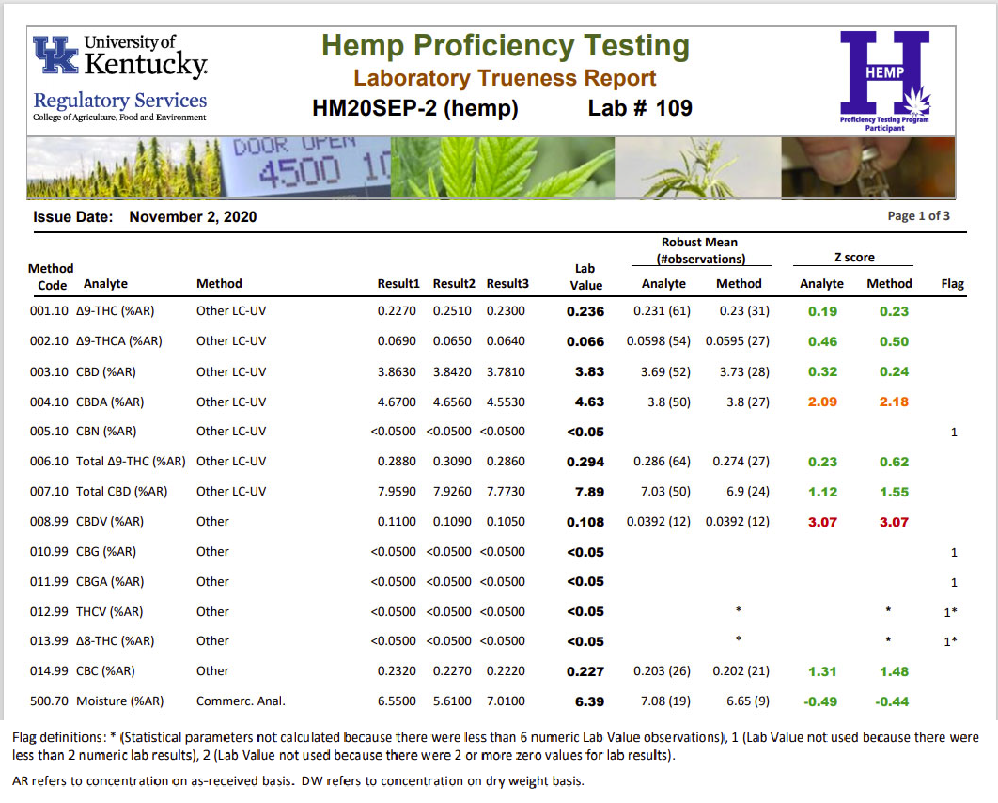

The Laboratory Precision Report, as shown below, is very similar to the Laboratory Accuracy Report. Instead of Lab Value, the Precision Report displays the lab’s relative standard deviation for repeatability (Lab RSDr) from the three reported results for an analyte. All lab RSDr values are considered for calculating robust mean for all results for the analyte or method. The HorRat(r) value is a ratio of the Lab RSDr value to an expected Horowitz reproducibility value. Any value greater than 0 and less than or equal to 1.3 is in green and considered acceptable. Values that are greater than 1.3 and less than or equal to 4.9 are in orange and are a cautionary warning that the values are high. Values greater than 4.9 are in red and are a heightened warning that the variability of the three results is very high. Appendix B contains details on the calculation of HorRat(r) and an explanation of the warning levels used.

As with the trueness report, flag indicators will appear in the far right hand column of the report for situations with limited data for statistical analysis. Robust Means are only determined with 6 or more observations. A value for RSDr and HorRat(r) is only determined when 3 nonzero numeric results are reported. A key to the flags is provided at the bottom of the reports when these situations arise. Rules used for considering nonnumeric values are shown in Appendix C.

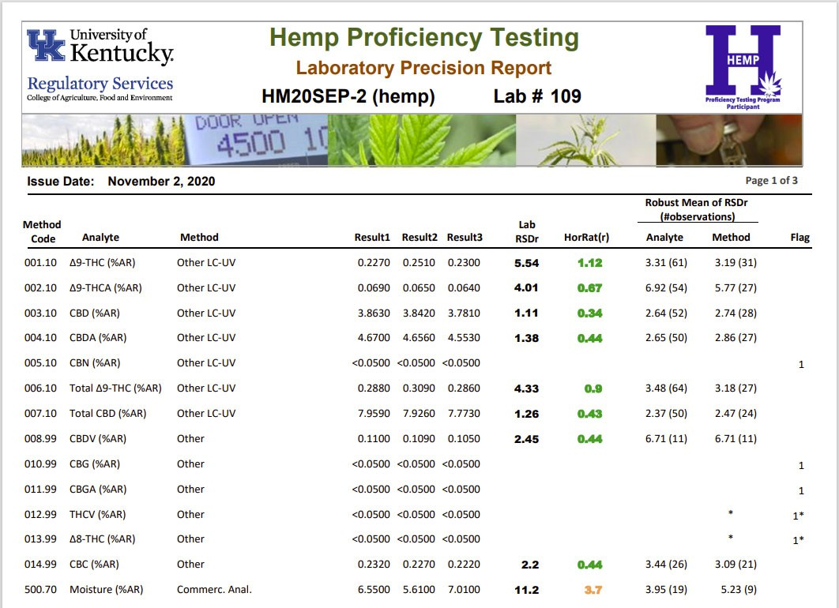

All Labs Trueness Report
The All Labs Trueness report is a multipage report displaying all lab results grouped by Analyte and Sample Number. Page 1 and 2 of the report is shown on page 5. For each set of Analyte and Sample Number, data is sorted by Lab Value. Z scores are also shown in green, orange, and red colors as described for Laboratory Trueness reports. Flag values other than 0 note Lab Values were not used to calculate robust mean or Z scores due to limited numeric results. This report is useful to determine where an individual Lab Value fell within the range of all Lab Values for an analyte. The report also provides useful information on lower and upper limits used by various labs where results are reported with “<” or “>”.

All Labs Precision Report
The All Labs Precision report is a multipage report displaying all lab RSDr values grouped by Analyte and Sample Number. Page 1 and 2 of the report is shown on page 6. HorRat(r) values are shown in green, orange, and red colors as described for Laboratory Precision reports. For each set of Analyte and Sample Number, data is sorted by the HorRat(r) values. Flag values other than 0 note RSDr and HorRat(r) values were not calculated due to limited numeric results. This report is useful to determine where individual Lab RSDr and HorRat(r) values fell within the range of all Lab RSDr and HorRat(r) values for an analyte.

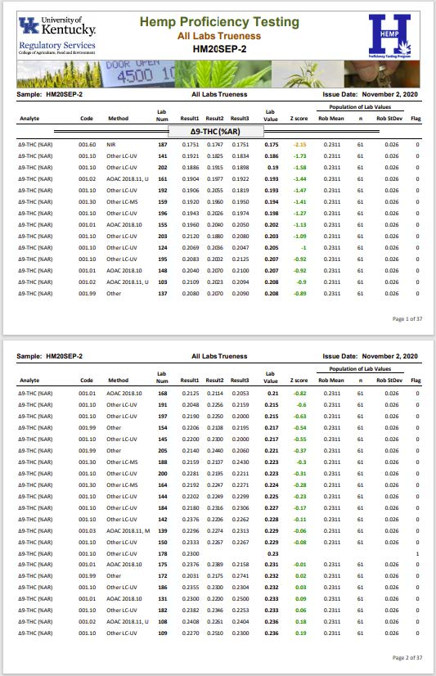

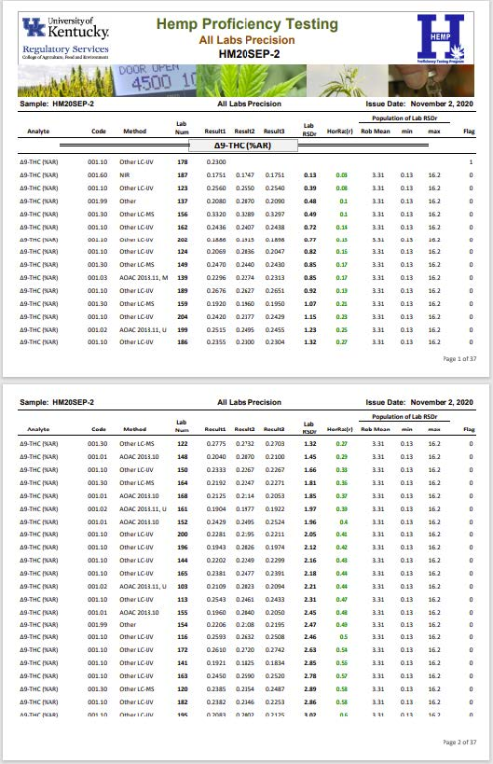

Summary Statistics Report
The Summary Statistics report presents robust means, number of observations (n), and robust standard deviation for Lab Values for trueness and robust means, minimum, and maximum RSDr Values precision. Page 1 of the report is shown below. Robust means, n, and robust standard deviation of Lab Values are presented for an analyte tested by all methods (Analyte), analyte tested by method group such as LC or GC (Method Group), and analyte tested by a specific method (Method). The robust means and standard deviation for trueness in this report are used for determining lab Z scores in the other reports.

This report also shows % relative standard deviation (%RSD) and Horwitz %RSD for trueness. The %RSD is the trueness robust standard deviation divided by the trueness robust mean times 100. Horwitz was a scientist who studied results from several collaborative studies and found %RSD for reproducibility from those data followed the formula shown as

Horwitz %RSD = 2 x C^{-0.15}

where C is the concentration expressed as a dimensionless mass fraction (eg., C = 0.03 for 3%). The Horwitz %RSD is a benchmark value that the trueness %RSD values can be compared against. A method is considered acceptable with respect to reproducibility if the trueness %RSD is less than 2 × Horwitz %RSD.
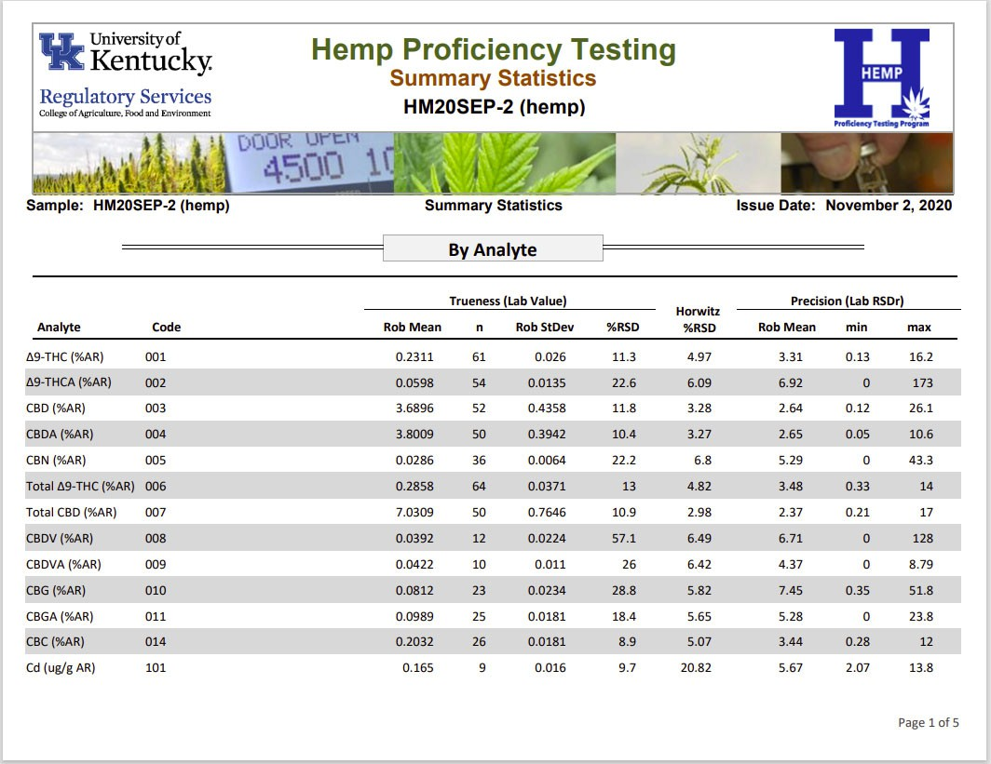

Homogeneity and Stability
Samples in a proficiency testing program should be homogeneous and stable with respect to the analytes tested. Homogeneity and stability is evaluated with analysis of total THC and total CBD by GC-FID and shown in the Homogeneity and Stability reports (example shown below).

Homogeneity was evaluated by analyzing 10 randomly selecting sample packets.
Duplicate test portions were analyzed in each packet. If the between-sample standard deviation was less than 30% of the standard deviation used to determine analyte z-scores, variability amongst packets was deemed minimal and sample packets were considered homogeneous with respect to the analyte tested. Stability was evaluated by testing an analyte in one sample packet stored at room temperature over the length of time between sample being shipped and results due. If the slope of concentration versus time was not significantly different from zero, the sample was considered stable with respect to the analyte tested.
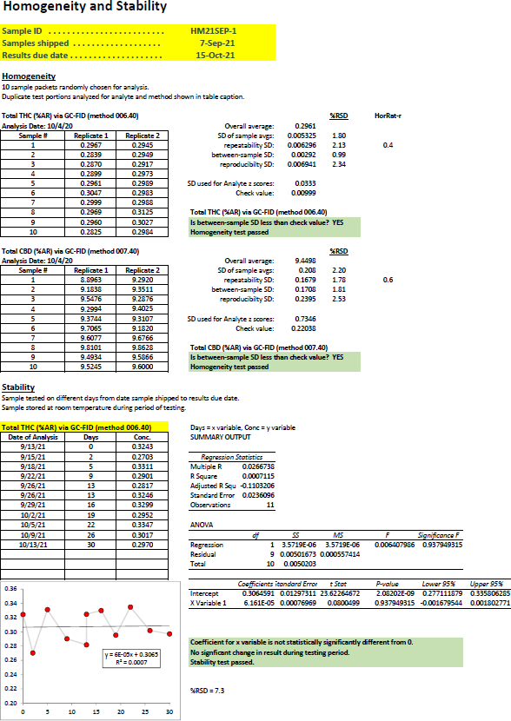

Certificate of Analysis
Samples in the program have a certificate of analysis with concentrations based on results submitted by the laboratories. An example of a certificate of analysis (COA) is shown below. The COA presents standard uncertainties for concentration of analytes in the sample.

Standard uncertainty is different from robust standard deviation shown on the Summary Statistics report. The robust standard deviation is a measure of the variability of all results submitted by laboratories. Approximately 67% of the results are within the robust mean ± robust standard deviation. Approximately 95% of the results are within the robust mean ± 2 × robust standard deviation. The standard uncertainty on COA reports is a measure of where the true analyte concentration is expected to be and is calculated using the robust standard deviation (robust stdev) and number of laboratory results (n) as shown below (ISO 13528:2015).

Standard Uncertainty = 1.25 × robust stdev / √n

Since the number of laboratory results is in the denominator, there is greater certainty on the location of the true analyte concentration with an increased number of laboratory results.

The standard uncertainty can be used to predict where the true concentration lies at different confidence intervals. A 67% confidence interval ranges from the robust mean – standard uncertainty to robust mean + standard uncertainty. An approximate 95% confidence interval ranges from the robust mean – (2 × standard uncertainty) and robust mean + (2 × standard uncertainty).
A laboratory can evaluate their laboratory bias using uncertainty in the Certificate of Analysis. Laboratory bias is one component of measurement uncertainty for an analytical method. Other components of measurement uncertainty include variability in preparing an analytical sample from the laboratory sample and reproducibility of results from the analytical sample. ISO 11352 and NORDTEST (2017) provide detailed information on how to use uncertainties from a proficiency test program to determine bias.

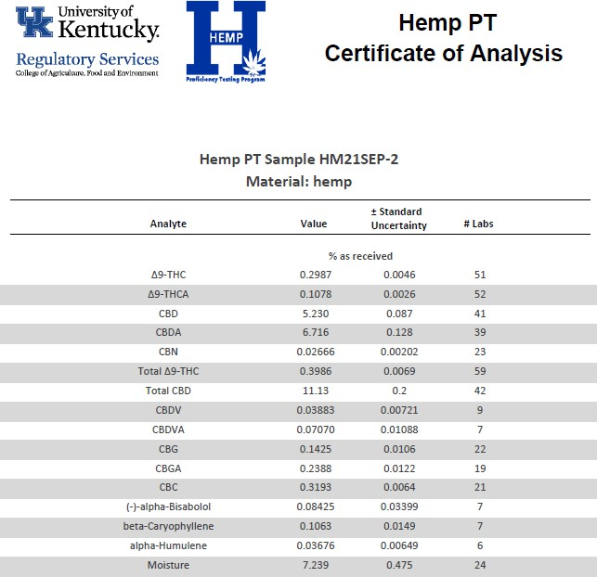

References
AOAC. 2016. Official Methods of Analysis of AOAC INTERNATIONAL. Appendix F: Guidelines for Standard Method Performance Requirements. AOAC INTERNATIONAL, Gaithersburg, MD, USA.

ISO. 1994. Accuracy (trueness and precision) of measurement methods and results – Part 2: Basic method for the determination of repeatability and reproducibility of a standard measurement method. ISO 5725-2:1994(E). Geneva, Switzerland.

ISO. 2012. Water quality – Estimation of measurement uncertainty based on validation and quality control data. ISO 11352:2012(E).

ISO. 2015. Statistical methods for use in proficiency testing by interlaboratory comparison.
ISO 13528:2015(E). Geneva, Switzerland.

Horwitz, W. and R. Albert. 2006. The Horwitz ratio (HorRat): A useful index of method performance with respect to precision. J AOAC Int.: 1095-1099.

NORDTEST. 2017. NORDTEST: Handbook for Calculation of Measurement Uncertainty in Environmental Laboratories, Edition 4 (2017). Available at www.nordtest.info

Rivera, C. and R. Rodriguez. Horwitz Equation as Quality Benchmark in ISO/IEC 17025 Testing Laboratory. http://bii.mx/documentos/horwitzCf11.pdf (verified Dec. 2018).
Thompson, M. 2004. The amazing Horwitz Function. AMC Technical Brief, Royal Society of Chemistry. http://www.rsc.org/images/horwitz-function-technical-brief-17_tcm18-214859.pdf (verified Dec. 2018).

APPENDIX A
List of Method Codes, Analytes, Method Groups and Methods in the Program
The first three numbers in the Method Code identifies the analyte and concentration basis. Values up to 500 have concentration on an as-received basis. Values greater than 500 have concentration on a dry weight basis. The last two numbers identifies the method. Method groups are identified where enough data existed for methods to be grouped into larger sets for comparison.

Method Code | Analyte | Method Group | Conc. Basis (w/w) | Method; Description
001.01 | Δ9-THC |  | %AR | AOAC 2018.10; LC-UV, 80% methanol extraction
001.02 | Δ9-THC |  | %AR | AOAC 2018.11, UV; LC-UV, ethanol extraction
001.03 | Δ9-THC |  | %AR | AOAC 2018.11, MS; LC-mass spec, ethanol  extraction
001.10 | Δ9-THC |  | %AR | Other LC-UV;
001.30 | Δ9-THC |  | %AR | Other LC-MS;
001.60 | Δ9-THC |  | %AR | NIR; Near Infrared (NIR)
001.61 | Δ9-THC |  | %AR | MIR; Mid Infrared (MIR)
001.99 | Δ9-THC |  | %AR | Other;
002.01 | Δ9-THCA |  | %AR | AOAC 2018.10; LC-UV, 80% methanol extraction
002.02 | Δ9-THCA |  | %AR | AOAC 2018.11, UV; LC-UV, ethanol extraction
002.03 | Δ9-THCA |  | %AR | AOAC 2018.11, MS; LC-mass spec, ethanol extraction
002.10 | Δ9-THCA |  | %AR | Other LC-UV;
002.30 | Δ9-THCA |  | %AR | Other LC-MS;
002.60 | Δ9-THCA |  | %AR | NIR; Near Infrared (NIR)
002.61 | Δ9-THCA |  | %AR | MIR; Mid Infrared (MIR)
002.99 | Δ9-THCA |  | %AR | Other;
003.01 | CBD |  | %AR | AOAC 2018.10; LC-UV, 80% methanol extraction
003.02 | CBD |  | %AR | AOAC 2018.11, UV; LC-UV, ethanol extraction
003.03 | CBD |  | %AR | AOAC 2018.11, MS; LC-mass spec, ethanol extraction
003.10 | CBD |  | %AR | Other LC-UV;
003.30 | CBD |  | %AR | Other LC-MS;
003.60 | CBD |  | %AR | NIR; Near Infrared (NIR)
003.61 | CBD |  | %AR | MIR; Mid Infrared (MIR)

Method Code | Analyte | Method Group | Conc. Basis (w/w) | Method; Description
003.99 | CBD |  | %AR | Other;
004.01 | CBDA |  | %AR | AOAC 2018.10; LC-UV, 80% methanol extraction
004.02 | CBDA |  | %AR | AOAC 2018.11, UV; LC-UV, ethanol extraction
004.03 | CBDA |  | %AR | AOAC 2018.11, MS; LC-mass spec, ethanol extraction
004.10 | CBDA |  | %AR | Other LC-UV;
004.30 | CBDA |  | %AR | Other LC-MS;
004.60 | CBDA |  | %AR | NIR; Near Infrared (NIR)
004.61 | CBDA |  | %AR | MIR; Mid Infrared (MIR)
004.99 | CBDA |  | %AR | Other;
005.01 | CBN | 005LC | %AR | AOAC 2018.10; LC-UV, 80% methanol extraction
005.02 | CBN | 005LC | %AR | AOAC 2018.11, UV; LC-UV, ethanol extraction
005.03 | CBN | 005LC | %AR | AOAC 2018.11, MS; LC-mass spec, ethanol extraction
005.10 | CBN | 005LC | %AR | Other LC-UV;
005.20 | CBN | 005LC | %AR | Other LC-MS;
005.30 | CBN | 005GC | %AR | GC-FID; GC, flame ionization detection
005.40 | CBN | 005GC | %AR | GC-MS; GC, mass spec detection
005.99 | CBN |  | %AR | Other;
006.01 | Total Δ9-THC | 006LC | %AR | AOAC 2018.10; LC-UV, % Δ9-THC+(% Δ9-THCA x  0.877), 80% methanol extraction
006.02 | Total Δ9-THC | 006LC | %AR | AOAC 2018.11, UV; LC-UV, % Δ9-THC+(% Δ9-THCA  x 0.877), ethanol extraction
006.03 | Total Δ9-THC | 006LC | %AR | AOAC 2018.11, MS; LC-mass spec, % Δ9-THC+(%  Δ9-THCA x 0.877), ethanol extraction
006.10 | Total Δ9-THC | 006LC | %AR | LC-UV, other; Other LC-UV, % Δ9-THC+(% Δ9-THCA  x 0.877)
006.30 | Total Δ9-THC | 006LC | %AR | LC-MS, other; Other LC-mass spec, % Δ9-THC+(% Δ9-THCA x 0.877)
006.40 | Total Δ9-THC | 006GC | %AR | GC-FID; GC, flame ionization detection
006.50 | Total Δ9-THC | 006GC | %AR | GC-MS; GC, mass spec detection
006.60 | Total Δ9-THC | 006IR | %AR | NIR; Near Infrared (NIR)
006.61 | Total Δ9-THC | 006IR | %AR | MIR; Mid Infrared (MIR)
006.99 | Total Δ9-THC |  | %AR | Other;

Method Code | Analyte | Method Group | Conc. Basis (w/w) | Method; Description
007.01 | Total CBD | 007LC | %AR | AOAC 2018.10; LC-UV, % Δ9-THC+(% Δ9-THCA x  0.877), 80% methanol extraction
007.02 | Total CBD | 007LC | %AR | AOAC 2018.11, UV; LC-UV, % Δ9-THC+(% Δ9-THCA  x 0.877), ethanol extraction
007.03 | Total CBD | 007LC | %AR | AOAC 2018.11, MS; LC-mass spec, % Δ9-THC+(%  Δ9-THCA x 0.877), ethanol extraction
007.10 | Total CBD | 007LC | %AR | LC-UV, other; Other LC-UV, % Δ9-THC+(% Δ9-THCA x 0.877)
007.30 | Total CBD | 007LC | %AR | LC-MS, other; Other LC-mass spec, % Δ9-THC+(%  Δ9-THCA x 0.877)
007.40 | Total CBD | 007GC | %AR | GC-FID; GC, flame ionization detection
007.50 | Total CBD | 007GC | %AR | GC-MS; GC, mass spec detection
007.60 | Total CBD | 007IR | %AR | NIR; Near Infrared (NIR)
007.61 | Total CBD | 007IR | %AR | MIR; Mid Infrared (MIR)
007.99 | Total CBD |  | %AR | Other;
008.02 | CBDV |  | %AR | AOAC 2018.11, UV; LC-UV, ethanol extraction
008.03 | CBDV |  | %AR | AOAC 2018.11, MS; LC-mass spec, ethanol  extraction
008.99 | CBDV |  | %AR | Other;
009.01 | CBDVA |  | %AR | AOAC 2018.10; LC-UV, 80% methanol extraction
009.02 | CBDVA |  | %AR | AOAC 2018.11, UV; LC-UV, ethanol extraction
009.03 | CBDVA |  | %AR | AOAC 2018.11, MS; LC-mass spec, ethanol extraction
009.99 | CBDVA |  | %AR | Other;
010.01 | CBG |  | %AR | AOAC 2018.10; LC-UV, 80% methanol extraction
010.02 | CBG |  | %AR | AOAC 2018.11, UV; LC-UV, ethanol extraction
010.03 | CBG |  | %AR | AOAC 2018.11, MS; LC-mass spec, ethanol extraction
010.99 | CBG |  | %AR | Other;
011.01 | CBGA |  | %AR | AOAC 2018.10; LC-UV, 80% methanol extraction
011.02 | CBGA |  | %AR | AOAC 2018.11, UV; LC-UV, ethanol extraction
011.03 | CBGA |  | %AR | AOAC 2018.11, MS; LC-mass spec, ethanol extraction
011.99 | CBGA |  | %AR | Other;
012.02 | THCV |  | %AR | AOAC 2018.11, UV; LC-UV, ethanol extraction
012.03 | THCV |  | %AR | AOAC 2018.11, MS; LC-mass spec, ethanol extraction

Method Code | Analyte | Method Group | Conc. Basis (w/w) | Method; Description
012.99 | THCV |  | %AR | Other;
013.01 | Δ8-THC |  | %AR | AOAC 2018.10; LC-UV, 80% methanol extraction
013.02 | Δ8-THC |  | %AR | AOAC 2018.11, UV; LC-UV, ethanol extraction
013.03 | Δ8-THC |  | %AR | AOAC 2018.11, MS; LC-mass spec, ethanol extraction
013.99 | Δ8-THC |  | %AR | Other;
014.01 | CBC |  | %AR | AOAC 2018.10; LC-UV, 80% methanol extraction
014.02 | CBC |  | %AR | AOAC 2018.11, UV; LC-UV, ethanol extraction
014.03 | CBC |  | %AR | AOAC 2018.11, MS; LC-mass spec, ethanol  extraction
014.99 | CBC |  | %AR | Other;
101.01 | Cd |  | ug/g AR | flame AA;
101.02 | Cd |  | ug/g AR | furnace AA;
101.03 | Cd |  | ug/g AR | ICP-OES;
101.04 | Cd |  | ug/g AR | ICP-MS;
101.99 | Cd |  | ug/g AR | Other;
102.01 | As |  | ug/g AR | flame AA;
102.02 | As |  | ug/g AR | furnace AA;
102.03 | As |  | ug/g AR | ICP-OES;
102.04 | As |  | ug/g AR | ICP-MS;
102.99 | As |  | ug/g AR | Other;
103.01 | Hg |  | ug/g AR | flame AA;
103.02 | Hg |  | ug/g AR | furnace AA;
103.03 | Hg |  | ug/g AR | ICP-OES;
103.04 | Hg |  | ug/g AR | ICP-MS;
103.99 | Hg |  | ug/g AR | Other;
104.01 | Pb |  | ug/g AR | flame AA;
104.02 | Pb |  | ug/g AR | furnace AA;
104.03 | Pb |  | ug/g AR | ICP-OES;
104.04 | Pb |  | ug/g AR | ICP-MS;
104.99 | Pb |  | ug/g AR | Other;

Method Code | Analyte | Method Group | Conc. Basis (w/w) | Method; Description
105.01 | Cu |  | ug/g AR | flame AA;
105.02 | Cu |  | ug/g AR | furnace AA;
105.03 | Cu |  | ug/g AR | ICP-OES;
105.04 | Cu |  | ug/g AR | ICP-MS;
105.99 | Cu |  | ug/g AR | Other;
106.01 | Ni |  | ug/g AR | flame AA;
106.02 | Ni |  | ug/g AR | furnace AA;
106.03 | Ni |  | ug/g AR | ICP-OES;
106.04 | Ni |  | ug/g AR | ICP-MS;
106.99 | Ni |  | ug/g AR | Other;
107.01 | Cr |  | ug/g AR | flame AA;
107.02 | Cr |  | ug/g AR | furnace AA;
107.03 | Cr |  | ug/g AR | ICP-OES;
107.04 | Cr |  | ug/g AR | ICP-MS;
107.99 | Cr |  | ug/g AR | Other;
108.01 | Se |  | ug/g AR | flame AA;
108.02 | Se |  | ug/g AR | furnace AA;
108.03 | Se |  | ug/g AR | ICP-OES;
108.04 | Se |  | ug/g AR | ICP-MS;
108.99 | Se |  | ug/g AR | Other;
109.01 | Ag |  | ug/g AR | flame AA;
109.02 | Ag |  | ug/g AR | furnace AA;
109.03 | Ag |  | ug/g AR | ICP-OES;
109.04 | Ag |  | ug/g AR | ICP-MS;
109.99 | Ag |  | ug/g AR | Other;
110.01 | Ba |  | ug/g AR | flame AA;
110.02 | Ba |  | ug/g AR | furnace AA;
110.03 | Ba |  | ug/g AR | ICP-OES;
110.04 | Ba |  | ug/g AR | ICP-MS;

Method Code | Analyte | Method Group | Conc. Basis (w/w) | Method; Description
110.99 | Ba |  | ug/g AR | Other;
111.01 | Zn |  | ug/g AR | flame AA;
111.02 | Zn |  | ug/g AR | furnace AA;
111.03 | Zn |  | ug/g AR | ICP-OES;
111.04 | Zn |  | ug/g AR | ICP-MS;
111.99 | Zn |  | ug/g AR | Other;
112.01 | Sb |  | ug/g AR | flame AA;
112.02 | Sb |  | ug/g AR | furnace AA;
112.03 | Sb |  | ug/g AR | ICP-OES;
112.04 | Sb |  | ug/g AR | ICP-MS;
112.99 | Sb |  | ug/g AR | Other;
201.01 | (-)-alpha-Bisabolol |  | %AR | GC, flame ionization detection;
201.02 | (-)-alpha-Bisabolol |  | %AR | GC, mass spec detection;
201.03 | (-)-alpha-Bisabolol |  | %AR | LC, mass spec detection;
201.04 | (-)-alpha-Bisabolol |  | %AR | Other;
202.01 | beta-Caryophyllene |  | %AR | GC, flame ionization detection;
202.02 | beta-  Caryophyllene |  | %AR | GC, mass spec detection;
202.03 | beta-Caryophyllene |  | %AR | LC, mass spec detection;
202.04 | beta-  Caryophyllene |  | %AR | Other;
203.01 | (-)-Caryophyllene oxide |  | %AR | GC, flame ionization detection;
203.02 | (-)-Caryophyllene  oxide |  | %AR | GC, mass spec detection;
203.03 | (-)-Caryophyllene oxide |  | %AR | LC, mass spec detection;
203.04 | (-)-Caryophyllene  oxide |  | %AR | Other;
204.01 | Geraniol |  | %AR | GC, flame ionization detection;
204.02 | Geraniol |  | %AR | GC, mass spec detection;
204.03 | Geraniol |  | %AR | LC, mass spec detection;
204.05 | Geraniol |  | %AR | Other;

Method Code | Analyte | Method Group | Conc. Basis (w/w) | Method; Description
205.01 | alpha-Humulene |  | %AR | GC, flame ionization detection;
205.02 | alpha-Humulene |  | %AR | GC, mass spec detection;
205.03 | alpha-Humulene |  | %AR | LC, mass spec detection;
205.04 | alpha-Humulene |  | %AR | Other;
206.01 | d-Limonene |  | %AR | GC, flame ionization detection;
206.02 | d-Limonene |  | %AR | GC, mass spec detection;
206.03 | d-Limonene |  | %AR | LC, mass spec detection;
206.04 | d-Limonene |  | %AR | Other;
207.01 | Linalool |  | %AR | GC, flame ionization detection;
207.02 | Linalool |  | %AR | GC, mass spec detection;
207.03 | Linalool |  | %AR | LC, mass spec detection;
207.04 | Linalool |  | %AR | Other;
208.01 | beta-Myrcene |  | %AR | GC, flame ionization detection;
208.02 | beta-Myrcene |  | %AR | GC, mass spec detection;
208.03 | beta-Myrcene |  | %AR | LC, mass spec detection;
208.04 | beta-Myrcene |  | %AR | Other;
209.01 | Nopinene |  | %AR | GC, flame ionization detection;
209.02 | Nopinene |  | %AR | GC, mass spec detection;
209.03 | Nopinene |  | %AR | LC, mass spec detection;
209.04 | Nopinene |  | %AR | Other;
210.01 | Ocimene |  | %AR | GC, flame ionization detection;
210.02 | Ocimene |  | %AR | GC, mass spec detection;
210.03 | Ocimene |  | %AR | LC, mass spec detection;
210.04 | Ocimene |  | %AR | Other;
211.01 | alpha-Pinene |  | %AR | GC, flame ionization detection;
211.02 | alpha-Pinene |  | %AR | GC, mass spec detection;
211.03 | alpha-Pinene |  | %AR | LC, mass spec detection;
211.04 | alpha-Pinene |  | %AR | Other;
212.01 | (-)-beta-Pinene |  | %AR | GC, flame ionization detection;

Method Code | Analyte | Method Group | Conc. Basis (w/w) | Method; Description
212.02 | (-)-beta-Pinene |  | %AR | GC, mass spec detection;
212.03 | (-)-beta-Pinene |  | %AR | LC, mass spec detection;
212.04 | (-)-beta-Pinene |  | %AR | Other;
213.01 | alpha-Terpinene |  | %AR | GC, flame ionization detection;
213.02 | alpha-Terpinene |  | %AR | GC, mass spec detection;
213.03 | alpha-Terpinene |  | %AR | LC, mass spec detection;
213.04 | alpha-Terpinene |  | %AR | Other;
214.01 | gamma-Terpinene |  | %AR | GC, flame ionization detection;
214.02 | gamma-Terpinene |  | %AR | GC, mass spec detection;
214.03 | gamma-Terpinene |  | %AR | LC, mass spec detection;
214.04 | gamma-Terpinene |  | %AR | Other;
215.01 | alpha-Terpinolene |  | %AR | GC, flame ionization detection;
215.02 | alpha-Terpinolene |  | %AR | GC, mass spec detection;
215.03 | alpha-Terpinolene |  | %AR | LC, mass spec detection;
215.04 | alpha-Terpinolene |  | %AR | Other;
500.20 | Moisture |  | %AR | AOAC 2001.12, Method I; Karl-Fisher, Extraction into Methanol-Formamide
500.30 | Moisture |  | %AR | AOAC 2001.12, Method II; Karl-Fisher, Boiling  Methanol Extraction
500.40 | Moisture |  | %AR | AOAC 934.01; Loss on Drying, 95 to 100 C under pressure
500.50 | Moisture |  | %AR | AOAC 930.15; Loss on Drying, 135 C for 2 hours
500.60 | Moisture |  | %AR | AOAC 2018.11; Loss on Drying at 100 C under pressure
500.70 | Moisture |  | %AR | Commercial Analyzer; Commercial analyzer  determining wt loss after heating
500.72 | Moisture |  | %AR | NIR; Near Infrared (NIR)
500.74 | Moisture |  | %AR | MIR; Mid Infrared (MIR)
500.99 | Moisture |  | %AR | Other;
501.01 | Δ9-THC |  | %DW | AOAC 2018.10; LC-UV, 80% methanol extraction
501.02 | Δ9-THC |  | %DW | AOAC 2018.11, UV; LC-UV, ethanol extraction
501.03 | Δ9-THC |  | %DW | AOAC 2018.11, MS; LC-mass spec, ethanol  extraction
501.10 | Δ9-THC |  | %DW | Other LC-UV;

Method Code | Analyte | Method Group | Conc. Basis (w/w) | Method; Description
501.30 | Δ9-THC |  | %DW | Other LC-MS;
501.60 | Δ9-THC |  | %DW | NIR; Near Infrared (NIR)
501.61 | Δ9-THC |  | %DW | MIR; Mid Infrared (MIR)
501.99 | Δ9-THC |  | %DW | Other;
502.01 | Δ9-THCA |  | %DW | AOAC 2018.10; LC-UV, 80% methanol extraction
502.02 | Δ9-THCA |  | %DW | AOAC 2018.11, UV; LC-UV, ethanol extraction
502.03 | Δ9-THCA |  | %DW | AOAC 2018.11, MS; LC-mass spec, ethanol extraction
502.10 | Δ9-THCA |  | %DW | Other LC-UV;
502.30 | Δ9-THCA |  | %DW | Other LC-MS;
502.60 | Δ9-THCA |  | %DW | NIR; Near Infrared (NIR)
502.61 | Δ9-THCA |  | %DW | MIR; Mid Infrared (MIR)
502.99 | Δ9-THCA |  | %DW | Other;
503.01 | CBD |  | %DW | AOAC 2018.10; LC-UV, 80% methanol extraction
503.02 | CBD |  | %DW | AOAC 2018.11, UV; LC-UV, ethanol extraction
503.03 | CBD |  | %DW | AOAC 2018.11, MS; LC-mass spec, ethanol extraction
503.10 | CBD |  | %DW | Other LC-UV;
503.30 | CBD |  | %DW | Other LC-MS;
503.60 | CBD |  | %DW | NIR; Near Infrared (NIR)
503.61 | CBD |  | %DW | MIR; Mid Infrared (MIR)
503.99 | CBD |  | %DW | Other;
504.01 | CBDA |  | %DW | AOAC 2018.10; LC-UV, 80% methanol extraction
504.02 | CBDA |  | %DW | AOAC 2018.11, UV; LC-UV, ethanol extraction
504.03 | CBDA |  | %DW | AOAC 2018.11, MS; LC-mass spec, ethanol extraction
504.10 | CBDA |  | %DW | Other LC-UV;
504.30 | CBDA |  | %DW | Other LC-MS;
504.60 | CBDA |  | %DW | NIR; Near Infrared (NIR)
504.61 | CBDA |  | %DW | MIR; Mid Infrared (MIR)
504.99 | CBDA |  | %DW | Other;
505.01 | CBN | 505LC | %DW | AOAC 2018.10; LC-UV, 80% methanol extraction

Method Code | Analyte | Method Group | Conc. Basis (w/w) | Method; Description
505.02 | CBN | 505LC | %DW | AOAC 2018.11, UV; LC-UV, ethanol extraction
505.03 | CBN | 505LC | %DW | AOAC 2018.11, MS; LC-mass spec, ethanol extraction
505.10 | CBN | 505LC | %DW | Other LC-UV;
505.20 | CBN | 505LC | %DW | Other LC-MS;
505.30 | CBN | 505GC | %DW | GC-FID; GC, flame ionization detection
505.40 | CBN | 505GC | %DW | GC-MS; GC, mass spec detection
505.99 | CBN |  | %DW | Other;
506.01 | Total Δ9-THC | 506LC | %DW | AOAC 2018.10; LC-UV, % Δ9-THC+(% Δ9-THCA x  0.877), 80% methanol extraction
506.02 | Total Δ9-THC | 506LC | %DW | AOAC 2018.11, UV; LC-UV, % Δ9-THC+(% Δ9-THCA  x 0.877), ethanol extraction
506.03 | Total Δ9-THC | 506LC | %DW | AOAC 2018.11, MS; LC-mass spec, % Δ9-THC+(%  Δ9-THCA x 0.877), ethanol extraction
506.10 | Total Δ9-THC | 506LC | %DW | LC-UV, other; Other LC-UV, % Δ9-THC+(% Δ9-THCA x 0.877)
506.30 | Total Δ9-THC | 506LC | %DW | LC-MS, other; Other LC-mass spec, % Δ9-THC+(%  Δ9-THCA x 0.877)
506.40 | Total Δ9-THC | 506GC | %DW | GC-FID; GC, flame ionization detection
506.50 | Total Δ9-THC | 506GC | %DW | GC-MS; GC, mass spec detection
506.60 | Total Δ9-THC | 506IR | %DW | NIR; Near Infrared (NIR)
506.61 | Total Δ9-THC | 506IR | %DW | MIR; Mid Infrared (MIR)
506.99 | Total Δ9-THC |  | %DW | Other;
507.01 | Total CBD | 507LC | %DW | AOAC 2018.10; LC-UV, % Δ9-THC+(% Δ9-THCA x  0.877), 80% methanol extraction
507.02 | Total CBD | 507LC | %DW | AOAC 2018.11, UV; LC-UV, % Δ9-THC+(% Δ9-THCA  x 0.877), ethanol extraction
507.03 | Total CBD | 507LC | %DW | AOAC 2018.11, MS; LC-mass spec, % Δ9-THC+(%  Δ9-THCA x 0.877), ethanol extraction
507.10 | Total CBD | 507LC | %DW | LC-UV, other; Other LC-UV, % Δ9-THC+(% Δ9-THCA x 0.877)
507.30 | Total CBD | 507LC | %DW | LC-MS, other; Other LC-mass spec, % Δ9-THC+(%  Δ9-THCA x 0.877)
507.40 | Total CBD | 507GC | %DW | GC-FID; GC, flame ionization detection
507.50 | Total CBD | 507GC | %DW | GC-MS; GC, mass spec detection
507.60 | Total CBD | 507IR | %DW | NIR; Near Infrared (NIR)
507.61 | Total CBD | 507IR | %DW | MIR; Mid Infrared (MIR)

Method Code | Analyte | Method Group | Conc. Basis (w/w) | Method; Description
507.99 | Total CBD |  | %DW | Other;
508.02 | CBDV |  | %DW | AOAC 2018.11, UV; LC-UV, ethanol extraction
508.03 | CBDV |  | %DW | AOAC 2018.11, MS; LC-mass spec, ethanol  extraction
508.99 | CBDV |  | %DW | Other;
509.01 | CBDVA |  | %DW | AOAC 2018.10; LC-UV, 80% methanol extraction
509.02 | CBDVA |  | %DW | AOAC 2018.11, UV; LC-UV, ethanol extraction
509.03 | CBDVA |  | %DW | AOAC 2018.11, MS; LC-mass spec, ethanol extraction
509.99 | CBDVA |  | %DW | Other;
510.01 | CBG |  | %DW | AOAC 2018.10; LC-UV, 80% methanol extraction
510.02 | CBG |  | %DW | AOAC 2018.11, UV; LC-UV, ethanol extraction
510.03 | CBG |  | %DW | AOAC 2018.11, MS; LC-mass spec, ethanol extraction
510.99 | CBG |  | %DW | Other;
511.01 | CBGA |  | %DW | AOAC 2018.10; LC-UV, 80% methanol extraction
511.02 | CBGA |  | %DW | AOAC 2018.11, UV; LC-UV, ethanol extraction
511.03 | CBGA |  | %DW | AOAC 2018.11, MS; LC-mass spec, ethanol extraction
511.99 | CBGA |  | %DW | Other;
512.02 | THCV |  | %DW | AOAC 2018.11, UV; LC-UV, ethanol extraction
512.03 | THCV |  | %DW | AOAC 2018.11, MS; LC-mass spec, ethanol extraction
512.99 | THCV |  | %DW | Other;
513.01 | Δ8-THC |  | %DW | AOAC 2018.10; LC-UV, 80% methanol extraction
513.02 | Δ8-THC |  | %DW | AOAC 2018.11, UV; LC-UV, ethanol extraction
513.03 | Δ8-THC |  | %DW | AOAC 2018.11, MS; LC-mass spec, ethanol extraction
513.99 | Δ8-THC |  | %DW | Other;
514.01 | CBC |  | %DW | AOAC 2018.10; LC-UV, 80% methanol extraction
514.02 | CBC |  | %DW | AOAC 2018.11, UV; LC-UV, ethanol extraction
514.03 | CBC |  | %DW | AOAC 2018.11, MS; LC-mass spec, ethanol  extraction
514.99 | CBC |  | %DW | Other;

Method Code | Analyte | Method Group | Conc. Basis (w/w) | Method; Description
601.01 | Cd |  | ug/g DW | flame AA;
601.02 | Cd |  | ug/g DW | furnace AA;
601.03 | Cd |  | ug/g DW | ICP-OES;
601.04 | Cd |  | ug/g DW | ICP-MS;
601.99 | Cd |  | ug/g DW | Other;
602.01 | As |  | ug/g DW | flame AA;
602.02 | As |  | ug/g DW | furnace AA;
602.03 | As |  | ug/g DW | ICP-OES;
602.04 | As |  | ug/g DW | ICP-MS;
602.99 | As |  | ug/g DW | Other;
603.01 | Hg |  | ug/g DW | flame AA;
603.02 | Hg |  | ug/g DW | furnace AA;
603.03 | Hg |  | ug/g DW | ICP-OES;
603.04 | Hg |  | ug/g DW | ICP-MS;
603.99 | Hg |  | ug/g DW | Other;
604.01 | Pb |  | ug/g DW | flame AA;
604.02 | Pb |  | ug/g DW | furnace AA;
604.03 | Pb |  | ug/g DW | ICP-OES;
604.04 | Pb |  | ug/g DW | ICP-MS;
604.99 | Pb |  | ug/g DW | Other;
605.01 | Cu |  | ug/g DW | flame AA;
605.02 | Cu |  | ug/g DW | furnace AA;
605.03 | Cu |  | ug/g DW | ICP-OES;
605.04 | Cu |  | ug/g DW | ICP-MS;
605.99 | Cu |  | ug/g DW | Other;
606.01 | Ni |  | ug/g DW | flame AA;
606.02 | Ni |  | ug/g DW | furnace AA;
606.03 | Ni |  | ug/g DW | ICP-OES;
606.04 | Ni |  | ug/g DW | ICP-MS;

Method Code | Analyte | Method Group | Conc. Basis (w/w) | Method; Description
606.99 | Ni |  | ug/g DW | Other;
607.01 | Cr |  | ug/g DW | flame AA;
607.02 | Cr |  | ug/g DW | furnace AA;
607.03 | Cr |  | ug/g DW | ICP-OES;
607.04 | Cr |  | ug/g DW | ICP-MS;
607.99 | Cr |  | ug/g DW | Other;
608.01 | Se |  | ug/g DW | flame AA;
608.02 | Se |  | ug/g DW | furnace AA;
608.03 | Se |  | ug/g DW | ICP-OES;
608.04 | Se |  | ug/g DW | ICP-MS;
608.99 | Se |  | ug/g DW | Other;
609.01 | Ag |  | ug/g DW | flame AA;
609.02 | Ag |  | ug/g DW | furnace AA;
609.03 | Ag |  | ug/g DW | ICP-OES;
609.04 | Ag |  | ug/g DW | ICP-MS;
609.99 | Ag |  | ug/g DW | Other;
610.01 | Ba |  | ug/g DW | flame AA;
610.02 | Ba |  | ug/g DW | furnace AA;
610.03 | Ba |  | ug/g DW | ICP-OES;
610.04 | Ba |  | ug/g DW | ICP-MS;
610.99 | Ba |  | ug/g DW | Other;
611.01 | Zn |  | ug/g DW | flame AA;
611.02 | Zn |  | ug/g DW | furnace AA;
611.03 | Zn |  | ug/g DW | ICP-OES;
611.04 | Zn |  | ug/g DW | ICP-MS;
611.99 | Zn |  | ug/g DW | Other;
612.01 | Sb |  | ug/g DW | flame AA;
612.02 | Sb |  | ug/g DW | furnace AA;
612.03 | Sb |  | ug/g DW | ICP-OES;

Method Code | Analyte | Method Group | Conc. Basis (w/w) | Method; Description
612.04 | Sb |  | ug/g DW | ICP-MS;
612.99 | Sb |  | ug/g DW | Other;

APPENDIX B
Statistics used to evaluate trueness and precision
Trueness of Lab Values, as the average of three lab results for each analyte, was evaluated with robust statistics and Z scores. Proficiency test data often include outliers which can cause a misleadingly large spread in a bell curve used to evaluate lab values. There are several methods outlined in ISO 17025 (ISO, 2015) to analyze data with outliers to avoid the large spread and to achieve a more reasonable bell curve to evaluate lab values. The approach used in this Proficiency Program is Algorithm A found on page 53 of ISO 13528 (ISO, 2015). The method is an iterative process where outliers are adjusted to values closer to the central value and new mean and standard deviations are calculated. The process continues until the differences between old and new mean and standard deviations are minimal. The mean and standard deviations from this procedure are given the adjective “robust” to differentiate them from commonly used calculations for mean and standard deviation. The average of three results (Lab Value) was considered in robust statistic calculations. Calculations were only performed if there were 6 or more observations.
Z score to evaluate trueness is determined using the robust mean and standard deviation as shown below.

Z score = (LabValue – robust mean) / standard deviation

A Z score of -1 or +1 means the difference between the Lab Value and robust mean is equal to 1 standard deviation. A Z score of -2 or +2 means the difference between the Lab Value and robust mean is equal to 2 standard deviations, and so forth. The greater the absolute magnitude of the Z score, the further away the Lab Value is from the robust mean and the center of the bell curve.

Z scores between -2 and +2 are colored green and considered acceptable. Lab values between -3 and -2 or +2 and +3 are colored orange and are a cautionary warning that the laboratory’s procedure should be evaluated. Lab Values less than -3 or greater than +3 are colored red and are considered unacceptable where action should be taken to correct the laboratory’s procedure.

Precision of the three results submitted from a laboratory was evaluated using Horwitz formulas (AOAC, 2016 and Horowitz and Albert, 2006). Relative standard deviation for repeatability (RSDr) was determined using standard deviation and average of the three results as shown below.

RSDr = (standard deviation) / average × 100

Horowitz found the following formula to describe reproducibility (R) among lab results in many interlaboratory studies.

Horwitz %RSD = 2 x C^{-0.15}

The symbol C is the concentration expressed as a dimensionless mass fraction (eg., C = 0.03 for 3%). The ratio of RSDr to Horowitz %RSD is the Horwitz ratio for repeatability (HorRat(r)).

HorRat(r) = RSDr / (Horwitz %RSD)

AOAC advises that this ratio should be between 0.3 and 1.3 (AOAC, 2016). For the Hemp PT program, the upper limit of 1.3 is used to warn users that their repeatability exceeds the guidance from AOAC. The lower limit of 0.3 is not used to avoid warning laboratories that their repeatability is too good. The program assumes that each lab result reported is a single analysis result and does not represent an average of several results which AOAC warns can lead to erroneously low HorRat(r) values. A cautionary limit is imposed for HorRat(r ) values of 0.
This is a result of exactly the same result obtained in triplicate. The probability of this occurring is highly unlikely.

Another upper limit is used for HorRat(r) to warn laboratories that their values are exceedingly high. From an analysis of HorRat(r) values for all analytes in the 2018 Hemp PT program, 95% of all the data had HorRat(r) value of 4.9 or less.

Any HorRat(r) value greater than 0 or less than or equal to 1.3 is colored green signifying an acceptable value. A HorRat(r) greater than 1.3 and less than or equal to 4.9 is colored orange signifying a warning that the value is above the guidance level from AOAC. A HorRat(r) above 4.9 is colored red signifying a warning that the value is very high compared to the population of all HorRat(r) values from 2018. HorRat(r) values of 0 are colored orange warning laboratories that this result is highly unlikely from three individual lab results.

APPENDIX C
Rules for Nonnumeric Lab Reported Values
Laboratories can report values less than detection or quantitation limit, 0, or nonnumeric entry such as “na”. Entries can also be left blank with laboratory reporting only one or two results rather than three. There can also be a combination of numeric and nonnumeric values for the three results. Only numeric entries greater than zero were considered in the statistical evaluation. A Lab Value was used in statistical analysis if there were two or more numeric results greater than zero. Relative standard deviation for repeatability (RSDr) was calculated and used in statistical analysis if there were three numeric results greater than zero. Flag indicators are present on the Laboratory Reports for instances were Lab Value was not used and RSDr was not calculated.

