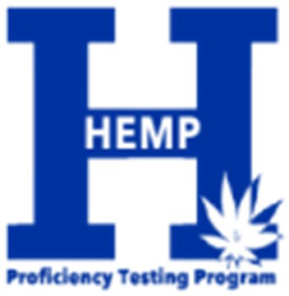

HEMP PROFICIENCY TESTING GENERAL INSTRUCTIONS
Hemp Scheme with samples HM21NOV-1 and HM21NOV-2 Results Due: December 15th, 2021
- The samples provided are ready for analysis. Do not perform any preliminary processing step such as drying or grinding prior to analysis. The sample number syntax is: HM21NOV-1 (material, year, sample month, sample number).
- Provide triplicate analyte results for each sample replicating the entire methodological procedure on separate test portions of the sample. Perform the methodological procedure for each replicate on separate days. Analytes with a single result will not be considered in the statistical analysis.
- Analyte concentrations can be reported on an “as-received” or “dry weight” basis. As-Received basis is the concentration of analyte in the sample without any drying. Dry-weight basis is the concentration of analyte in the sample excluding all moisture. You may report concentrations on both “as-received” and “dry weight” basis. If reporting on a “dry-weight” basis, use the approach in AOAC method 2018.11 where cannabinoids and moisture are determined on separate test portions. The concentrations of cannabinoids and moisture in the separate test portions on an “as-received” basis are used to calculate concentration on a “dry-weight” basis as shown below.
% dry weight basis = % as-received x (100 / (100 - % moisture) )

- Information about the origin of the samples can be found on the Rounds page of the Lap Portal, in the “Round Name/Label” column.

- Our submitting results webpage has a complete list of current method codes (including terpenes) and the Lab Portal Quick Start Guide includes instructions about how to submit data. http://www.rs.uky.edu/regulatory/hpt/submit.php.
- Record your analyte result to 4 decimal places with the appropriate method code. Record the result with the “Other” method if your result is from a method not shown. Pay special attention to your entries because the data cannot be changed after reports are issued.

- Very low concentrations are normally reported as less than a limit of detection (LOD) or limit of quantification (LOQ). Record very low concentrations as you would report results to your client. Place a "<" in front of the value considered a limit in your lab. For example, record "<0.0100" for a limit of 0.01.

- Contact: Hemp Proficiency Testing Program
Frank Sikora or Marilyn Smith hpt@uky.edu
859-218-2468

