

Interpreting Hemp Proficiency Testing Reports

September 2020
Statistical analysis of data in the Hemp Proficiency Testing Program follows guidelines in ISO 13528 (ISO, 2015). Laboratories are asked to provide the method performed and triplicate results for each sample. Laboratory results are evaluated for trueness and precision. This document presents information on interpreting each of the following reports.

- Laboratory Trueness Report - Individualized lab report evaluating lab’s trueness.
- Laboratory Precision Report - Individualized lab report evaluating lab’s precision.
- All Labs Trueness - Report evaluating trueness of all lab results.
e) All Labs Precision - Report evaluating precision of all lab results.
- Summary Statistics - Report on medians and variabilities for the analytes.
- Homogeneity and Stability - Summary report comparing analytes and methods.
- Methodology Survey - Summary of laboratory responses to questions on methodology.
- Certificate of Analysis - Analytical results and uncertainties of analytes in samples based on results submitted.

Method Codes, Analytes, and Method Groups
Laboratories report their results and the methods they used. The methods are defined with method codes as shown in Appendix A. Analytes in the program include cannabinoids and metals. Laboratories report their results in units of % (w/w) on an as received or dry weight basis.
Abbreviations of %AR and %DW are used in the reports to specify concentrations on as received or dry weight basis, respectively.

Laboratory Trueness and Precision Reports
Prior to 1994, accuracy referred to how close an average result was to the true value.
This term was modified in ISO 5725 (ISO 1994) to include both the closeness of an average to the true value (trueness) and closeness of repeated results (precision). Trueness replaced accuracy as a term to describe the closeness of an average result to the true value. Both figures

below display poor accuracy. The figure on the left has good trueness because the average location of the holes is close to the center target. However, there is poor accuracy because the holes have poor precision. The figure on the right has good precision because the holes are close to one another. However, there is poor accuracy because the average location of the holes has poor trueness.
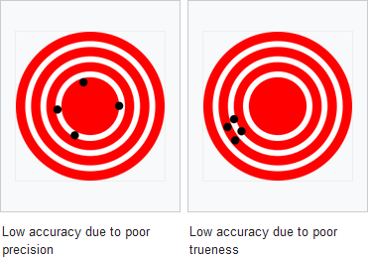

Individualized lab reports are prepared that evaluates trueness and precision of lab results. Page 1 of a Laboratory Trueness Report is shown below. The laboratory number and sample identifications are identified in the banner. A table of data is presented for each sample. The three lab results and the average of the three results (Lab Value) are displayed for each method code which defines the analyte and method used to obtain the results
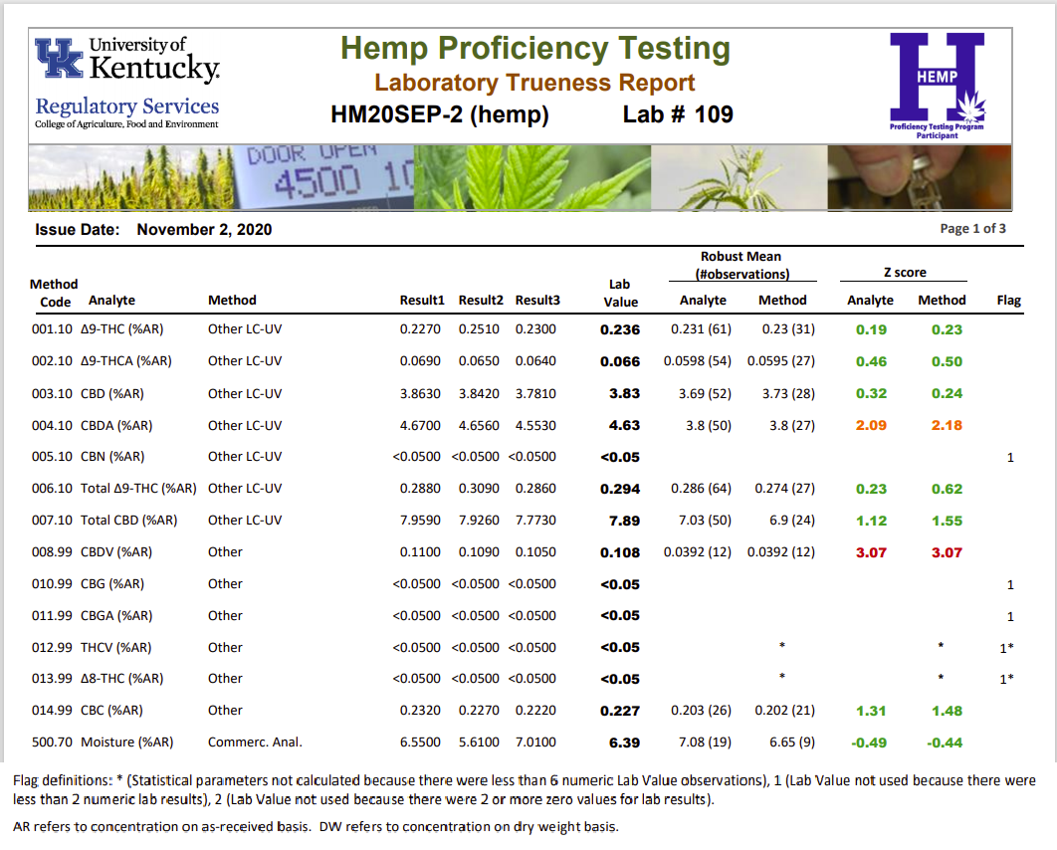

A robust mean and number of observations is displayed for all Lab Values for an analyte regardless of method used (Analyte heading) and all Lab Values for an analyte in a Method (Method heading). Z scores are presented for each of these data sets. A Z score is a measurement of the agreement between the individual lab result and the robust mean considering data distribution of each set. An exact match between Lab Value and Robust Mean would result in a Z score of 0. Lab Values between -2 and +2 are within 2 standard deviations of the data distribution. Lab Values between -3 and +3 are within 3 standard deviations of the data distribution. Lab Values between -2 and +2 are green and considered acceptable. Lab values between -3 and -2 or +2 and +3 are colored orange and are a cautionary warning that the laboratory’s procedure should be evaluated. Lab Values less than -3 or greater than +3 are colored red and are considered unacceptable where action should be taken to correct the laboratory’s procedure. A laboratory’s proficiency in testing an analyte is evaluated with all values for an Analyte (Analyte Z score). Z scores for Method are for evaluating how a lab performed with other labs using the same method. Appendix B has information on robust statistics and Z score calculations that were used.

Flag indicators will appear in the far right hand column of the report for situations with limited data for statistical analysis. Robust means and Z scores are only calculated with 6 or more observations. Lab value is not used to determine robust means and Z scores if there are less than 2 numeric results for an analyte reported from the lab. A key to the flags is provided at the bottom of the reports when these situations arise. Rules used for considering nonnumeric values are shown in Appendix C.

The Laboratory Precision Report, as shown below, is very similar to the Laboratory Accuracy Report. Instead of Lab Value, the Precision Report displays the lab’s relative standard deviation for repeatability (Lab RSDr) from the three reported results for an analyte. All lab RSDr values are considered for calculating robust mean for all results for the analyte or method. The HorRat(r) value is a ratio of the Lab RSDr value to an expected Horowitz reproducibility value. Any value greater than 0 and less than or equal to 1.3 is in green and considered acceptable. Values that are greater than 1.3 and less than or equal to 4.9 are in orange and are a cautionary warning that the values are high. Values greater than 4.9 are in red and are a heightened warning that the variability of the three results is very high. Appendix B contains details on the calculation of HorRat(r) and an explanation of the warning levels used.
As with the trueness report, flag indicators will appear in the far right hand column of the report for situations with limited data for statistical analysis. Robust Means are only determined with 6 or more observations. A value for RSDr and HorRat(r) is only determined when 3 nonzero numeric results are reported. A key to the flags is provided at the bottom of the reports when these situations arise. Rules used for considering nonnumeric values are shown in Appendix C.

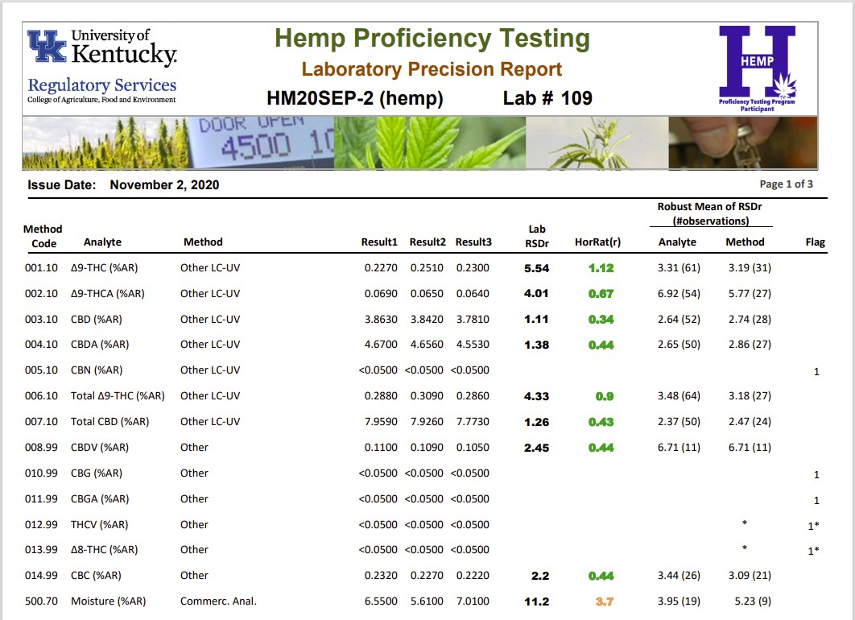

All Labs Trueness Report
The All Labs Trueness report is a multipage report displaying all lab results grouped by Analyte and Sample Number. Page 1 and 2 of the report is shown on page 5. For each set of Analyte and Sample Number, data is sorted by Lab Value. Z scores are also shown in green, orange, and red colors as described for Laboratory Trueness reports. Flag values other than 0 note Lab Values were not used to calculate robust mean or Z scores due to limited numeric results. This report is useful to determine where an individual Lab Value fell within the range of all Lab Values for an analyte. The report also provides useful information on lower and upper limits used by various labs where results are reported with “<” or “>”.

All Labs Precision Report
The All Labs Precision report is a multipage report displaying all lab RSDr values grouped by Analyte and Sample Number. Page 1 and 2 of the report is shown on page 6. HorRat(r) values are shown in green, orange, and red colors as described for Laboratory Precision reports. For each set of Analyte and Sample Number, data is sorted by the HorRat(r) values. Flag values other than 0 note RSDr and HorRat(r) values were not calculated due to limited numeric results. This report is useful to determine where individual Lab RSDr and HorRat(r) values fell within the range of all Lab RSDr and HorRat(r) values for an analyte.

Summary Statistics Report
The Summary Statistics report presents robust means, number of observations (n), and robust standard deviation for Lab Values for trueness and robust means, minimum, and maximum RSDr Values precision. Page 1 of the report is shown on page 7. Robust means, n, and robust standard deviation of Lab Values are presented for an analyte tested by all methods (Analyte), analyte tested by method group such as LC or GC (Method Group), and analyte tested by a specific method (Method). The robust means and standard deviation for trueness in this report are used for determining lab Z scores in the other reports.
This report also shows % relative standard deviation (%RSD) and Horwitz %RSD for trueness. The %RSD is the trueness robust standard deviation divided by the trueness robust mean times 100. Horwitz was a scientist who studied results from several collaborative studies and found %RSD for reproducibility from those data followed the formula shown as

Horwitz %RSD = 2 x C^{-0.15}

where C is the concentration expressed as a dimensionless mass fraction (eg., C = 0.03 for 3%). The Horwitz %RSD is a benchmark value that the trueness %RSD values can be compared against. A reasonable goal would be to have trueness %RSD values for hemp analysis be approximately equal to or less than the Horwitz %RSD.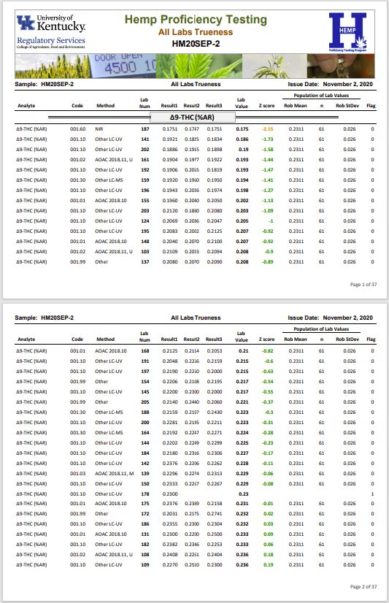
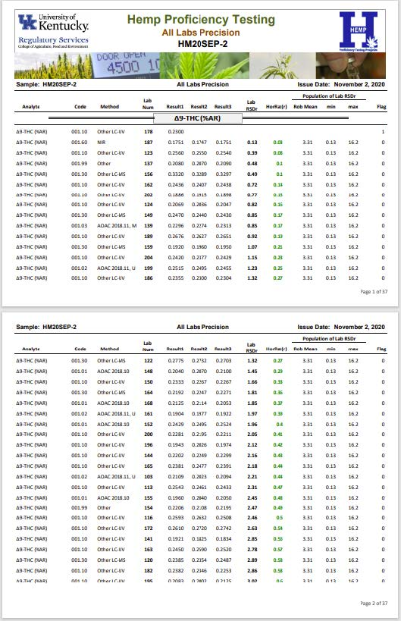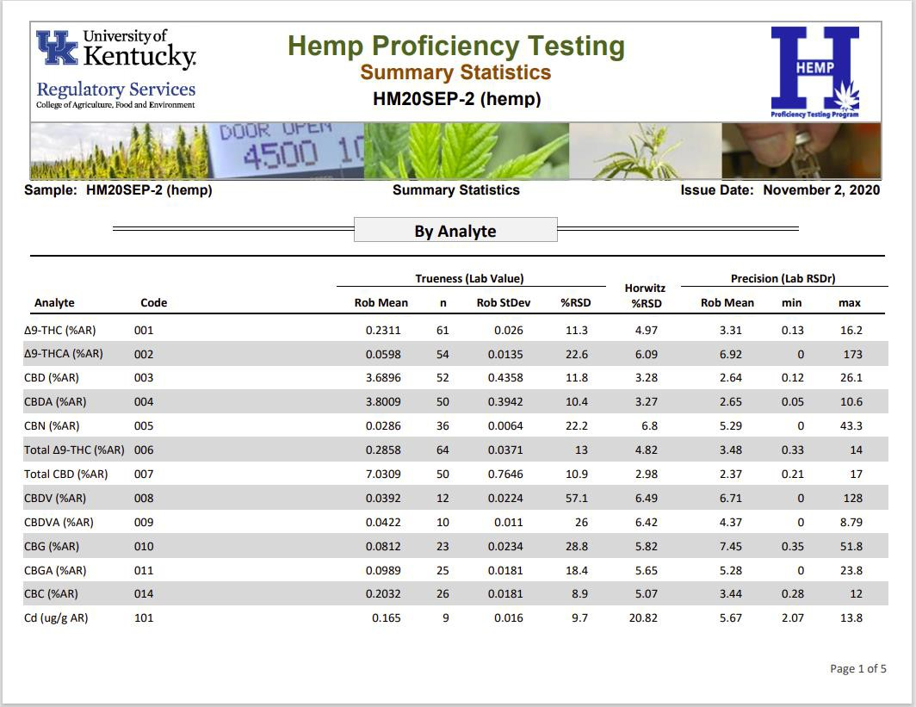

Homogeneity and Stability
Samples in a proficiency testing program should be homogeneous and stable with respect to the analytes tested. Homogeneity and stability were evaluated with analysis of total THC by GC-FID (method code 006.40) and shown in the Homogeneity and Stability reports (example shown below).

Homogeneity was evaluated by analyzing total THC in 10 randomly selecting sample packets. Duplicate test portions were analyzed in each packet. If the between-sample standard deviation was less than 30% of the standard deviation used to determine analyte z-scores, variability amongst packets was deemed minimal and sample packets were considered homogeneous with respect to the analyte tested. Stability was evaluated by analyzing total THC by GC-FID in one sample packet stored at room temperature over the length of time between sample being shipped and results due. If the slope of concentration versus time was not significantly different from zero, the sample was considered stable with respect to the analyte tested.

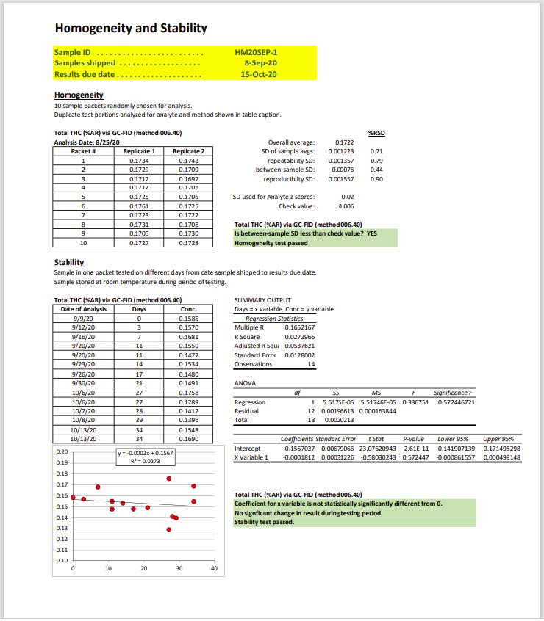

Methodology Survey
Laboratories were asked to answer survey questions on methodology for each shipment of samples. Questions addressed items such as method of extraction for cannabinoids, method of digestion for metals, and measurement uncertainty for total THC. This report summarizes the responses from each of the laboratories with each response identified by laboratory number and method used for THC on questions regarding cannabinoid analysis.

Certificate of Analysis
Samples in the program have a certificate of analysis with concentrations based on results submitted by the laboratories. An example of a certificate of analysis (COA) is shown below. The COA presents standard uncertainties for concentration of analytes in the sample.

Standard uncertainty is different from robust standard deviation shown on the Summary Statistics report. The robust standard deviation is a measure of the variability of all results submitted by laboratories. Approximately 67% of the results are within the robust mean ± robust standard deviation. Approximately 95% of the results are within the robust mean ± 2 × robust standard deviation. The standard uncertainty on COA reports is a measure of where the true analyte concentration is expected to be and is calculated using the robust standard deviation (robust stdev) and number of laboratory results (n) as shown below (ISO 13528:2015).

Standard Uncertainty = 1.25 × robust stdev / √n

Since the number of laboratory results is in the denominator, there is greater certainty on the location of the true analyte concentration with an increased number of laboratory results.

The standard uncertainty can be used to predict where the true concentration lies at different confidence intervals. A 67% confidence interval ranges from the robust mean – standard uncertainty to robust mean + standard uncertainty. An approximate 95% confidence interval ranges from the robust mean – (2 × standard uncertainty) and robust mean + (2 × standard uncertainty).

A laboratory can evaluate their laboratory bias using uncertainty in the Certificate of Analysis. Laboratory bias is one component of measurement uncertainty for an analytical method. Other components of measurement uncertainty include variability in preparing an analytical sample from the laboratory sample and reproducibility of results from the analytical sample. ISO 11352 and NORDTEST (2017) provide detailed information on how to use uncertainties from a proficiency test program to determine bias.

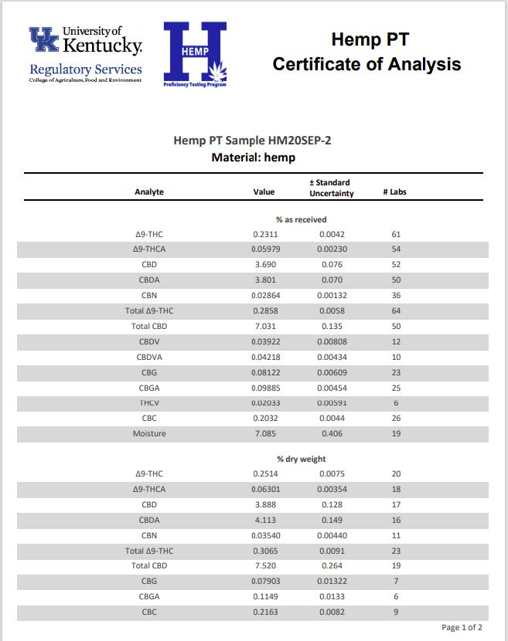

References
AOAC. 2016. Official Methods of Analysis of AOAC INTERNATIONAL. Appendix F: Guidelines for Standard Method Performance Requirements. AOAC INTERNATIONAL, Gaithersburg, MD, USA.

ISO. 1994. Accuracy (trueness and precision) of measurement methods and results – Part 2: Basic method for the determination of repeatability and reproducibility of a standard measurement method. ISO 5725-2:1994(E). Geneva, Switzerland.

ISO. 2012. Water quality – Estimation of measurement uncertainty based on validation and quality control data. ISO 11352:2012(E).

ISO. 2015. Statistical methods for use in proficiency testing by interlaboratory comparison.
ISO 13528:2015(E). Geneva, Switzerland.

Horwitz, W. and R. Albert. 2006. The Horwitz ratio (HorRat): A useful index of method performance with respect to precision. J AOAC Int.: 1095-1099.

NORDTEST. 2017. NORDTEST: Handbook for Calculation of Measurement Uncertainty in Environmental Laboratories, Edition 4 (2017). Available at www.nordtest.info

Rivera, C. and R. Rodriguez. Horwitz Equation as Quality Benchmark in ISO/IEC 17025 Testing Laboratory. http://bii.mx/documentos/horwitzCf11.pdf (verified Dec. 2018).
Thompson, M. 2004. The amazing Horwitz Function. AMC Technical Brief, Royal Society of Chemistry. http://www.rsc.org/images/horwitz-function-technical-brief-17_tcm18-214859.pdf (verified Dec. 2018).

APPENDIX A
List of Method Codes, Analytes, Method Groups and Methods in the Program
The first three numbers in the Method Code identifies the analyte and concentration basis. Values up to 500 have concentration on an as-received basis. Values greater than 500 have concentration on a dry weight basis. The last two numbers identifies the method. Method groups are identified where enough data existed for methods to be grouped into larger sets for comparison.

Method Code | Analyte | Method Group | Conc. Basis (% w/w) | Method; Description
001.01 | Δ9-THC |  | % AR | LC-UV, 80% methanol extraction; AOAC 2018.10
001.02 | Δ9-THC |  | % AR | LC-UV, ethanol extraction; AOAC 2018.11, diode array
001.03 | Δ9-THC |  | % AR | LC-mass spec, ethanol extraction; AOAC 2018.11, mass spec
001.10 | Δ9-THC |  | % AR | Other LC-UV
001.30 | Δ9-THC |  | % AR | Other LC-mass spec
001.60 | Δ9-THC |  | % AR | Near Infrared (NIR)
001.61 | Δ9-THC |  | % AR | Mid Infrared (MIR)
001.99 | Δ9-THC |  | % AR | Other
002.01 | Δ9-THCA |  | % AR | LC-UV, 80% methanol extraction; AOAC 2018.10
002.02 | Δ9-THCA |  | % AR | LC-UV, ethanol extraction; AOAC 2018.11, diode array
002.03 | Δ9-THCA |  | % AR | LC-mass spec, ethanol extraction; AOAC 2018.11, mass spec
002.10 | Δ9-THCA |  | % AR | Other LC-UV
002.30 | Δ9-THCA |  | % AR | Other LC-mass spec
002.60 | Δ9-THCA |  | % AR | Near Infrared (NIR)
002.61 | Δ9-THCA |  | % AR | Mid Infrared (MIR)
002.99 | Δ9-THCA |  | % AR | Other
003.01 | CBD |  | % AR | LC-UV, 80% methanol extraction; AOAC 2018.10
003.02 | CBD |  | % AR | LC-UV, ethanol extraction; AOAC 2018.11, diode array
003.03 | CBD |  | % AR | LC-mass spec, ethanol extraction; AOAC 2018.11, mass spec
003.10 | CBD |  | % AR | Other LC-UV
003.30 | CBD |  | % AR | Other LC-mass spec
003.60 | CBD |  | % AR | Near Infrared (NIR)
003.61 | CBD |  | % AR | Mid Infrared (MIR)
003.99 | CBD |  | % AR | Other

Method Code | Analyte | Method Group | Conc. Basis (% w/w) | Method; Description
004.01 | CBDA |  | % AR | LC-UV, 80% methanol extraction; AOAC 2018.10
004.02 | CBDA |  | % AR | LC-UV, ethanol extraction; AOAC 2018.11, diode array
004.03 | CBDA |  | % AR | LC-mass spec, ethanol extraction; AOAC 2018.11, mass spec
004.10 | CBDA |  | % AR | Other LC-UV
004.30 | CBDA |  | % AR | Other LC-mass spec
004.60 | CBDA |  | % AR | Near Infrared (NIR)
004.61 | CBDA |  | % AR | Mid Infrared (MIR)
004.99 | CBDA |  | % AR | Other
005.01 | CBN | LC | % AR | LC-UV, 80% methanol extraction; AOAC 2018.10
005.02 | CBN | LC | % AR | LC-UV, ethanol extraction; AOAC 2018.11, diode array
005.03 | CBN | LC | % AR | LC-mass spec, ethanol extraction; AOAC 2018.11, mass spec
005.10 | CBN | LC | % AR | Other LC-UV
005.20 | CBN | LC | % AR | Other LC-mass spec
005.30 | CBN | GC | % AR | GC, flame ionization detection
005.40 | CBN | GC | % AR | GC, mass spec detection
005.99 | CBN |  | % AR | Other
006.01 | Total Δ9-THC | LC | % AR | LC-UV, % Δ9-THC+(% Δ9-THCA x 0.877), 80% methanol extraction; AOAC 2018.10
006.02 | Total Δ9-  THC | LC | % AR | LC-UV, % Δ9-THC+(% Δ9-THCA x 0.877), ethanol extraction; AOAC  2018.11, diode array
006.03 | Total Δ9-  THC | LC | % AR | LC-mass spec, % Δ9-THC+(% Δ9-THCA x 0.877), ethanol extraction;  AOAC 2018.11, mass spec
006.10 | Total Δ9-THC | LC | % AR | Other LC-UV, % Δ9-THC+(% Δ9-THCA x 0.877)
006.30 | Total Δ9-  THC | LC | % AR | Other LC-mass spec, % Δ9-THC+(% Δ9-THCA x 0.877)
006.40 | Total Δ9-THC | GC | % AR | GC, flame ionization detection
006.50 | Total Δ9-  THC | GC | % AR | GC, mass spec detection
006.60 | Total Δ9-THC | IR | % AR | Near Infrared (NIR)
006.61 | Total Δ9-  THC | IR | % AR | Mid Infrared (MIR)
006.99 | Total Δ9-  THC |  | % AR | Other
007.01 | Total CBD | LC | % AR | LC-UV, % Δ9-CBD+(% Δ9-CBDA x 0.877), 80% methanol extraction;

Method Code | Analyte | Method Group | Conc. Basis (% w/w) | Method; Description
 |  |  |  | AOAC 2018.10
007.02 | Total CBD | LC | % AR | LC-UV, % Δ9-CBD+(% Δ9-CBDA x 0.877), ethanol extraction; AOAC 2018.11, diode array
007.03 | Total CBD | LC | % AR | LC-mass spec, % Δ9-CBD+(% Δ9-CBDA x 0.877), ethanol extraction;  AOAC 2018.11, mass spec
007.10 | Total CBD | LC | % AR | Other LC-UV, % Δ9-CBD+(% Δ9-CBDA x 0.877)
007.30 | Total CBD | LC | % AR | Other LC-mass spec, % Δ9-CBD+(% Δ9-CBDA x 0.877)
007.40 | Total CBD | GC | % AR | GC, flame ionization detection
007.50 | Total CBD | GC | % AR | GC, mass spec detection
007.60 | Total CBD | IR | % AR | Near Infrared (NIR)
007.61 | Total CBD | IR | % AR | Mid Infrared (MIR)
007.99 | Total CBD |  | % AR | Other
008.02 | CBDV |  | % AR | LC-UV, ethanol extraction; AOAC 2018.11, diode array
008.03 | CBDV |  | % AR | LC-mass spec, ethanol extraction; AOAC 2018.11, mass spec
008.99 | CBDV |  | % AR | Other
009.01 | CBDVA |  | % AR | LC-UV, 80% methanol extraction; AOAC 2018.10
009.02 | CBDVA |  | % AR | LC-UV, ethanol extraction; AOAC 2018.11, diode array
009.03 | CBDVA |  | % AR | LC-mass spec, ethanol extraction; AOAC 2018.11, mass spec
009.99 | CBDVA |  | % AR | Other
010.01 | CBG |  | % AR | LC-UV, 80% methanol extraction; AOAC 2018.10
010.02 | CBG |  | % AR | LC-UV, ethanol extraction; AOAC 2018.11, diode array
010.03 | CBG |  | % AR | LC-mass spec, ethanol extraction; AOAC 2018.11, mass spec
010.99 | CBG |  | % AR | Other
011.01 | CBGA |  | % AR | LC-UV, 80% methanol extraction; AOAC 2018.10
011.02 | CBGA |  | % AR | LC-UV, ethanol extraction; AOAC 2018.11, diode array
011.03 | CBGA |  | % AR | LC-mass spec, ethanol extraction; AOAC 2018.11, mass spec
011.99 | CBGA |  | % AR | Other
012.02 | THCV |  | % AR | LC-UV, ethanol extraction; AOAC 2018.11, diode array
012.03 | THCV |  | % AR | LC-mass spec, ethanol extraction; AOAC 2018.11, mass spec
012.99 | THCV |  | % AR | Other
013.01 | Δ8-THC |  | % AR | LC-UV, 80% methanol extraction; AOAC 2018.10

Method Code | Analyte | Method Group | Conc. Basis (% w/w) | Method; Description
013.02 | Δ8-THC |  | % AR | LC-UV, ethanol extraction; AOAC 2018.11, diode array
013.03 | Δ8-THC |  | % AR | LC-mass spec, ethanol extraction; AOAC 2018.11, mass spec
013.99 | Δ8-THC |  | % AR | Other
014.01 | CBC |  | % AR | LC-UV, 80% methanol extraction; AOAC 2018.10
014.02 | CBC |  | % AR | LC-UV, ethanol extraction; AOAC 2018.11, diode array
014.03 | CBC |  | % AR | LC-mass spec, ethanol extraction; AOAC 2018.11, mass spec
014.99 | CBC |  | % AR | Other
101.01 | Cd |  | µg/g AR | flame AA
101.02 | Cd |  | µg/g AR | furnace AA
101.03 | Cd |  | µg/g AR | ICP-OES
101.04 | Cd |  | µg/g AR | ICP-MS
101.99 | Cd |  | µg/g AR | Other
102.01 | As |  | µg/g AR | flame AA
102.02 | As |  | µg/g AR | furnace AA
102.03 | As |  | µg/g AR | ICP-OES
102.04 | As |  | µg/g AR | ICP-MS
102.99 | As |  | µg/g AR | Other
103.01 | Hg |  | µg/g AR | flame AA
103.02 | Hg |  | µg/g AR | furnace AA
103.03 | Hg |  | µg/g AR | ICP-OES
103.04 | Hg |  | µg/g AR | ICP-MS
103.99 | Hg |  | µg/g AR | Other
104.01 | Pb |  | µg/g AR | flame AA
104.02 | Pb |  | µg/g AR | furnace AA
104.03 | Pb |  | µg/g AR | ICP-OES
104.04 | Pb |  | µg/g AR | ICP-MS
104.99 | Pb |  | µg/g AR | Other
105.01 | Cu |  | µg/g AR | flame AA
105.02 | Cu |  | µg/g AR | furnace AA

Method Code | Analyte | Method Group | Conc. Basis (% w/w) | Method; Description
105.03 | Cu |  | µg/g AR | ICP-OES
105.04 | Cu |  | µg/g AR | ICP-MS
105.99 | Cu |  | µg/g AR | Other
106.01 | Ni |  | µg/g AR | flame AA
106.02 | Ni |  | µg/g AR | furnace AA
106.03 | Ni |  | µg/g AR | ICP-OES
106.04 | Ni |  | µg/g AR | ICP-MS
106.99 | Ni |  | µg/g AR | Other
107.01 | Cr |  | µg/g AR | flame AA
107.02 | Cr |  | µg/g AR | furnace AA
107.03 | Cr |  | µg/g AR | ICP-OES
107.04 | Cr |  | µg/g AR | ICP-MS
107.99 | Cr |  | µg/g AR | Other
108.01 | Se |  | µg/g AR | flame AA
108.02 | Se |  | µg/g AR | furnace AA
108.03 | Se |  | µg/g AR | ICP-OES
108.04 | Se |  | µg/g AR | ICP-MS
108.99 | Se |  | µg/g AR | Other
109.01 | Ag |  | µg/g AR | flame AA
109.02 | Ag |  | µg/g AR | furnace AA
109.03 | Ag |  | µg/g AR | ICP-OES
109.04 | Ag |  | µg/g AR | ICP-MS
109.99 | Ag |  | µg/g AR | Other
110.01 | Ba |  | µg/g AR | flame AA
110.02 | Ba |  | µg/g AR | furnace AA
110.03 | Ba |  | µg/g AR | ICP-OES
110.04 | Ba |  | µg/g AR | ICP-MS
110.99 | Ba |  | µg/g AR | Other
111.01 | Zn |  | µg/g AR | flame AA

Method Code | Analyte | Method Group | Conc. Basis (% w/w) | Method; Description
111.02 | Zn |  | µg/g AR | furnace AA
111.03 | Zn |  | µg/g AR | ICP-OES
111.04 | Zn |  | µg/g AR | ICP-MS
111.99 | Zn |  | µg/g AR | Other
112.01 | Sb |  | µg/g AR | flame AA
112.02 | Sb |  | µg/g AR | furnace AA
112.03 | Sb |  | µg/g AR | ICP-OES
112.04 | Sb |  | µg/g AR | ICP-MS
112.99 | Sb |  | µg/g AR | Other
500.20 | Moisture |  | % AR | Karl-Fisher, Extraction into Methanol-Formamide; AOAC 2001.12, Method I
500.30 | Moisture |  | % AR | Karl-Fisher, Boiling Methanol Extraction; AOAC 2001.12, Method II
500.40 | Moisture |  | % AR | Loss on Drying, 95 to 100 C under pressure; AOAC 934.01
500.50 | Moisture |  | % AR | Loss on Drying, 135 C for 2 hours; AOAC 930.15
500.60 | Moisture |  | % AR | Loss on Drying at 100 C under pressure; AOAC 2018.11, %  Moisture = 100 - % Dry weight
500.70 | Moisture |  | % AR | Commercial analyzer determining wt loss after heating
500.72 | Moisture |  | % AR | Near Infrared (NIR)
500.74 | Moisture |  | % AR | Mid Infrared (MIR)
500.99 | Moisture |  | % AR | Other
501.01 | Δ9-THC |  | % DW | LC-UV, 80% methanol extraction; AOAC 2018.10
501.02 | Δ9-THC |  | % DW | LC-UV, ethanol extraction; AOAC 2018.11, diode array
501.03 | Δ9-THC |  | % DW | LC-mass spec, ethanol extraction; AOAC 2018.11, mass spec
501.10 | Δ9-THC |  | % DW | Other LC-UV
501.30 | Δ9-THC |  | % DW | Other LC-mass spec
501.60 | Δ9-THC |  | % DW | Near Infrared (NIR)
501.61 | Δ9-THC |  | % DW | Mid Infrared (MIR)
501.99 | Δ9-THC |  | % DW | Other
502.01 | Δ9-THCA |  | % DW | LC-UV, 80% methanol extraction; AOAC 2018.10
502.02 | Δ9-THCA |  | % DW | LC-UV, ethanol extraction; AOAC 2018.11, diode array
502.03 | Δ9-THCA |  | % DW | LC-mass spec, ethanol extraction; AOAC 2018.11, mass spec

Method Code | Analyte | Method Group | Conc. Basis (% w/w) | Method; Description
502.10 | Δ9-THCA |  | % DW | Other LC-UV
502.30 | Δ9-THCA |  | % DW | Other LC-mass spec
502.60 | Δ9-THCA |  | % DW | Near Infrared (NIR)
502.61 | Δ9-THCA |  | % DW | Mid Infrared (MIR)
502.99 | Δ9-THCA |  | % DW | Other
503.01 | CBD |  | % DW | LC-UV, 80% methanol extraction; AOAC 2018.10
503.02 | CBD |  | % DW | LC-UV, ethanol extraction; AOAC 2018.11, diode array
503.03 | CBD |  | % DW | LC-mass spec, ethanol extraction; AOAC 2018.11, mass spec
503.10 | CBD |  | % DW | Other LC-UV
503.30 | CBD |  | % DW | Other LC-mass spec
503.60 | CBD |  | % DW | Near Infrared (NIR)
503.61 | CBD |  | % DW | Mid Infrared (MIR)
503.99 | CBD |  | % DW | Other
504.01 | CBDA |  | % DW | LC-UV, 80% methanol extraction; AOAC 2018.10
504.02 | CBDA |  | % DW | LC-UV, ethanol extraction; AOAC 2018.11, diode array
504.03 | CBDA |  | % DW | LC-mass spec, ethanol extraction; AOAC 2018.11, mass spec
504.10 | CBDA |  | % DW | Other LC-UV
504.30 | CBDA |  | % DW | Other LC-mass spec
504.60 | CBDA |  | % DW | Near Infrared (NIR)
504.61 | CBDA |  | % DW | Mid Infrared (MIR)
504.99 | CBDA |  | % DW | Other
505.01 | CBN | LC | % DW | LC-UV, 80% methanol extraction; AOAC 2018.10
505.02 | CBN | LC | % DW | LC-UV, ethanol extraction; AOAC 2018.11, diode array
505.03 | CBN | LC | % DW | LC-mass spec, ethanol extraction; AOAC 2018.11, mass spec
505.10 | CBN | LC | % DW | other LC-UV
505.20 | CBN | LC | % DW | other LC-mass spec
505.30 | CBN | GC | % DW | GC, flame ionization detection
505.40 | CBN | GC | % DW | GC, mass spec detection
505.99 | CBN |  | % DW | Other

Method Code | Analyte | Method Group | Conc. Basis (% w/w) | Method; Description
506.01 | Total Δ9-  THC | LC | % DW | LC-UV, % Δ9-THC+(% Δ9-THCA x 0.877), 80% methanol extraction;  AOAC 2018.10
506.02 | Total Δ9-  THC | LC | % DW | LC-UV, % Δ9-THC+(% Δ9-THCA x 0.877), ethanol extraction; AOAC  2018.11, diode array
506.03 | Total Δ9-THC | LC | % DW | LC-mass spec, % Δ9-THC+(% Δ9-THCA x 0.877), ethanol extraction; AOAC 2018.11, mass spec
506.10 | Total Δ9-  THC | LC | % DW | Other LC-UV, % Δ9-THC+(% Δ9-THCA x 0.877)
506.30 | Total Δ9-THC | LC | % DW | Other LC-mass spec, % Δ9-THC+(% Δ9-THCA x 0.877)
506.40 | Total Δ9-  THC | GC | % DW | GC, flame ionization detection
506.50 | Total Δ9-THC | GC | % DW | GC, mass spec detection
506.60 | Total Δ9-  THC | IR | % DW | Near Infrared (NIR)
506.61 | Total Δ9-THC | IR | % DW | Mid Infrared (MIR)
506.99 | Total Δ9-  THC |  | % DW | Other
507.01 | Total CBD | LC | % DW | LC-UV, % Δ9-CBD+(% Δ9-CBDA x 0.877), 80% methanol extraction; AOAC 2018.10
507.02 | Total CBD | LC | % DW | LC-UV, % Δ9-CBD+(% Δ9-CBDA x 0.877), ethanol extraction; AOAC  2018.11, diode array
507.03 | Total CBD | LC | % DW | LC-mass spec, % Δ9-CBD+(% Δ9-CBDA x 0.877), ethanol extraction; AOAC 2018.11, mass spec
507.10 | Total CBD | LC | % DW | Other LC-UV, % Δ9-CBD+(% Δ9-CBDA x 0.877)
507.30 | Total CBD | LC | % DW | Other LC-mass spec, % Δ9-CBD+(% Δ9-CBDA x 0.877)
507.40 | Total CBD | GC | % DW | GC, flame ionization detection
507.50 | Total CBD | GC | % DW | GC, mass spec detection
507.60 | Total CBD | IR | % DW | Near Infrared (NIR)
507.61 | Total CBD | IR | % DW | Mid Infrared (MIR)
507.99 | Total CBD |  | % DW | Other
508.02 | CBDV |  | % DW | LC-UV, ethanol extraction; AOAC 2018.11, diode array
508.03 | CBDV |  | % DW | LC-mass spec, ethanol extraction; AOAC 2018.11, mass spec
508.99 | CBDV |  | % DW | Other
509.01 | CBDVA |  | % DW | LC-UV, 80% methanol extraction; AOAC 2018.10
509.02 | CBDVA |  | % DW | LC-UV, ethanol extraction; AOAC 2018.11, diode array
509.03 | CBDVA |  | % DW | LC-mass spec, ethanol extraction; AOAC 2018.11, mass spec

Method Code | Analyte | Method Group | Conc. Basis (% w/w) | Method; Description
509.99 | CBDVA |  | % DW | Other
510.01 | CBG |  | % DW | LC-UV, 80% methanol extraction; AOAC 2018.10
510.02 | CBG |  | % DW | LC-UV, ethanol extraction; AOAC 2018.11, diode array
510.03 | CBG |  | % DW | LC-mass spec, ethanol extraction; AOAC 2018.11, mass spec
510.99 | CBG |  | % DW | Other
511.01 | CBGA |  | % DW | LC-UV, 80% methanol extraction; AOAC 2018.10
511.02 | CBGA |  | % DW | LC-UV, ethanol extraction; AOAC 2018.11, diode array
511.03 | CBGA |  | % DW | LC-mass spec, ethanol extraction; AOAC 2018.11, mass spec
511.99 | CBGA |  | % DW | Other
512.02 | THCV |  | % DW | LC-UV, ethanol extraction; AOAC 2018.11, diode array
512.03 | THCV |  | % DW | LC-mass spec, ethanol extraction; AOAC 2018.11, mass spec
512.99 | THCV |  | % DW | Other
513.01 | Δ8-THC |  | % DW | LC-UV, 80% methanol extraction; AOAC 2018.10
513.02 | Δ8-THC |  | % DW | LC-UV, ethanol extraction; AOAC 2018.11, diode array
513.03 | Δ8-THC |  | % DW | LC-mass spec, ethanol extraction; AOAC 2018.11, mass spec
513.99 | Δ8-THC |  | % DW | Other
514.01 | CBC |  | % DW | LC-UV, 80% methanol extraction; AOAC 2018.10
514.02 | CBC |  | % DW | LC-UV, ethanol extraction; AOAC 2018.11, diode array
514.03 | CBC |  | % DW | LC-mass spec, ethanol extraction; AOAC 2018.11, mass spec
514.99 | CBC |  | % DW | Other
601.01 | Cd |  | µg/g DW | flame AA
601.02 | Cd |  | µg/g DW | furnace AA
601.03 | Cd |  | µg/g DW | ICP-OES
601.04 | Cd |  | µg/g DW | ICP-MS
601.99 | Cd |  | µg/g DW | Other
602.01 | As |  | µg/g DW | flame AA
602.02 | As |  | µg/g DW | furnace AA
602.03 | As |  | µg/g DW | ICP-OES
602.04 | As |  | µg/g DW | ICP-MS

Method Code | Analyte | Method Group | Conc. Basis (% w/w) | Method; Description
602.99 | As |  | µg/g DW | Other
603.01 | Hg |  | µg/g DW | flame AA
603.02 | Hg |  | µg/g DW | furnace AA
603.03 | Hg |  | µg/g DW | ICP-OES
603.04 | Hg |  | µg/g DW | ICP-MS
603.99 | Hg |  | µg/g DW | Other
604.01 | Pb |  | µg/g DW | flame AA
604.02 | Pb |  | µg/g DW | furnace AA
604.03 | Pb |  | µg/g DW | ICP-OES
604.04 | Pb |  | µg/g DW | ICP-MS
604.99 | Pb |  | µg/g DW | Other
605.01 | Cu |  | µg/g DW | flame AA
605.02 | Cu |  | µg/g DW | furnace AA
605.03 | Cu |  | µg/g DW | ICP-OES
605.04 | Cu |  | µg/g DW | ICP-MS
605.99 | Cu |  | µg/g DW | Other
606.01 | Ni |  | µg/g DW | flame AA
606.02 | Ni |  | µg/g DW | furnace AA
606.03 | Ni |  | µg/g DW | ICP-OES
606.04 | Ni |  | µg/g DW | ICP-MS
606.99 | Ni |  | µg/g DW | Other
607.01 | Cr |  | µg/g DW | flame AA
607.02 | Cr |  | µg/g DW | furnace AA
607.03 | Cr |  | µg/g DW | ICP-OES
607.04 | Cr |  | µg/g DW | ICP-MS
607.99 | Cr |  | µg/g DW | Other
608.01 | Se |  | µg/g DW | flame AA
608.02 | Se |  | µg/g DW | furnace AA
608.03 | Se |  | µg/g DW | ICP-OES

Method Code | Analyte | Method Group | Conc. Basis (% w/w) | Method; Description
608.04 | Se |  | µg/g DW | ICP-MS
608.99 | Se |  | µg/g DW | Other
609.01 | Ag |  | µg/g DW | flame AA
609.02 | Ag |  | µg/g DW | furnace AA
609.03 | Ag |  | µg/g DW | ICP-OES
609.04 | Ag |  | µg/g DW | ICP-MS
609.99 | Ag |  | µg/g DW | Other
610.01 | Ba |  | µg/g DW | flame AA
610.02 | Ba |  | µg/g DW | furnace AA
610.03 | Ba |  | µg/g DW | ICP-OES
610.04 | Ba |  | µg/g DW | ICP-MS
610.99 | Ba |  | µg/g DW | Other
611.01 | Zn |  | µg/g DW | flame AA
611.02 | Zn |  | µg/g DW | furnace AA
611.03 | Zn |  | µg/g DW | ICP-OES
611.04 | Zn |  | µg/g DW | ICP-MS
611.99 | Zn |  | µg/g DW | Other
612.01 | Sb |  | µg/g DW | flame AA
612.02 | Sb |  | µg/g DW | furnace AA
612.03 | Sb |  | µg/g DW | ICP-OES
612.04 | Sb |  | µg/g DW | ICP-MS
612.99 | Sb |  | µg/g DW | Other

APPENDIX B
Statistics used to evaluate trueness and precision
Trueness of Lab Values, as the average of three lab results for each analyte, was evaluated with robust statistics and Z scores. Proficiency test data often include outliers which can cause a misleadingly large spread in a bell curve used to evaluate lab values. There are several methods outlined in ISO 17025 (ISO, 2015) to analyze data with outliers to avoid the large spread and to achieve a more reasonable bell curve to evaluate lab values. The approach used in this Proficiency Program is Algorithm A found on page 53 of ISO 13528 (ISO, 2015). The method is an iterative process where outliers are adjusted to values closer to the central value and new mean and standard deviations are calculated. The process continues until the differences between old and new mean and standard deviations are minimal. The mean and standard deviations from this procedure are given the adjective “robust” to differentiate them from commonly used calculations for mean and standard deviation. The average of three results (Lab Value) was considered in robust statistic calculations. Calculations were only performed if there were 6 or more observations.

Z score to evaluate trueness is determined using the robust mean and standard deviation as shown below.

Z score = (LabValue – robust mean) / standard deviation

A Z score of -1 or +1 means the difference between the Lab Value and robust mean is equal to 1 standard deviation. A Z score of -2 or +2 means the difference between the Lab Value and robust mean is equal to 2 standard deviations, and so forth. The greater the absolute magnitude of the Z score, the further away the Lab Value is from the robust mean and the center of the bell curve.
Z scores between -2 and +2 are colored green and considered acceptable. Lab values between -3 and -2 or +2 and +3 are colored orange and are a cautionary warning that the laboratory’s procedure should be evaluated. Lab Values less than -3 or greater than +3 are colored red and are considered unacceptable where action should be taken to correct the laboratory’s procedure.

Precision of the three results submitted from a laboratory was evaluated using Horwitz formulas (AOAC, 2016 and Horowitz and Albert, 2006). Relative standard deviation for repeatability (RSDr) was determined using standard deviation and average of the three results as shown below.

RSDr = (standard deviation) / average × 100

Horowitz found the following formula to describe reproducibility (R) among lab results in many interlaboratory studies.

Horwitz %RSD = 2 x C^{-0.15}

The symbol C is the concentration expressed as a dimensionless mass fraction (eg., C = 0.03 for 3%). The ratio of RSDr to Horowitz %RSD is the Horwitz ratio for repeatability (HorRat(r)).

HorRat(r) = RSDr / (Horwitz %RSD)

AOAC advises that this ratio should be between 0.3 and 1.3 (AOAC, 2016). For the Hemp PT program, the upper limit of 1.3 is used to warn users that there repeatability exceeds the guidance from AOAC. The lower limit of 0.3 is not used to avoid warning laboratories that there repeatability is too good. The program assumes that each lab result reported is a single analysis result and does not represent an average of several results which AOAC warns can lead to erroneously low HorRat(r) values. A cautionary limit is imposed for HorRat(r ) values of 0.
This is a result of exactly the same result obtained in triplicate. The probability of this occurring is highly unlikely.

Another upper limit is used for HorRat(r) to warn laboratories that their values are exceedingly high. From an analysis of HorRat(r) values for all analytes in the 2018 Hemp PT program, 95% of all the data had HorRat(r) value of 4.9 or less.

Any HorRat(r) value greater than 0 or less than or equal to 1.3 is colored green signifying an acceptable value. A HorRat(r) greater than 1.3 and less than or equal to 4.9 is colored orange signifying a warning that the value is above the guidance level from AOAC. A HorRat(r) above 4.9 is colored red signifying a warning that the value is very high compared to the population of all HorRat(r) values from 2018. HorRat(r) values of 0 are colored orange warning laboratories that this result is highly unlikely from three individual lab results.

APPENDIX C
Rules for Nonnumeric Lab Reported Values
Laboratories can report values less than detection or quantitation limit, 0, or nonnumeric entry such as “na”. Entries can also be left blank with laboratory reporting only one or two results rather than three. There can also be a combination of numeric and nonnumeric values for the three results. Only numeric entries greater than zero were considered in the statistical evaluation. A Lab Value was used in statistical analysis if there were two or more numeric results greater than zero. Relative standard deviation for repeatability (RSDr) was calculated and used in statistical analysis if there were three numeric results greater than zero. Flag indicators are present on the Laboratory Reports for instances were Lab Value was not used and RSDr was not calculated.

