

Quick Start Guide
We appreciate your participation!
Feel free to contact us with questions. hpt@uky.edu
(859) 218-2468



Table of Contents

Information Button – Page 3
This page provides quick links and is the first page you see after logging in.
Rounds Button – Page 4
This is where you find the samples.
This is the starting point for entering your testing results.
Entering your Testing Results – Page 5
You access this page by selecting “Data Submission and Receipts” from the Rounds Button
Entering Analytes & Survey Questions - Page 6
You access this page by selecting “Data Submission and Receipts” from the Rounds Button
Confirmation & Correcting Errors - Page 7
You access this page by selecting “Data Submission and Receipts” from the Rounds Button
Reports Button – Page 8
This is where you access your reports.
Shipments Button – Page 9
This is where you find shipment tracking information.
User Admin Button – Page 10
This is where you manage your Lab Portal login and password
Lab Admin Button – Page 11
This button is only available to your lab’s “Manager”. This is where contact information & lab portal users are managed.

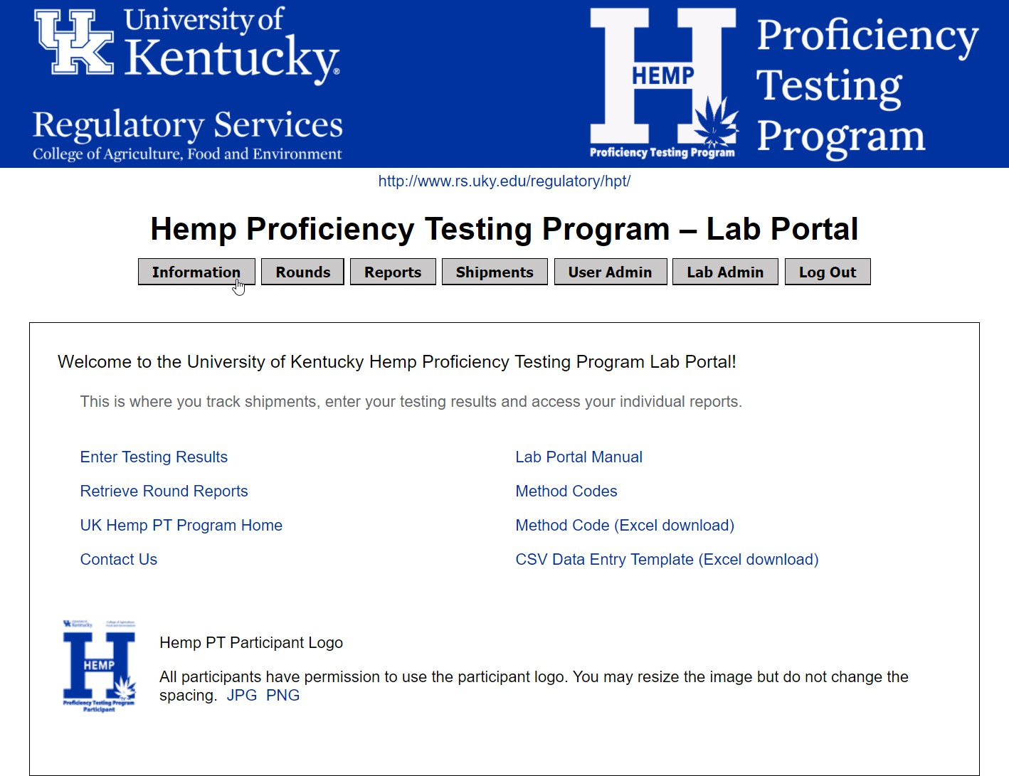

Navigate through the portal using the buttons at the top of each page

Information Button
This page provides quick links and is the first page you see after logging in.

Rounds Button
This Is where you find the samples,
This is the starting point for entering your testing results.

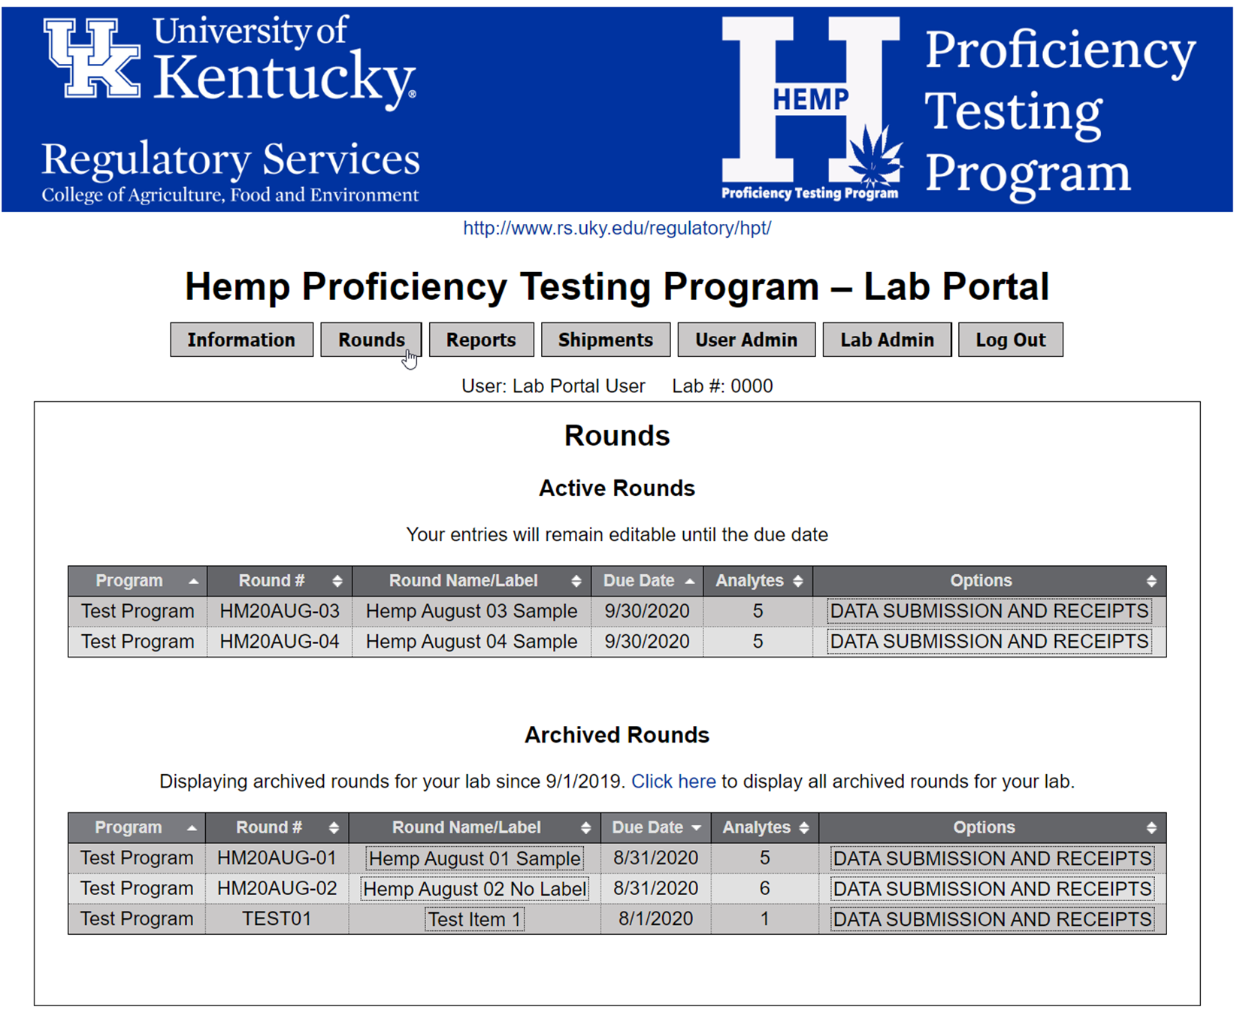
Information about the origin of the samples can be found here.

Choose “Data Submission and Receipts”. You will be presented with a form to submit your testing results. Specific instructions are next!

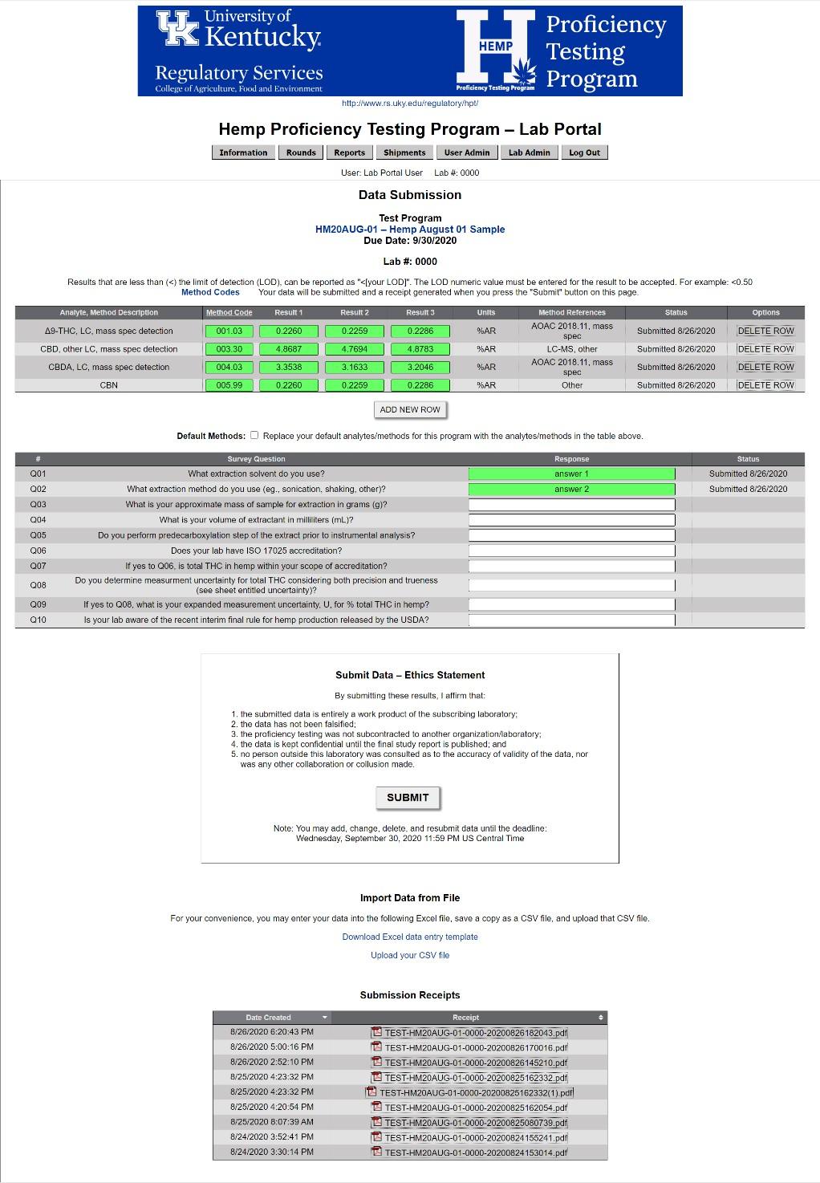
Entering your Testing Results
You access this page by selecting “Data Submission and Receipts” from the Rounds Button

This section is where you submit your results.
We will walk through this next!

A receipt is issued each time you submit results. The most recent submission is used in our statistical analysis.

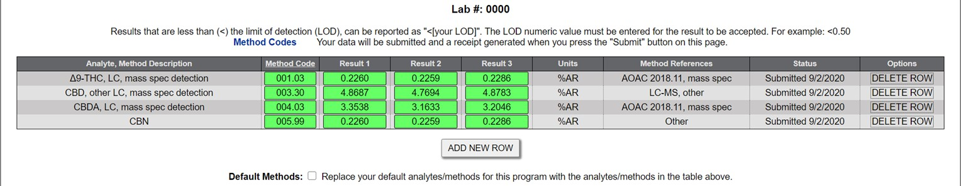
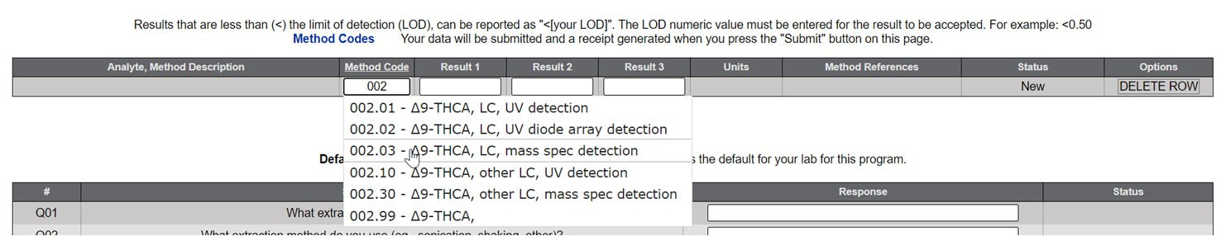

Entering Analytes and Survey Questions
You access this page by selecting “Data Submission and Receipts” from the Rounds Button
Start by typing the method code in the white box. A drop down list will appear. Choose your method from this list. Method codes can be retrieved from the information button or as indicated in the image below.

When a method code is entered correctly, the name is populated and the entry box is green.

You can save the list as your default methods so they will be preloaded in the future.

Add new method codes here
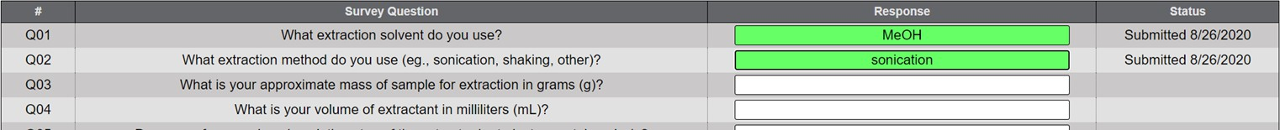
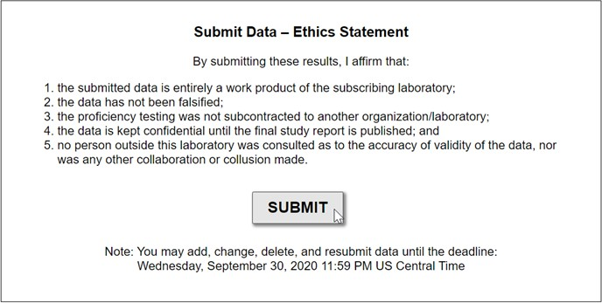
Answer survey questions
Review your entries. Agree to the ethics statement and press “Submit”
Return to the Rounds page
to submit your results for additional samples.

Confirmation & Correcting Errors
You access this page by selecting “Data Submission and Receipts” from the Rounds Button
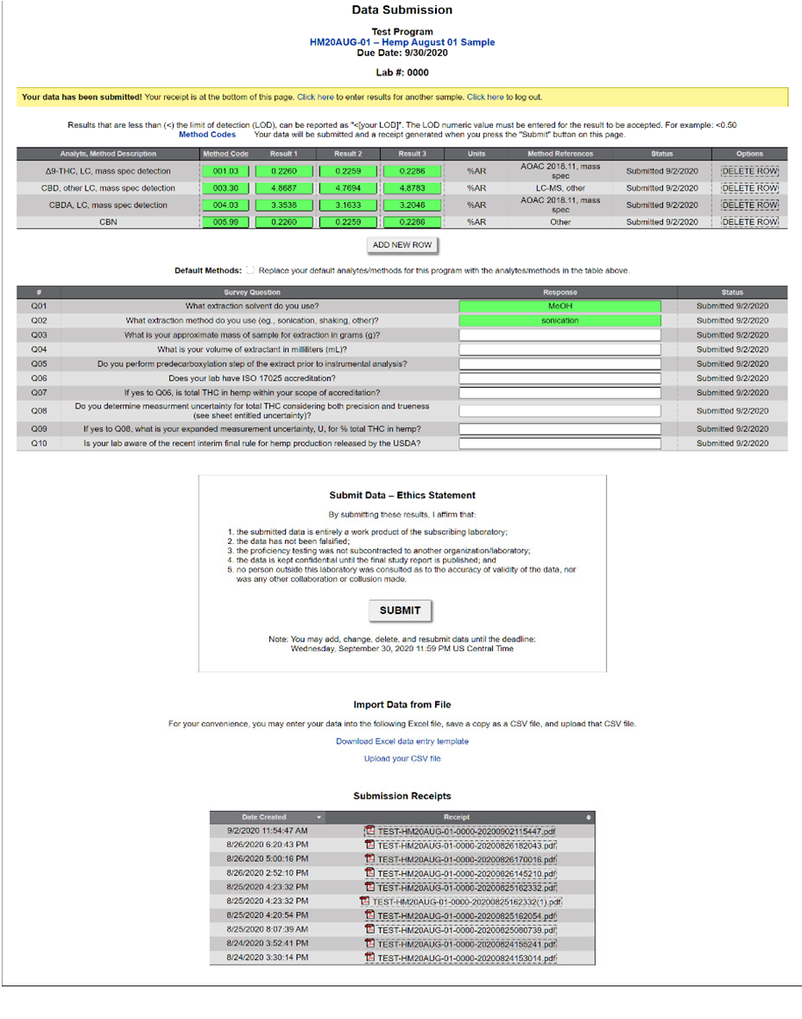
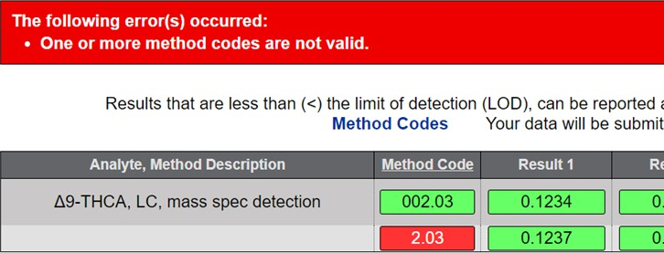
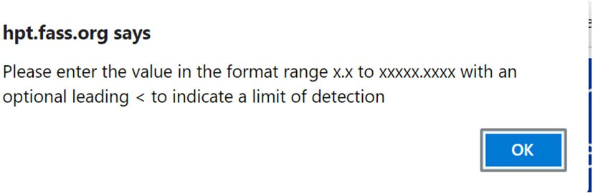
After you press the “Submit” button the system will confirm you submission in a variety of ways (pictured below).
If you make a mistake the system will notify you of the specifics in a variety of ways (pictured below).
To correct an error use the backspace and delete keys to clear the mistake, then enter the correct data.

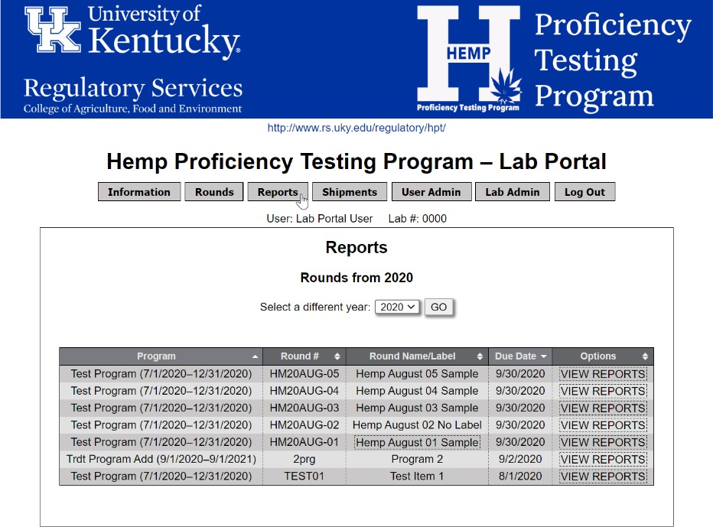
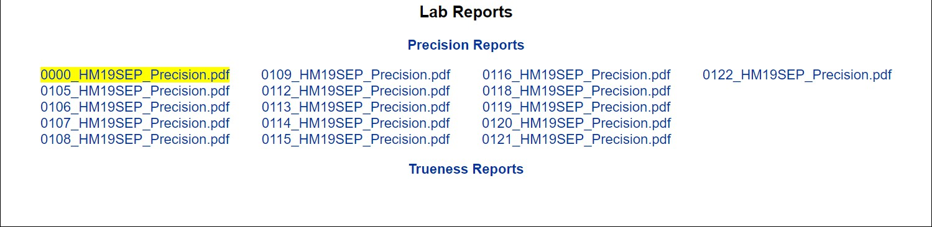
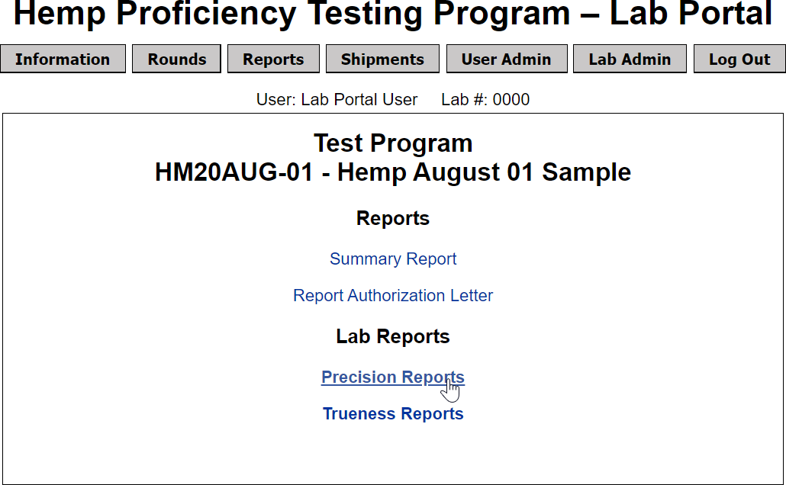
Reports Button
This is where you access your reports.

Choose “View Reports” to display the reports for the sample.

Your lab’s report will be highlighted

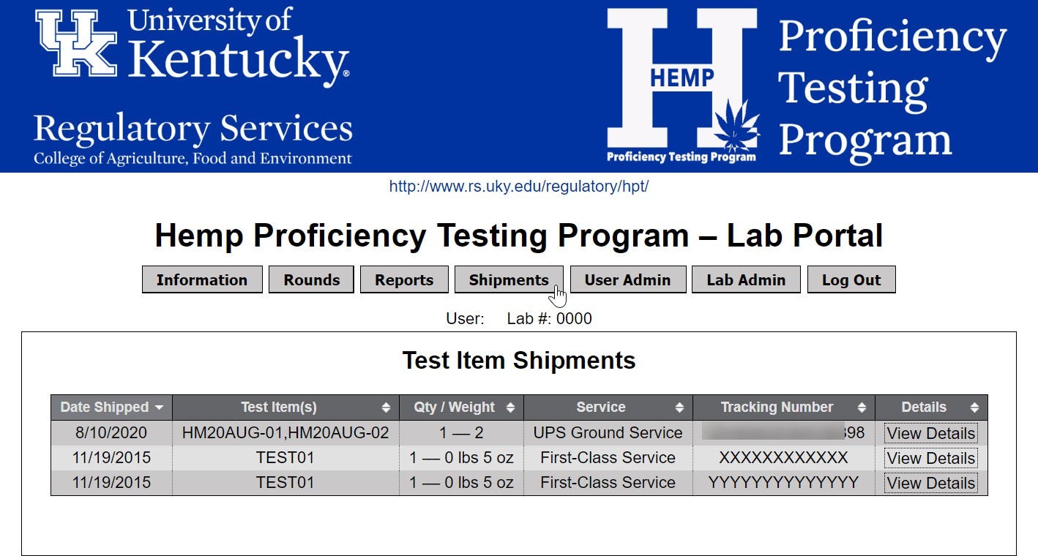
Shipments Button
This is where you find shipment tracking information.
All users will receive email notification from UK Lab Portal (hpt@uky.edu) when samples ship.

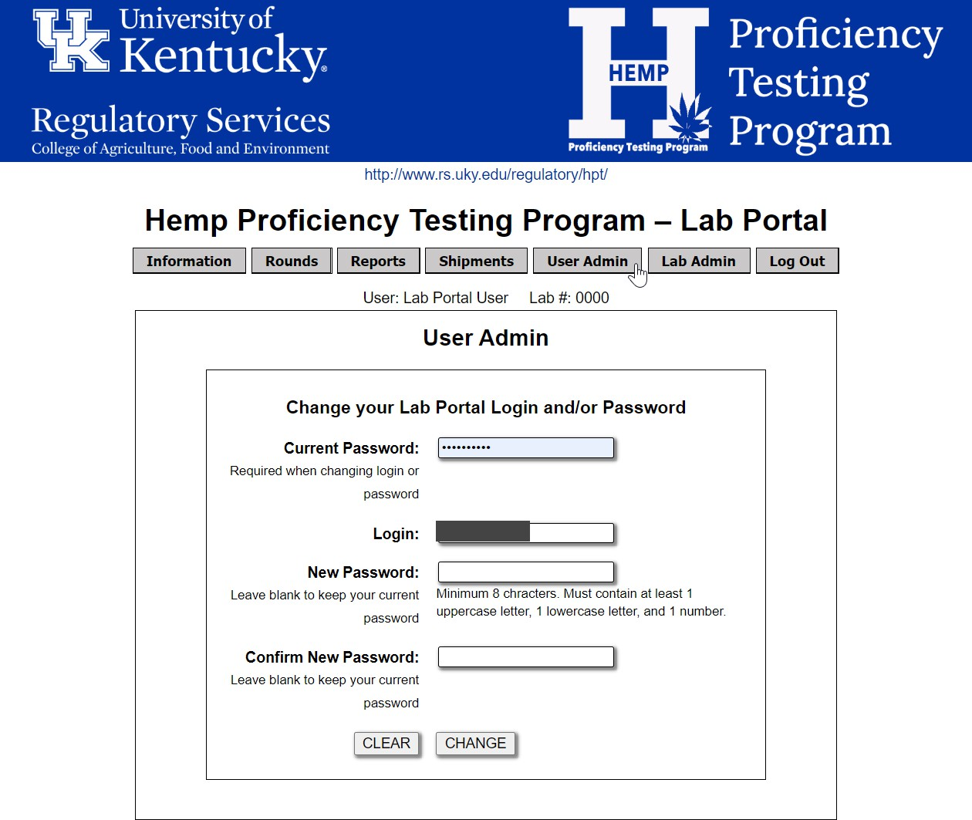
User Admin Button
This is where you manage your Lab Portal login and password.

Lab Admin Button
This button is only available to your lab’s “Manager”.
Your lab’s contact information and users are managed from this page.

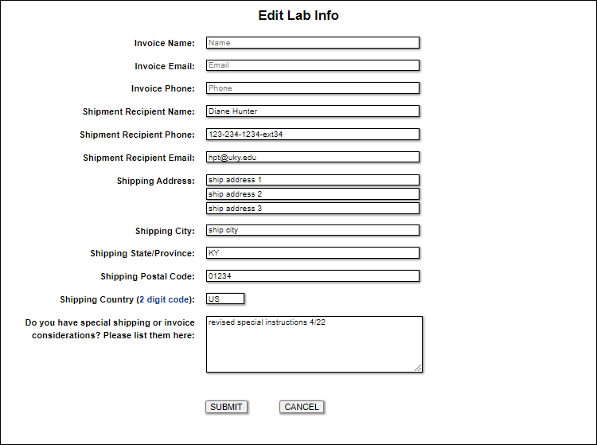
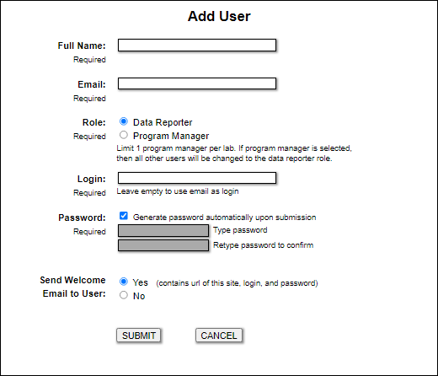
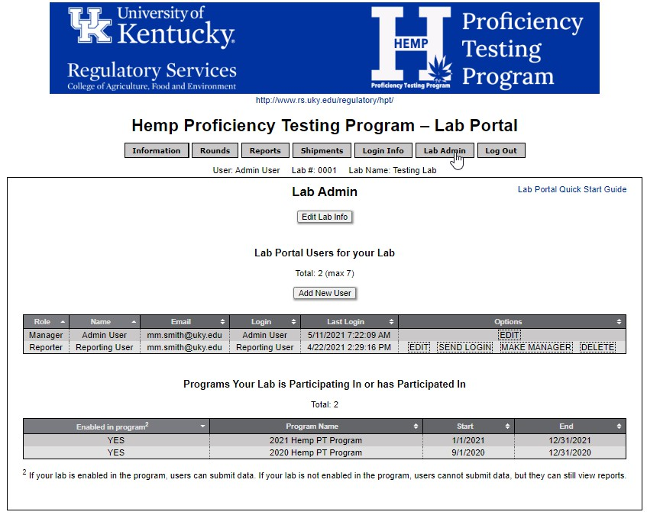
The people listed here do not have the ability to login. If you want them to login in you must add them as a user.

You must assign a role to each user. The difference between a “Data Reporter” and “Program Manager” is that the Manager manages your lab’s contact information & users. The Lab Admin button is only available to Program Managers.

