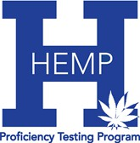

HEMP PROFICIENCY TESTING PROGRAM ENROLLMENT

To join the program:
1) Save this form to your device 2) Fill in the form 3) Email completed form to hpt@uky.edu
After enrollment, you will have the ability to add additional users.
In July, all labs are sent an invoice where you will choose your participation level.

Lab Name:

Address 1:
Address 2:
Address 3:
City: State/Province: Postal Code

Hemp Program Lab Manager:
Name:
Email: Phone:

Shipment Recipient:
Name:
Email: Phone:

Invoice Contact:
Name:
Email: Phone:

Do you have special shipping or invoice considerations? Please list them here:

